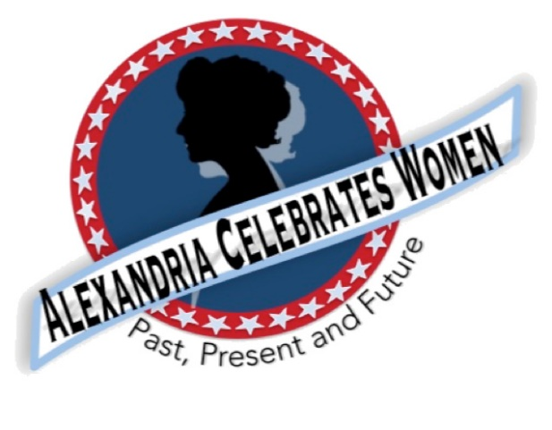
Alexandria Celebrates Women
August 2021 Newsletter
Editor: Gayle Converse

“The right of citizens of the United States to vote shall not be denied or abridged by the United States or by any State on account of sex.”
- 19th Amendment to the United States Constitution

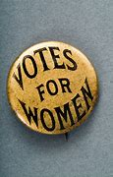 Welcome to the August 2021 newsletter of Alexandria Celebrates Women (ACW).

August 2021 brings to a close “National Women’s Suffrage Year” -- created to continue the centennial of the ratification of the 19th Amendment to the United States Constitution.
Because it became necessary to postpone most commemorations in 2020, National Women’s Suffrage Year has been celebrated from August 2020-August 2021. ACW has continued its history information, including the milestones in the fight for women’s suffrage, in our newsletters this year.

One special event coming up in three weeks is the dedication of the new historic marker at South Saint Asaph and Prince Streets in Alexandria. This long-waited occasion will be held at 9 a.m. EDT Thursday, August 26, 2021. Additional information regarding this free outdoor event can be found directly below, along with newsletter details regarding Alexandria’s women of past and current history in the ACW monthly Alexandria Times column and on the ACW Website Alexandria Celebrates Women

We hope that you, your family and friends are well and safe during this time and we hope the and educational links and stories that follow can serve as a part of a plan to encourage your family’s enthusiasm for American history.

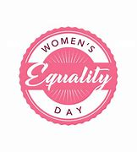 Events & Items of Interest

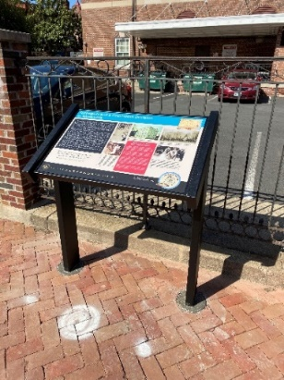
South St. Asaph and Prince Streets

Historic Marker Dedication SET FOR August 26!

Please Join us as Alexandria Celebrates Women and The Office of Historic Alexandria commemorate Women’s Equality Day with the formal dedication of the City’s new women’s history marker!

ACW is honored to have worked with the Office of Historic Alexandria for the creation and recent installation of a new “tabletop” marker in Old Town. The marker is designated as part of the Alexandria Heritage Trail and is located on the site which housed the Federal District Court in the early 20th century. The third-floor courtroom was located in the old Customs House which stood on the corner of South St. Asaph and Prince Streets in Alexandria. Information is live at Visit Alexandria Twitter (thread) and Instagram Stories. Please take a moment to visit this exciting piece of our city’s history! A formal dedication is scheduled (rain or shine) beginning at 9 a.m. August 26, 2021 – Women’s Equality Day (also the 101st anniversary of the U.S. certification of the 19th Amendment. The 30-minute program will conclude with a reception (complete with “Suffragist Chocolate Cake” and the inaugural guided tour of the new Alexandria Women’s History Walk! Please join Alexandria Mayor Justin Wilson and other dignitaries as we honor the brave women who placed themselves at risk to gain equality at the ballot box.

Event: Women’s Historic Martker Dedication
Date: August 26, 2021
Time: 9 a.m. – 9:30 a.m.
Location: Corner of South Saint Asaph and Prince Streets, Alexandria, Va.

Suffragist Prisoners at Occoquan:
in November 1917, 32 suffragists were arrested in Washington, D.C. for allegedly “blocking traffic” on a Pennsylvania Avenue sidewalk. They were sent to the District of Columbia workhouse at nearby Occoquan, Virginia. The women were subjected to undue hardships and torture, resulting in the infamous November 14, 1917 “Night of Terror.” A number of women prisoners were threatened, beaten and hurled against walls and floors. A few days later, force feedings began. The suffragist prisoners were eventually freed from Occoquan following a hearing in Alexandria’s federal courthouse.
ACW greatly appreciates your help in achieving recognition of the women who bravely endured imprisonment and brutality in their efforts to gain the vote for all women – across the nation and here in Alexandria.

We would like to take this opportunity to thank the American Association of University Women (AAUW) for its generous $200. donation to help make this historic marker a reality.

THANK YOU TO ALL WHO HAVE DONATED!

New Women’s History Walk Inaugural Tour August 26!
Join us August 26, 2021, for the new Alexandria Women’s History Walk (immediately following the historic marker dedication reception). Discover where Alexandria’s women of the past and present have lived, worked and made history on Alexandria Celebrates Women’s new Women’s History Walk! The extensive self-guided journey is designed to enable history seekers to explore as little or as much as you like at your own pace. The new Walk includes an optional extended tour. ACW will post the route soon!

Replay of Celebrate Women Awards
Alexandria Celebrates Women was proud to host the first Celebrate Women Awards March 29, 2021. The virtual event honored women who have had a hand in caring for all Alexandrians during the COVID-19 pandemic. The Awards show benefited the Alexandria Domestic Violence Safehouse. A replay of the Awards show can be found at Alexandria Celebrates Women.

Women Impacted by Pandemic Need Your Help
The Alexandria Domestic Violence Safehouse – a place of refuge for many women impacted by the pandemic – needs your help. When women and their families are able to leave the shelter, there is a need for housewares -- silverware, pots and pans, dishes. You can assist by clicking here http://www.target.com/gift-registry/gift/effb54910b8145f2ba507c26a79eb5a6

From the National Women’s History Museum (NWHM)

“The Olympics are in full swing, and we love cheering on the spectacular women athletes competing in Tokyo. But did you know it wasn't until 1908 in London that female athletes were specifically included? Margaret Abbot took first in women's golf in Paris in 1900, making her the first female American Olympic champion.

It took generations of activism and Title IX regulations to increase female representation in U.S. sports, although glaring inequities persist. Despite these hurdles, American women continue to dominate the Olympic field. Learn more about women's representation in the Olympics at our online exhibit, Getting into the Games: Women and the Olympics.”

Enjoy the NWHM free virtual museum at www.womenshistory.org

History

August 26, 1920 – U.S. Certification of the 19th Amendment

Woman Suffrage Committee Chairman James R. Mann

On August 26, 1920, United States Secretary of State Bainbridge Colby certified that the 19th Amendment—extending the vote to women—would be part of the U.S. Constitution. The State of Tennessee ratified the amendment on August 18, 1920. More than a year earlier, the House voted to approve the amendment on May 21, 1919. Introduced by Woman Suffrage Committee Chairman James R. Mann of Illinois, the “Susan B. Anthony Amendment” was successfully pushed by suffrage lobbyists who tied U.S. defense of democracy abroad to the extension of democracy at home. The bill gained momentum as the U.S. mobilized to fight World War I with the help of many women. Mann declared, “The time is ripe, the people are ready and the beneficiaries of this amendment are eager, willing and able to perform the duties of citizenship.”
https://history.house.gov/Historical-Highlights/1901-1950/The-19th-Amendment
NEWS

Alexandria Times, July 29, 2021 – “Caroline Hallowell Miller” Alexandria Celebrates Women: Caroline Hallowell Miller | Alexandria Times | Alexandria, VA (alextimes.com)

CBS News, July 20, 2021 – “Wally Funk makes history during Blue Origin's launch to space”
Wally Funk makes history during Blue Origin's launch to space (msn.com)
NBC News, July 21, 2021 – Norwegian women's beach handball team fined for not playing in bikinis Norwegian women's beach handball team fined for not playing in bikinis (nbcnews.com)
New York Times, July 28, 2021 – “She changed astronomy forever. But you’ve probably never heard of her” Opinion | The Silent Pulse of the Universe: What Jocelyn Bell Burnell Discovered - The New York Times (nytimes.com)

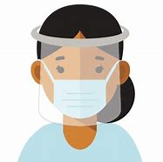 COVID-19
From the U.S. Department of Health and Human Services (HHS) Office on Women’s Health
For the latest COVID-19 guidelines, please visit:
Office on Women's Health | womenshealth.gov
Coronavirus Disease 2019 (COVID-19) | CDC
Choosing Safer Activities | CDC

Career
Most essential workers in the United States are women. If you are experiencing changes in your routine – whether currently working from home or being asked to return to your workplace, you might be worrying about finances and quarantine fatigue. Additional worry about mental health and risk of exposure to COVID-19 have affected most of us.

We salute those of you who work in essential industries, including cleaning services, grocery and drug stores, farmer’s markets, transportation, federal, state and local government, active-duty U.S. Military and Reserves, teaching, U.S. Post Office, and other delivery businesses. We thank the region’s brave first responders and their equally brave families: medical personnel, firefighters, law enforcement, and City and County maintenance crews and volunteers – everyone!

If you are looking for employment: The City of Alexandria's Workforce Development Center (WDC), a partner of the American Job Center network, offers staffing solutions that provide businesses with employees who are skilled and ready to work. As a certified One Stop Center, WDC serves a variety of skill levels from those with advanced degrees and years of experience to those with limited education and experience. It provides services and resources for job seekers including access to the WDC Career Center, career readiness workshops, career assessments and customized hiring events. https://www.alexandriava.gov/WorkforceDevelopment https://www.vec.virginia.gov/alexandria
If you are a business looking for employees: The WDC provides a range of business services at no cost to businesses, including job placement, recruitment, labor market information and certified Business Services Specialists to assist in workforce planning. WDC operates the Virginia Initiative for Employment not Welfare (VIEW) Program, Workforce Innovation and Opportunity Act (WIOA - Adult Employment, Dislocated Worker and Youth and Young Adult), Supplemental Nutrition Assistance Program Employment Training (SNAPET), TeensWork! (public and private programs), Refugee Employment Program, Disability Employment and Veteran Services. https://www.vec.virginia.gov/alexandria
https://www.alexandriava.gov/WorkforceDevelopment
If you are looking for emergency child care: The Alexandria Emergency Child Care Collaborative supports all families in need of child care and works to match them with open providers. COVID-19 Emergency Child Care: Information for Parents and Providers | City of Alexandria, VA

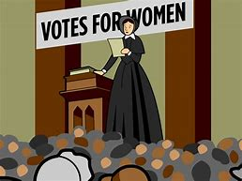 The Basics
The 19th Amendment to the United States Constitution (Amendment XIX – often referred to an the “Susan B. Anthony Amendment”) granted American women the right to vote, a right known as women’s suffrage. The Amendment prohibits the states and the federal government from denying the right to vote to citizens of the United States on the basis of sex. When the Amendment was ratified August 18, 1920, it ended almost a century of protest. https://www.history.com/topics/womens-history/19th-amendment-1

National Key Dates:
- 1848: Seneca Falls Convention – National-level launch of the movement for women’s rights
- Following the Convention, the demand for the vote became a centerpiece of the women’s rights movement. Elizabeth Cady Stanton and Lucretia Mott, along with Susan B. Anthony and other activists, raised public awareness and lobbied the government to grant voting rights to women.
- August 18, 1920: Tennessee legislature ratifies 19th Amendment
- Tennessee becomes the last of the necessary 36 states to secure ratification.
- August 26, 1920: 19th Amendment officially certified by the U.S. Secretary of State
- U.S. Secretary of State Bainbridge Colby certified the 19th Amendment and made the adoption of the Amendment official. Every year on this date, we celebrate Women’s Equality Day in commemoration.
Virginia Key Dates
- November 27, 1909 - A group of women, including Ellen Glasgow, Mary Johnston, Kate Langley Bosher, Adèle Clark, Nora Houston, Kate Waller Barrett, and Lila Meade Valentine, found the Equal Suffrage League of Virginia.
- 1917-- Women suffragists force fed at the “Occoquan” Workhouse
- November 23, 1917 -- Suffragist prisoners released from Workhouse to attend hearing in Federal Court in Alexandria, VA Judge ruled those women protesters had been unlawfully imprisoned at Workhouse
- August 1920 - Virginia women gain the right to vote after the Nineteenth Amendment to the U.S. Constitution becomes law.
- 1924 - Kate Waller Barrett of Alexandria serves as a delegate to the Democratic National Convention.
- February 21, 1952 - The Virginia General Assembly ratifies the Nineteenth Amendment to the U.S. Constitution, thirty-two years after it became law.
Resources
- Virginia Museum of History and Culture https://www.virginiahistory.org/what-you-can-see/story-virginia/explore-story-virginia/1876-1924/virginia-and-women’s-suffrage
- Turning Point Suffragist Memorial Association https://suffragistmemorial.org/suffragist-memorial-site-surroundings/
- Women’s Suffrage Museum (Lucy Burns Museum) “From the White House to the Workhouse to the Franchise” https://workhousemuseums.org/history/importance-of-womens-suffrage/
- Encyclopedia Virginia “Woman Suffrage in Virginia” https://www.encyclopediavirginia.org/Woman_Suffrage_in_Virginia
- William & Mary (W&M) Women's Law Society “Women's Suffrage in Virginia” http://wmpeople.wm.edu/site/page/wmws/womenssuffrageinvirginia
- League of Women Voters of Fairfax Area (LWVFA) https://www.lwv-fairfax.org/
- League of Women Voters Centennial http://www.lwvnca.org/Centennial.html
- The National Women’s History Museum “Crusade for the Vote: Suffrage Resource Center”
https://www.crusadeforthevote.org/educational-resources
https://www.crusadeforthevote.org/partners
https://www.womenshistory.org/womens-history/online-exhibits
https://www.womenshistory.org/exhibits/creating-female-political-culture
- Women's Suffrage Centennial Commission https://www.womensvote100.org/about
- Suffrage Sisters media@womensvote100.org
- General inquiries | staff@womensvote100.org
- Virginia History https://wmpeople.wm.edu/site/page/wmws/womenssuffrageinvirginia
Alexandria Celebrates Women (ACW) recognizes the accomplishments and contributions of Alexandria, Virginia’s women of the past, present and future. The volunteer 501(c)(3) charitable non-profit organization acknowledges the distinguished history of Alexandria’s heroines while celebrating the empowerment of Alexandria’s modern woman. https://alexandriacelebrateswomen.com/
For more information contact Pat Miller at AlexandriaCelebratesWomen@gmail.com

