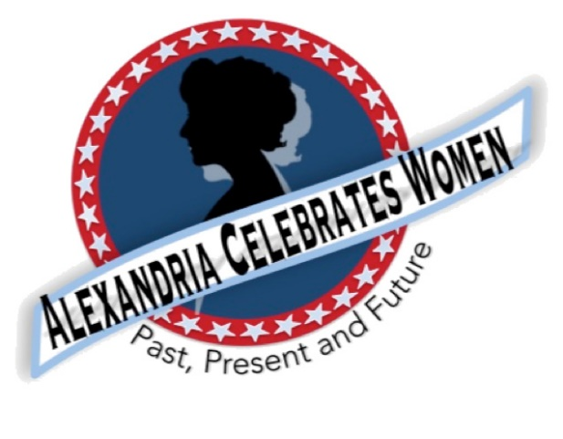

Alexandria Celebrates Women
January 2021 Newsletter

Editor: Gayle Converse

“The right of citizens of the United States to vote shall not be denied or abridged by the United States or by any State on account of sex.”
- 19th Amendment to the United States Constitution

Welcome to the January 2022 issue of the Alexandria Celebrates Women (ACW) newsletter. We wish you a wonderful New Year!

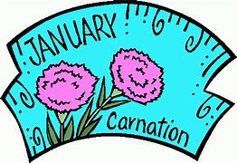 January launches the new year on its resolution-filled first day, however you could eliminate those good intentions Jan. 17 – on “Ditch News Year’s Resolutions Day.” January is National Cervical Cancer Awareness Month and National Blood Donor Month. Treat yourself to a warming beverage and relaxing bath -- because Jan. is also National Hot Tea Month and National Bubble Bath Day occurs Jan. 8. Jan. 18 is Martin Luther King, Jr., Day.
ACW has continued its tradition of bringing you history information, including the milestones in the fight for women’s suffrage, in our newsletters this year. You can find information regarding Alexandria’s women of past, present and future in the ACW monthly Alexandria Times column and on the ACW Website Alexandria Celebrates Women – and speaking of Websites…ACW is looking for a Webmaster. If you or someone you know is interested and would like to learn more regarding the position, please contact Pat Miller at pmiller1806@comcast,net .
We hope that you, your family and friends are well and safe during this time and we hope the educational links and stories that follow can serve as a part of a plan to encourage your family’s enthusiasm for American history.

Events & Items of Interest

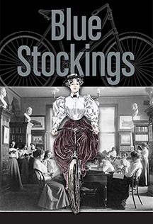 Join us March 8, 2022 for the Little Theatre of Alexandria production of “Blue Stockings!”
The women’s suffrage movement is Great Britain is the backdrop. The play chronicles the story of four women fighting for an education and is set in 1896 at Cambridge University. Ticket information in upcoming ACW newsletters. 2021_22 Season - LTA (thelittletheatre.com)

Women Impacted by Pandemic Need Your Help
The Alexandria Domestic Violence Safehouse – a place of refuge for many women impacted by the pandemic – needs your help. When women and their families are able to leave the shelter, there is a need for housewares -- silverware, pots and pans, dishes. You can assist by clicking here http://www.target.com/gift-registry/gift/effb54910b8145f2ba507c26a79eb5a6
New Alexandria Women’s History Walk

Discover where Alexandria’s women of the past and present have lived, worked and made history on Alexandria Celebrates Women’s new Women’s History Walk! The extensive self-guided journey is designed to enable history seekers to explore as little or as much as you like at your own pace. The new Walk includes an optional extended tour. ACW will post the route soon! If you would like a free guided tour, please contact Gayle Converse at AlexandriaCelebratesWomen@gmail.com

Replay of Celebrate Women Awards

Alexandria Celebrates Women was proud to host the first Celebrate Women Awards March 29, 2021. The virtual event honored women who have had a hand in caring for all Alexandrians during the COVID-19 pandemic. The Awards show benefited the Alexandria Domestic Violence Safehouse. A replay of the Awards show can be found at Alexandria Celebrates Women.

From the National Women’s History Museum (NWHM)

Enjoy the NWHM free virtual museum at www.womenshistory.org

History
From the National Women’s History Alliance
- January 3, 1949 – Margaret Chase Smith (R-Maine) starts her tenure in the Senate, where she stays in office until 1973, became the first woman to serve in both the House and Senate as she previously served in the House (1940-49)
- January 5, 1925 – Nellie Tayloe Ross is inaugurated as the first woman Governor in U.S. history (Governor of Wyoming)
- January 7, 1955 – Marian Anderson is the first African American woman to sing at the Metropolitan Opera
- January 11, 1935 – Amelia Earhart makes the first solo flight from Hawaii to North America
- January 12, 1932 – Hattie Wyatt Caraway (D-Arkansas) is the first woman elected to the U.S. Senate, becomes the first woman to chair a Senate Committee and the first to serve as the Senate’s presiding officer
- January 25, 1890 – Nellie Bly, journalist, completed her around the world trip in 72 days, 6 hours, 11 minutes, and 14 seconds after setting sail east to prove she could circle the globe in less than 80 days
- January 25, 1980 – Mary Decker became the first woman to run a mile under 4 1/2 minutes, running it at 4:17.55

NEWS

Alexandria Times, December 23, 2021 – “The History of America’s ‘Deputy Husbands’” ALEXT122321_FULL.pdf (alextimes.com) page 13

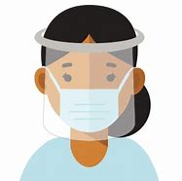
From the U.S. Department of Health and Human Services (HHS) Office on Women’s Health
From the beginning, the mission of the Office on Women’s Health (OWH) has involved connecting women and girls with up-to-date, actionable health information. Today, the OWH continues that tradition using a variety of digital platforms. We invite you to explore the OWH website (womenshealth.gov), Twitter (@womenshealth), or sign up to receive the OWH blog for the latest news, updates and health guidelines.
COVID-19
For the latest COVID-19 guidelines, please visit:
Office on Women's Health | womenshealth.gov
Coronavirus Disease 2019 (COVID-19) | CDC
Choosing Safer Activities | CDC

Career
Most essential workers in the United States are women. If you are experiencing changes in your routine – whether currently working from home or being asked to return to your workplace, you might be worrying about finances and quarantine fatigue. Additional worry about mental health and risk of exposure to COVID-19 have affected most of us.
We salute those of you who work in essential industries, including cleaning services, grocery and drug stores, farmer’s markets, transportation, federal, state and local government, active-duty U.S. Military and Reserves, teaching, U.S. Post Office, and other delivery businesses. We thank the region’s brave first responders and their equally brave families: medical personnel, firefighters, law enforcement, and City and County maintenance crews and volunteers – everyone!

If you are looking for employment: The City of Alexandria's Workforce Development Center (WDC), a partner of the American Job Center network, offers staffing solutions that provide businesses with employees who are skilled and ready to work. As a certified One Stop Center, WDC serves a variety of skill levels from those with advanced degrees and years of experience to those with limited education and experience. It provides services and resources for job seekers including access to the WDC Career Center, career readiness workshops, career assessments and customized hiring events. https://www.alexandriava.gov/WorkforceDevelopment https://www.vec.virginia.gov/alexandria
If you are a business looking for employees: The WDC provides a range of business services at no cost to businesses, including job placement, recruitment, labor market information and certified Business Services Specialists to assist in workforce planning. WDC operates the Virginia Initiative for Employment not Welfare (VIEW) Program, Workforce Innovation and Opportunity Act (WIOA - Adult Employment, Dislocated Worker and Youth and Young Adult), Supplemental Nutrition Assistance Program Employment Training (SNAPET), TeensWork! (public and private programs), Refugee Employment Program, Disability Employment and Veteran Services. https://www.vec.virginia.gov/alexandria
https://www.alexandriava.gov/WorkforceDevelopment
Child Care: Please see “Fueled by the pandemic, the child-care crisis is keeping moms out of work” in our NEWS section above.
The Alexandria Emergency Child Care Collaborative supports all families in need of child care and works to match them with open providers. COVID-19 Emergency Child Care: Information for Parents and Providers | City of Alexandria, VA
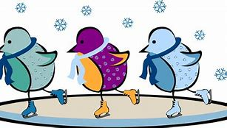 The Basics
The 19th Amendment to the United States Constitution (Amendment XIX – often referred to an the “Susan B. Anthony Amendment”) granted American women the right to vote, a right known as women’s suffrage. The Amendment prohibits the states and the federal government from denying the right to vote to citizens of the United States on the basis of sex. When the Amendment was ratified August 18, 1920, it ended almost a century of protest. https://www.history.com/topics/womens-history/19th-amendment-1

National Key Dates:

- 1848: Seneca Falls Convention – National-level launch of the movement for women’s rights
- Following the Convention, the demand for the vote became a centerpiece of the women’s rights movement. Elizabeth Cady Stanton and Lucretia Mott, along with Susan B. Anthony and other activists, raised public awareness and lobbied the government to grant voting rights to women.
- August 18, 1920: Tennessee legislature ratifies 19th Amendment
- Tennessee becomes the last of the necessary 36 states to secure ratification.
- August 26, 1920: 19th Amendment officially certified by the U.S. Secretary of State
- U.S. Secretary of State Bainbridge Colby certified the 19th Amendment and made the adoption of the Amendment official. Every year on this date, we celebrate Women’s Equality Day in commemoration.

Virginia Key Dates
- November 27, 1909 - A group of women, including Ellen Glasgow, Mary Johnston, Kate Langley Bosher, Adèle Clark, Nora Houston, Kate Waller Barrett, and Lila Meade Valentine, found the Equal Suffrage League of Virginia.
- 1917-- Women suffragists force fed at the “Occoquan” Workhouse
- November 23, 1917 -- Suffragist prisoners released from Workhouse to attend hearing in Federal Court in Alexandria, VA Judge ruled those women protesters had been unlawfully imprisoned at Workhouse
- August 1920 - Virginia women gain the right to vote after the Nineteenth Amendment to the U.S. Constitution becomes law.
- 1924 - Kate Waller Barrett of Alexandria serves as a delegate to the Democratic National Convention.
- February 21, 1952 - The Virginia General Assembly ratifies the Nineteenth Amendment to the U.S. Constitution, thirty-two years after it became law.

Resources

- Virginia Museum of History and Culture https://www.virginiahistory.org/what-you-can-see/story-virginia/explore-story-virginia/1876-1924/virginia-and-women’s-suffrage
- Turning Point Suffragist Memorial Association https://suffragistmemorial.org/suffragist-memorial-site-surroundings/
- Women’s Suffrage Museum (Lucy Burns Museum) “From the White House to the Workhouse to the Franchise” https://workhousemuseums.org/history/importance-of-womens-suffrage/
- Encyclopedia Virginia “Woman Suffrage in Virginia” https://www.encyclopediavirginia.org/Woman_Suffrage_in_Virginia
- William & Mary (W&M) Women's Law Society “Women's Suffrage in Virginia” http://wmpeople.wm.edu/site/page/wmws/womenssuffrageinvirginia
- League of Women Voters of Fairfax Area (LWVFA) https://www.lwv-fairfax.org/
- League of Women Voters Centennial http://www.lwvnca.org/Centennial.html
- The National Women’s History Museum “Crusade for the Vote: Suffrage Resource Center”
https://www.crusadeforthevote.org/educational-resources
https://www.crusadeforthevote.org/partners
https://www.womenshistory.org/womens-history/online-exhibits
https://www.womenshistory.org/exhibits/creating-female-political-culture
- Women's Suffrage Centennial Commission https://www.womensvote100.org/about
- Suffrage Sisters media@womensvote100.org
- General inquiries | staff@womensvote100.org
- Virginia History https://wmpeople.wm.edu/site/page/wmws/womenssuffrageinvirginia
Alexandria Celebrates Women (ACW) recognizes the accomplishments and contributions of Alexandria, Virginia’s women of the past, present and future. The volunteer 501(c)(3) charitable non-profit organization acknowledges the distinguished history of Alexandria’s heroines while celebrating the empowerment of Alexandria’s modern woman. https://alexandriacelebrateswomen.com/
For more information contact Pat Miller at AlexandriaCelebratesWomen@gmail.com

