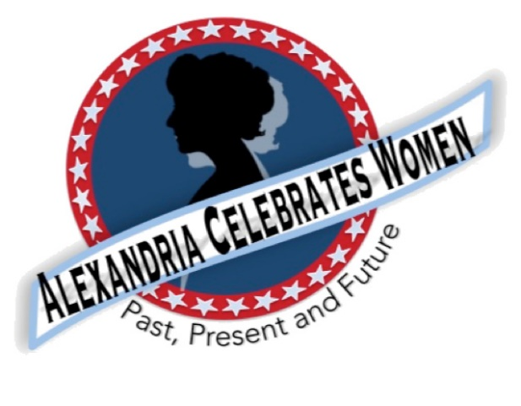
Alexandria Celebrates Women
June 2021 Newsletter
Editor: Gayle Converse

“The right of citizens of the United States to vote shall not be denied or abridged by the United States or by any State on account of sex.”
- 19th Amendment to the United States Constitution

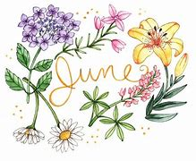 Welcome to the June 2021 newsletter of Alexandria Celebrates Women (ACW).

The month of June signifies the official start of summer: the Summer Solstice occurs Sunday, June 20, at 11:32 p.m. EDT. June is National Rose Month. June 5 is United Nations World Environment Day https://www.worldenvironmentday.global/ . June 8 features a local primary election. June 14 marks The World Health Organization’s World Blood Donor Day https://www.who.int/campaigns/world-blood-donor-day. Fly your colors during National Flag Week June 13-19.

Because it became necessary to postpone most commemorations in 2020, it is hoped that many 19th Amendment Ratification Centennial celebrations will be able to proceed in 2021. National Women’s Suffrage Year is being celebrated from August 2020-August 2021. ACW will keep historic information, including the milestones in the fight for women’s suffrage, in our newsletters this year – including the Alexandria Celebrates Women August18 dedication of the new historic marker at South Saint Asaph and Prince Streets. Additional information regarding this upcoming outdoor event can be found in this newsletter, along with details regarding Alexandria’s women of past and current history in the ACW monthly Alexandria Times column and on the ACW Website Alexandria Celebrates Women

We hope that you, your family and friends are well and safe during this time and we hope the and educational links and stories that follow can serve as a part of a plan to encourage your family’s enthusiasm for American history.

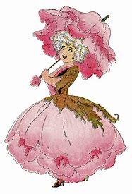 History
VOTE!
A century ago – after decades of battling for equality at the ballot box -- women across our nation won the right to vote. Alexandria holds a Democratic Primary Election Tuesday June 8. Voters will choose candidates for statewide and local races in advance of the November 2, 2021 election.
Please make history yourself and vote! For sample ballots and other information, please visit Voter Registration & Elections | City of Alexandria, VA (alexandriava.gov)
Early voting is underway at the Office of Voter Registrations and Elections. Polls open at 6 a.m. Tuesday June 8.

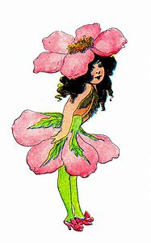 Events & Items of Interest
New Women’s History Walk Coming this Summer!
Discover where Alexandria’s women of the past and present have lived, worked and made history on Alexandria Celebrates Women’s new Women’s History Walk! The extensive self-guided journey is designed to enable history seekers to explore as little or as much as you like at your own pace. The new Walk includes an extended tour. ACW will post the route soon!

Replay of Celebrate Women Awards
Alexandria Celebrates Women was proud to host the first Celebrate Women Awards March 29, 2021. The virtual event honored women who have had a hand in caring for all Alexandrians during the COVID-19 pandemic. The Awards show benefited the Alexandria Domestic Violence Safehouse – a place of refuge for many women impacted by the pandemic. When women and their families are able to leave the shelter, there is a need for housewares -- silverware, pots and pans, dishes. You can help by clicking here http://www.target.com/gift-registry/gift/effb54910b8145f2ba507c26a79eb5a6
A replay of the Awards show can be found at Alexandria Celebrates Women.

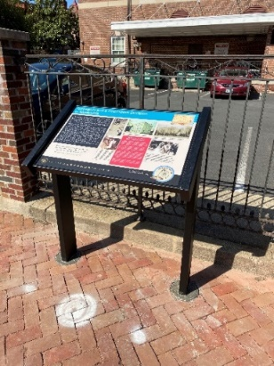 Historic Marker is A Reality!
South St. Asaph and Prince Streets

Alexandria Celebrates Women is honored to have worked with the Office of Historic Alexandria for the creation and recent installation of a new “tabletop” marker in Old Town. The marker is designated as part of the Alexandria Heritage Trail and is located on the site which housed the Federal District Court in the early 20th century. The third-floor courtroom was located in the old Customs House which stood on the corner of South St. Asaph and Prince Streets in Alexandria. Information is live at Visit Alexandria Twitter (thread) and Instagram Stories. Please take a moment to visit this exciting piece of our City’s history! A formal dedication is being planned for August 18, 2021 -- the 101st anniversary of the passage of the 19th Amendment. You are invited!
Details in upcoming ACW newsletters!

Suffragist Prisoners at Occoquan:
in November 1917, 32 suffragists were arrested in Washington, D.C. for allegedly “blocking traffic” on a Pennsylvania Avenue sidewalk. They were sent to the District of Columbia workhouse at nearby Occoquan, Virginia. The women were subjected to undue hardships and torture, resulting in the infamous November 14, 1917 “Night of Terror.” A number of women prisoners were threatened, beaten and hurled against walls and floors. A few days later, force feedings began. The suffragist prisoners were eventually freed from Occoquan following a hearing in Alexandria’s federal courthouse.
ACW greatly appreciates your help in achieving recognition of the women who bravely endured imprisonment and brutality in their efforts to gain the vote for all women – across the nation and here in Alexandria.
We would like to take this opportunity to thank the American Association of University Women (AAUW) for its generous $200. donation to help make this historic marker a reality.

THANK YOU TO ALL THOSE WHO HAVE DONATED!

From the National Women’s History Museum (NWHM):
"Girls to the Front: How Young Women are Shaping Their Future" from the latest issue of the NWHM magazine, A Different Point of View.

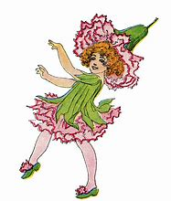 NEWS

Alexandria Times, May 26, 2021 – “The Story of Julia Johns, Community Pioneer” Page 31 05_27_2021-Alex_Times_WEB.pdf (alextimes.com)
New York Times, May 30, 2021 – “In Her Words: Women Do it All” In Her Words: 'Women do it all' (nytimes.com)
C-SPAN, May 25, 2021 – “Senate Confirms First Black Women to Lead DOJ Civil Rights and Medicare & Medicaid Services” Senate Session, Part 2 | C-SPAN.org

COVID-19 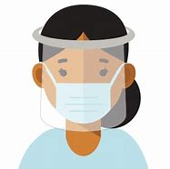
From the U.S. Department of Health and Human Services (HHS) Office on Women’s Health
For the latest COVID-19 guidelines, please visit:
Office on Women's Health | womenshealth.gov
Coronavirus Disease 2019 (COVID-19) | CDC
Choosing Safer Activities | CDC

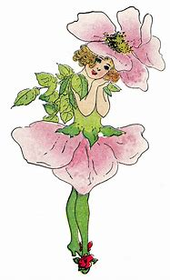 Career
Most essential workers in the United States are women. If you are experiencing changes in your routine – whether currently working from home or being asked to return to your workplace, you might be worrying about finances and quarantine fatigue. Additional worry about mental health and risk of exposure to COVID-19 have affected most of us.

We salute those of you who work in essential industries, including cleaning services, grocery and drug stores, farmer’s markets, transportation, federal, state and local government, active-duty U.S. Military and Reserves, teaching, U.S. Post Office, and other delivery businesses. We thank the region’s brave first responders and their equally brave families: medical personnel, firefighters, law enforcement, and City and County maintenance crews and volunteers – everyone!

If you are looking for employment: The City of Alexandria's Workforce Development Center (WDC), a partner of the American Job Center network, offers staffing solutions that provide businesses with employees who are skilled and ready to work. As a certified One Stop Center, WDC serves a variety of skill levels from those with advanced degrees and years of experience to those with limited education and experience. It provides services and resources for job seekers including access to the WDC Career Center, career readiness workshops, career assessments and customized hiring events. https://www.alexandriava.gov/WorkforceDevelopment https://www.vec.virginia.gov/alexandria
If you are a business looking for employees: The WDC provides a range of business services at no cost to businesses, including job placement, recruitment, labor market information and certified Business Services Specialists to assist in workforce planning. WDC operates the Virginia Initiative for Employment not Welfare (VIEW) Program, Workforce Innovation and Opportunity Act (WIOA - Adult Employment, Dislocated Worker and Youth and Young Adult), Supplemental Nutrition Assistance Program Employment Training (SNAPET), TeensWork! (public and private programs), Refugee Employment Program, Disability Employment and Veteran Services. https://www.vec.virginia.gov/alexandria
https://www.alexandriava.gov/WorkforceDevelopment
If you are looking for emergency child care: The Alexandria Emergency Child Care Collaborative supports all families in need of child care and works to match them with open providers. COVID-19 Emergency Child Care: Information for Parents and Providers | City of Alexandria, VA
The Basics
The 19th Amendment to the United States Constitution (Amendment XIX – often referred to an the “Susan B. Anthony Amendment”) granted American women the right to vote, a right known as women’s suffrage. The Amendment prohibits the states and the federal government from denying the right to vote to citizens of the United States on the basis of sex. When the Amendment was ratified August 18, 1920, it ended almost a century of protest. https://www.history.com/topics/womens-history/19th-amendment-1

National Key Dates:
- 1848: Seneca Falls Convention – National-level launch of the movement for women’s rights
- Following the Convention, the demand for the vote became a centerpiece of the women’s rights movement. Elizabeth Cady Stanton and Lucretia Mott, along with Susan B. Anthony and other activists, raised public awareness and lobbied the government to grant voting rights to women.
- August 18, 1920: Tennessee legislature ratifies 19th Amendment
- Tennessee becomes the last of the necessary 36 states to secure ratification.
- August 26, 1920: 19th Amendment officially certified by the U.S. Secretary of State
- U.S. Secretary of State Bainbridge Colby certified the 19th Amendment and made the adoption of the Amendment official. Every year on this date, we celebrate Women’s Equality Day in commemoration.
Virginia Key Dates
- November 27, 1909 - A group of women, including Ellen Glasgow, Mary Johnston, Kate Langley Bosher, Adèle Clark, Nora Houston, Kate Waller Barrett, and Lila Meade Valentine, found the Equal Suffrage League of Virginia.
- 1917-- Women suffragists force fed at the “Occoquan” Workhouse
- November 23, 1917 -- Suffragist prisoners released from Workhouse to attend hearing in Federal Court in Alexandria, VA Judge ruled those women protesters had been unlawfully imprisoned at Workhouse
- August 1920 - Virginia women gain the right to vote after the Nineteenth Amendment to the U.S. Constitution becomes law.
- 1924 - Kate Waller Barrett of Alexandria serves as a delegate to the Democratic National Convention.
- February 21, 1952 - The Virginia General Assembly ratifies the Nineteenth Amendment to the U.S. Constitution, thirty-two years after it became law.
Resources
- Virginia Museum of History and Culture https://www.virginiahistory.org/what-you-can-see/story-virginia/explore-story-virginia/1876-1924/virginia-and-women’s-suffrage
- Turning Point Suffragist Memorial Association https://suffragistmemorial.org/suffragist-memorial-site-surroundings/
- Women’s Suffrage Museum (Lucy Burns Museum) “From the White House to the Workhouse to the Franchise” https://workhousemuseums.org/history/importance-of-womens-suffrage/
- Encyclopedia Virginia “Woman Suffrage in Virginia” https://www.encyclopediavirginia.org/Woman_Suffrage_in_Virginia
- William & Mary (W&M) Women's Law Society “Women's Suffrage in Virginia” http://wmpeople.wm.edu/site/page/wmws/womenssuffrageinvirginia
- League of Women Voters of Fairfax Area (LWVFA) https://www.lwv-fairfax.org/
- League of Women Voters Centennial http://www.lwvnca.org/Centennial.html
- The National Women’s History Museum “Crusade for the Vote: Suffrage Resource Center”
https://www.crusadeforthevote.org/educational-resources
https://www.crusadeforthevote.org/partners
https://www.womenshistory.org/womens-history/online-exhibits
https://www.womenshistory.org/exhibits/creating-female-political-culture
- Women's Suffrage Centennial Commission https://www.womensvote100.org/about
- Suffrage Sisters media@womensvote100.org
- General inquiries | staff@womensvote100.org
- Virginia History https://wmpeople.wm.edu/site/page/wmws/womenssuffrageinvirginia
Alexandria Celebrates Women (ACW) recognizes the accomplishments and contributions of Alexandria, Virginia’s women of the past, present and future. The volunteer 501(c)(3) charitable non-profit organization acknowledges the distinguished history of Alexandria’s heroines while celebrating the empowerment of Alexandria’s modern woman. https://alexandriacelebrateswomen.com/
For more information contact Pat Miller at AlexandriaCelebratesWomen@gmail.com
