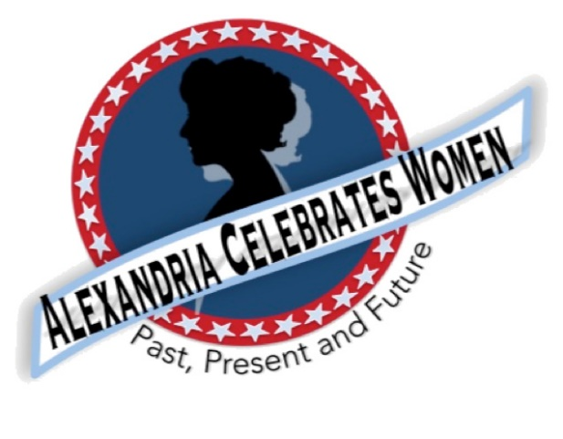

Alexandria Celebrates Women
November 2021 Newsletter
Editor: Gayle Converse

“The right of citizens of the United States to vote shall not be denied or abridged by the United States or by any State on account of sex.”
- 19th Amendment to the United States Constitution

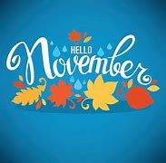 Welcome to the November 2021 issue of the Alexandria Celebrates Women (ACW) newsletter.

Among many November observances: National Native American Heritage Month, National Diabetes Month, National Family Stories Month, National Gratitude Month (Thanksgiving falls on Thursday Nov. 25), National Family Caregiver’s Appreciation Month, and National Inspirational Role Models Month (we know that you are an inspiration to all!). National Hunger & Homeless Awareness Week is November 13-21, National Young Readers Week is November 14-20 and World Kindness Week is November 14-20. Thursday Nov. 11 is Veteran’s Day; Tuesday Nov. 30 is National Giving Day. Wondering what to do with those leftover Hallowe’en treats? Enjoy them--Thursday Nov. 4 is National Candy Day!

ACW has continued its tradition of bringing you history information, including the milestones in the fight for women’s suffrage, in our newsletters this year. You can find information regarding Alexandria’s women of past, present and future in the ACW monthly Alexandria Times column and on the ACW Website Alexandria Celebrates Women

We hope that you, your family and friends are well and safe during this time and we hope the educational links and stories that follow can serve as a part of a plan to encourage your family’s enthusiasm for American history.

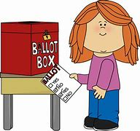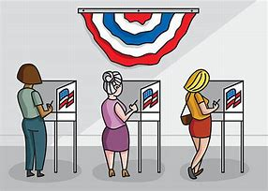

November 2, 2021 General Election
Polls are open Tuesday Nov. 2, 2021 from 6 a.m. to 7 p.m. EDT

As of July 1, 2020, Virginia law requires all voters to provide an acceptable form of identification at the polls.
For a complete list of acceptable IDs, please see Virginia's Department of Elections website, or Alexandria’s Office of Voter Registration and Elections Voter Registration & Elections | City of Alexandria, VA (alexandriava.gov) Virginia Voter Information – Citizen Portal Office of Voter Registration & Elections, 132 North Royal Street, Alexandria, VA.
To check the status of your mail in application and ballot, please visit: Virginia Department of Elections

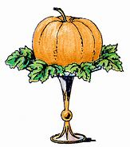 Events & Items of Interest

National Archives: Rightfully Hers: American Women and the Vote
The Rotunda of the National Archives Building in Washington, DC, is open for viewing of the Declaration of Independence, U.S. Constitution, and Bill of Rights with limited capacity from 10 a.m. to 5:30 p.m. daily. Starting August 16, 2021, the Lawrence F. O'Brien Gallery featuring Rightfully Hers: American Women and the Vote and the David M. Rubenstein Gallery featuring Records of Rights will also be open with limited capacity from 10 a.m. to 5:30 p.m. Reserve timed entry tickets on Recreation.gov. The reopening of the National Archives Museum and its continued operation will be contingent on local public health metrics remaining below targets for safe reopening.
All other Washington, DC, exhibits are closed at this time. All public events are cancelled until further notice. This includes in-person public programs, tours, school group visits, public meetings, external conferences, and facility rentals. For more information, go to Archives.gov/coronavirus or monitor National Archives accounts on Facebook and Twitter for operating status updates.
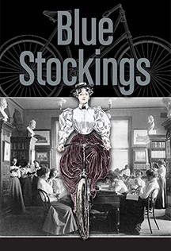 Join us March 8, 2022 for the Little Theatre of Alexandria production of “Blue Stockings!”
The women’s suffrage movement is Great Britain is the backdrop. The play chronicles the story of four women fighting for an education and is set in 1896 at Cambridge University. Ticket information in upcoming ACW newsletters. 2021_22 Season - LTA (thelittletheatre.com)
Special announcement From the Alexandria Domestic Violence Program: GIFT CARD DONATIONS NEEDED

The Alexandria Domestic Violence Program/Sexual Assault Center (DVP) is preparing for its annual Children’s Holiday Toy and Gift Card Drive. Due to the COVID-19 pandemic, the emphasis this year is on gift card donations for families who have been victims of domestic and sexual violence. The DVP reports that your donation might be the only gift these children will receive in 2021.

Gift cards from Target, Wal-Mart, Amazon, VISA, CVS, Walgreens and grocery stores are welcome.

The DVP will accept donations beginning November 22 through December 10, 2021.

For drop off locations, please call the Domestic Violence Hotline 703.746.4911. If you are not able to drop off, a pick- up of your donation can be arranged. For further information, please contact: Yeme Mehari at 703.746.4911 yeme.mehari@alexandriava.gov

Thank you for making the holidays -- despite the hardships of the past year and a half -- a special time for survivors and their children.

Women Impacted by Pandemic Need Your Help
The Alexandria Domestic Violence Safehouse – a place of refuge for many women impacted by the pandemic – needs your help. When women and their families are able to leave the shelter, there is a need for housewares -- silverware, pots and pans, dishes. You can assist by clicking here http://www.target.com/gift-registry/gift/effb54910b8145f2ba507c26a79eb5a6
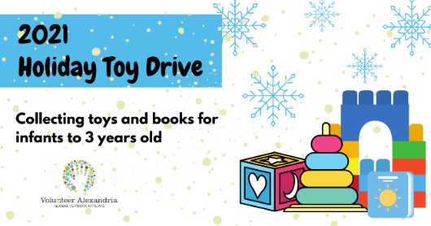 Volunteer Alexandria Holiday Toy Drive

Volunteer Alexandria is hosting its annual Holiday Toy Drive. Donations and volunteers are needed. Volunteers are needed to load, sort, count and inventory the donated toys. Children are encouraged to volunteer and help.
This Volunteer Alexandria event is in partnership with the Alexandria City Department of Community and Human Services. The annual Holiday Community Toy Drive, which will serve 300 families and 700 children engages volunteers six and older. Volunteer Alexandria | Holiday Toy Drive 2021 - Gift Sorting
New Alexandria Women’s History Walk

Discover where Alexandria’s women of the past and present have lived, worked and made history on Alexandria Celebrates Women’s new Women’s History Walk! The extensive self-guided journey is designed to enable history seekers to explore as little or as much as you like at your own pace. The new Walk includes an optional extended tour. ACW will post the route soon! If you would like a free guided tour, please contact Gayle Converse at AlexandriaCelebratesWomen@gmail.com

Replay of Celebrate Women Awards

Alexandria Celebrates Women was proud to host the first Celebrate Women Awards March 29, 2021. The virtual event honored women who have had a hand in caring for all Alexandrians during the COVID-19 pandemic. The Awards show benefited the Alexandria Domestic Violence Safehouse. A replay of the Awards show can be found at Alexandria Celebrates Women.

From the National Women’s History Museum (NWHM)

Enjoy the NWHM free virtual museum at www.womenshistory.org

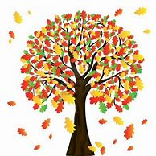 History

From the National Women’s History Alliance
November - National Women's History Alliance (nationalwomenshistoryalliance.org)

November 1, 1848 – First medical school for women, the New England Female Medical School, opens, in 1874 it merges with Boston University to become one of the world’s first co-ed medical schools

November 8, 1910 – The state of Washington passes a constitutional amendment to guarantee woman suffrage
November 11, 1993 – The Vietnam Women’s Memorial dedicated in Washington, D.C. ---- an idea created by former army combat nurse Diane Carlson Evans and sculpted by Glenna Goodacre to honor the 265,000 women who voluntarily served during the Vietnam era

November 28, 1881 – The first organizational meeting held for the predecessor group to the American Association of University Women (AAUW)

November 30, 1924– Birthday of Shirley Chisholm, first African American Congresswoman, (D-NY, 1969-83), first woman and first African American Democratic presidential nominee, received 151 delegate votes at the Democratic Convention in 1972

NEWS

Alexandria Times, October 21, 2021 – “Women of the Commonwealth – Women of Politics” Women of the Commonwealth: Women of politics | Alexandria Times | Alexandria, VA (alextimes.com)
Rutgers University, Oct. 13, 2021 “Power of Black Women Student Voters” BlackWomenVote_R4.pdf (rutgers.edu)
New York Times, September 30, 2021 In Her Words “Women and Aging” TV and Movies Are Finally Celebrating Older Women - The New York Times (nytimes.com)

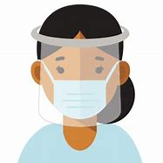
From the U.S. Department of Health and Human Services (HHS) Office on Women’s Health

30th Anniversary
This year the Office on Women’s Health (OWH) celebrates its 30-year anniversary. From the beginning, the mission of the OWH has involved connecting women and girls with up-to-date, actionable health information. Today, the OWH continues that tradition using a variety of digital platforms. We invite you to explore the OWH website (womenshealth.gov), Twitter (@womenshealth), or sign up to receive the OWH blog for the latest news, updates and health guidelines.
COVID-19
For the latest COVID-19 guidelines, please visit:
Office on Women's Health | womenshealth.gov
Coronavirus Disease 2019 (COVID-19) | CDC
Choosing Safer Activities | CDC

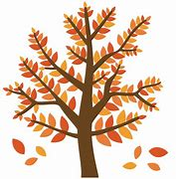 Career
Most essential workers in the United States are women. If you are experiencing changes in your routine – whether currently working from home or being asked to return to your workplace, you might be worrying about finances and quarantine fatigue. Additional worry about mental health and risk of exposure to COVID-19 have affected most of us.

We salute those of you who work in essential industries, including cleaning services, grocery and drug stores, farmer’s markets, transportation, federal, state and local government, active-duty U.S. Military and Reserves, teaching, U.S. Post Office, and other delivery businesses. We thank the region’s brave first responders and their equally brave families: medical personnel, firefighters, law enforcement, and City and County maintenance crews and volunteers – everyone!

If you are looking for employment: The City of Alexandria's Workforce Development Center (WDC), a partner of the American Job Center network, offers staffing solutions that provide businesses with employees who are skilled and ready to work. As a certified One Stop Center, WDC serves a variety of skill levels from those with advanced degrees and years of experience to those with limited education and experience. It provides services and resources for job seekers including access to the WDC Career Center, career readiness workshops, career assessments and customized hiring events. https://www.alexandriava.gov/WorkforceDevelopment https://www.vec.virginia.gov/alexandria
If you are a business looking for employees: The WDC provides a range of business services at no cost to businesses, including job placement, recruitment, labor market information and certified Business Services Specialists to assist in workforce planning. WDC operates the Virginia Initiative for Employment not Welfare (VIEW) Program, Workforce Innovation and Opportunity Act (WIOA - Adult Employment, Dislocated Worker and Youth and Young Adult), Supplemental Nutrition Assistance Program Employment Training (SNAPET), TeensWork! (public and private programs), Refugee Employment Program, Disability Employment and Veteran Services. https://www.vec.virginia.gov/alexandria
https://www.alexandriava.gov/WorkforceDevelopment
Child Care: Please see “Fueled by the pandemic, the child-care crisis is keeping moms out of work” in our NEWS section above.
The Alexandria Emergency Child Care Collaborative supports all families in need of child care and works to match them with open providers. COVID-19 Emergency Child Care: Information for Parents and Providers | City of Alexandria, VA
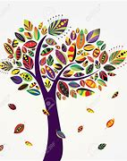 The Basics
The 19th Amendment to the United States Constitution (Amendment XIX – often referred to an the “Susan B. Anthony Amendment”) granted American women the right to vote, a right known as women’s suffrage. The Amendment prohibits the states and the federal government from denying the right to vote to citizens of the United States on the basis of sex. When the Amendment was ratified August 18, 1920, it ended almost a century of protest. https://www.history.com/topics/womens-history/19th-amendment-1

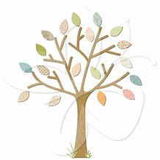 National Key Dates:

- 1848: Seneca Falls Convention – National-level launch of the movement for women’s rights
- Following the Convention, the demand for the vote became a centerpiece of the women’s rights movement. Elizabeth Cady Stanton and Lucretia Mott, along with Susan B. Anthony and other activists, raised public awareness and lobbied the government to grant voting rights to women.
- August 18, 1920: Tennessee legislature ratifies 19th Amendment
- Tennessee becomes the last of the necessary 36 states to secure ratification.
- August 26, 1920: 19th Amendment officially certified by the U.S. Secretary of State
- U.S. Secretary of State Bainbridge Colby certified the 19th Amendment and made the adoption of the Amendment official. Every year on this date, we celebrate Women’s Equality Day in commemoration.

Virginia Key Dates
- November 27, 1909 - A group of women, including Ellen Glasgow, Mary Johnston, Kate Langley Bosher, Adèle Clark, Nora Houston, Kate Waller Barrett, and Lila Meade Valentine, found the Equal Suffrage League of Virginia.
- 1917-- Women suffragists force fed at the “Occoquan” Workhouse
- November 23, 1917 -- Suffragist prisoners released from Workhouse to attend hearing in Federal Court in Alexandria, VA Judge ruled those women protesters had been unlawfully imprisoned at Workhouse
- August 1920 - Virginia women gain the right to vote after the Nineteenth Amendment to the U.S. Constitution becomes law.
- 1924 - Kate Waller Barrett of Alexandria serves as a delegate to the Democratic National Convention.
- February 21, 1952 - The Virginia General Assembly ratifies the Nineteenth Amendment to the U.S. Constitution, thirty-two years after it became law.

Resources

- Virginia Museum of History and Culture https://www.virginiahistory.org/what-you-can-see/story-virginia/explore-story-virginia/1876-1924/virginia-and-women’s-suffrage
- Turning Point Suffragist Memorial Association https://suffragistmemorial.org/suffragist-memorial-site-surroundings/
- Women’s Suffrage Museum (Lucy Burns Museum) “From the White House to the Workhouse to the Franchise” https://workhousemuseums.org/history/importance-of-womens-suffrage/
- Encyclopedia Virginia “Woman Suffrage in Virginia” https://www.encyclopediavirginia.org/Woman_Suffrage_in_Virginia
- William & Mary (W&M) Women's Law Society “Women's Suffrage in Virginia” http://wmpeople.wm.edu/site/page/wmws/womenssuffrageinvirginia
- League of Women Voters of Fairfax Area (LWVFA) https://www.lwv-fairfax.org/
- League of Women Voters Centennial http://www.lwvnca.org/Centennial.html
- The National Women’s History Museum “Crusade for the Vote: Suffrage Resource Center”
https://www.crusadeforthevote.org/educational-resources
https://www.crusadeforthevote.org/partners
https://www.womenshistory.org/womens-history/online-exhibits
https://www.womenshistory.org/exhibits/creating-female-political-culture
- Women's Suffrage Centennial Commission https://www.womensvote100.org/about
- Suffrage Sisters media@womensvote100.org
- General inquiries | staff@womensvote100.org
- Virginia History https://wmpeople.wm.edu/site/page/wmws/womenssuffrageinvirginia
Alexandria Celebrates Women (ACW) recognizes the accomplishments and contributions of Alexandria, Virginia’s women of the past, present and future. The volunteer 501(c)(3) charitable non-profit organization acknowledges the distinguished history of Alexandria’s heroines while celebrating the empowerment of Alexandria’s modern woman. https://alexandriacelebrateswomen.com/
For more information contact Pat Miller at AlexandriaCelebratesWomen@gmail.com
--00--
