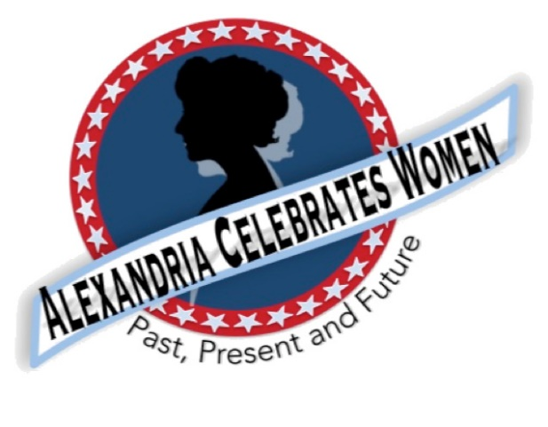
Alexandria Celebrates Women
September 2021 Newsletter
Editor: Gayle Converse

“The right of citizens of the United States to vote shall not be denied or abridged by the United States or by any State on account of sex.”
- 19th Amendment to the United States Constitution

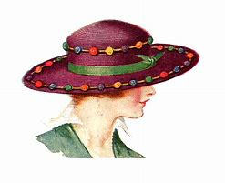 Welcome to the September 2021 issue of the Alexandria Celebrates Women (ACW) newsletter.

We hope that you are enjoying the long Labor Day weekend!
September observance also include National Gynecologic Cancer Awareness Month. Celebrate the anniversary of the signing of the United States Constitution on Constitution Day September 17th. Hispanic Heritage Month runs from Sept. 15-October 15.

ACW has continued its history information, including the milestones in the fight for women’s suffrage, in our newsletters this year. Please see photos and news coverage below of the August 26, 2021 dedication of the new historic marker at South Saint Asaph and Prince Streets in Alexandria. Look for information regarding Alexandria’s women of past and current history in the ACW monthly Alexandria Times column and on the ACW Website Alexandria Celebrates Women

We hope that you, your family and friends are well and safe during this time and we hope the and educational links and stories that follow can serve as a part of a plan to encourage your family’s enthusiasm for American history.

Events & Items of Interest

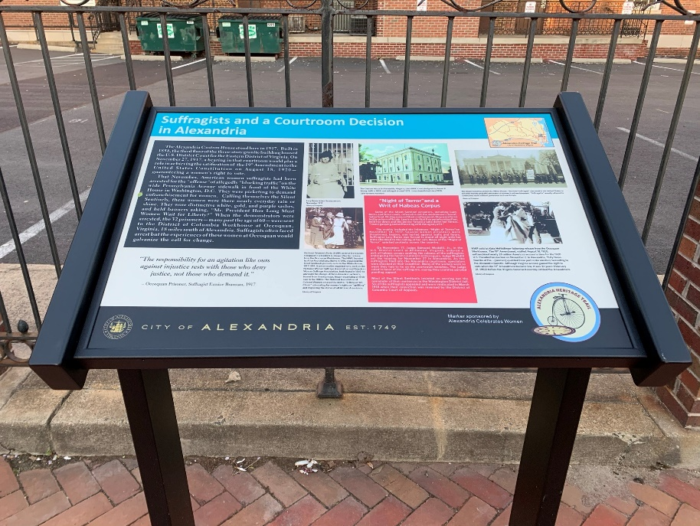

South St. Asaph and Prince Streets

Historic Marker Dedicated!

ACW was honored to work with the Office of Historic Alexandria (OHA) for the creation, installation and August 26, 2021 dedication of a new “tabletop” history marker in Old Town. The formal dedication was held August 26, 2021 – Women’s Equality Day (also the 101st anniversary of the U.S. certification of the 19th Amendment). The ceremony included a proclamation by Alexandria Mayor Justin Wilson, a commemorative letter from U.S. Senator Mark Warner, an announcement in the U.S. Congressional Record submitted by U.S. Representative Don Beyer, remarks by former Director of the Lucy Burns Museum at Occoquan Laura McKie, suffragist reenactor Lynn Garvey-Hodge, and remarks by Office of Historic Alexandria Director Gretch Bulova. The program concluded with the inaugural guided tour of the new Alexandria Women’s History Walk.

The marker is designated as part of the Alexandria Heritage Trail and is located on the site which housed the Federal District Court in the early 20th century. The third-floor courtroom was located in the old Customs House which stood on the corner of South St. Asaph and Prince Streets in Alexandria. It was here that suffragist prisoners were freed from the brutalities of the Occoquan Workhouse. Please take a moment to visit this exciting piece of our city’s history!

Suffragist Prisoners at Occoquan:
in November 1917, 32 suffragists were arrested in Washington, D.C. for allegedly “blocking traffic” on a Pennsylvania Avenue sidewalk. They were sent to the District of Columbia workhouse at nearby Occoquan, Virginia. The women were subjected to undue hardships and torture, resulting in the infamous November 14, 1917 “Night of Terror.” A number of women prisoners were threatened, beaten and hurled against walls and floors. A few days later, force feedings began. The suffragist prisoners were eventually freed from Occoquan following a hearing in Alexandria’s federal courthouse.
ACW greatly appreciates your help in achieving recognition of the women who bravely endured imprisonment and brutality in their efforts to gain the vote for all women – across the nation and here in Alexandria.

We would like to take this opportunity to thank the American Association of University Women (AAUW) for its generous $200. donation to help make this historic marker a reality.

THANK YOU TO ALL WHO HAVE DONATED!

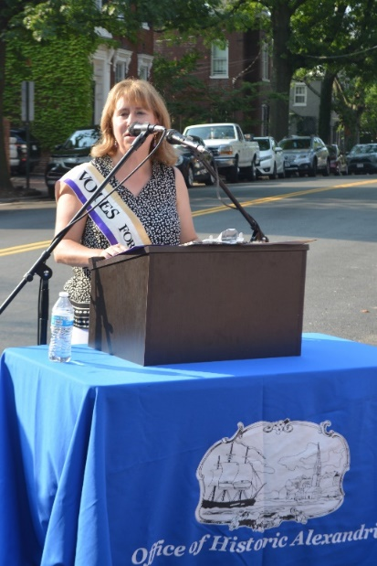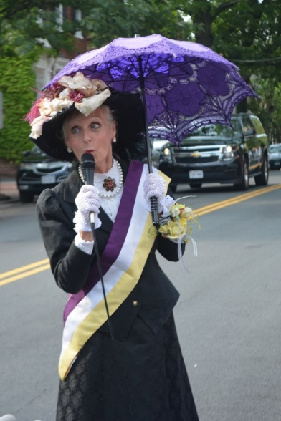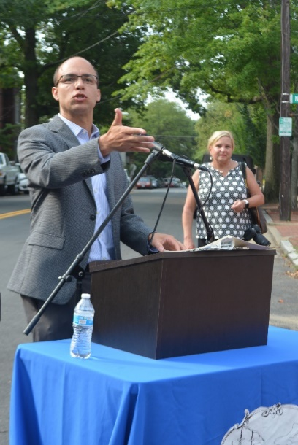
OHA Director Gretchen Bulova Reenactor Lynn Garvey-Hodge Alexandria Mayor Justin Wilson

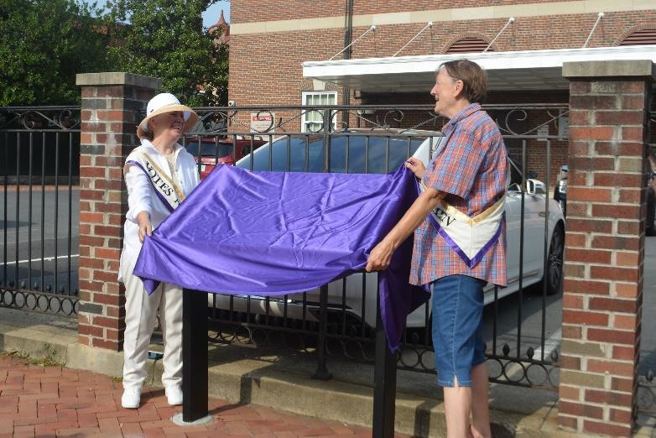
Alexandria Celebrates Women and The Office of Historic Alexandria commemorate Women’s Equality Day with the formal dedication of the City’s new women’s history marker!

New Alexandria Women’s History Walk
Discover where Alexandria’s women of the past and present have lived, worked and made history on Alexandria Celebrates Women’s new Women’s History Walk! The extensive self-guided journey is designed to enable history seekers to explore as little or as much as you like at your own pace. The new Walk includes an optional extended tour. ACW will post the route soon! If you would like a guided tour, please contact Gayle Converse at gcprod@bellsouth.net.
Replay of Celebrate Women Awards
Alexandria Celebrates Women was proud to host the first Celebrate Women Awards March 29, 2021. The virtual event honored women who have had a hand in caring for all Alexandrians during the COVID-19 pandemic. The Awards show benefited the Alexandria Domestic Violence Safehouse. A replay of the Awards show can be found at Alexandria Celebrates Women.
Women Impacted by Pandemic Need Your Help
The Alexandria Domestic Violence Safehouse – a place of refuge for many women impacted by the pandemic – needs your help. When women and their families are able to leave the shelter, there is a need for housewares -- silverware, pots and pans, dishes. You can assist by clicking here http://www.target.com/gift-registry/gift/effb54910b8145f2ba507c26a79eb5a6
From the National Women’s History Museum (NWHM)

Enjoy the NWHM free virtual museum at www.womenshistory.org

History

From the National Women’s History Alliance
September - National Women's History Alliance (nationalwomenshistoryalliance.org)

- September 14, 1964 – Helen Keller receives the Presidential Medal of Freedom along with 4 other women: Dr. Lena Edwards, Lynn Fontainne, Dr. Helen Taussig, and Leontyne Price
- September 20, 1973 – Billie Jean King defeats Bobby “No-Broad-Can-Beat-Me” Riggs in a battle of the sex’s tennis match
- September 25, 1981 – Sandra Day O’Connor is sworn in as the first woman U.S. Supreme Court Justice
- September 26, 1971 – Rep. Shirley Chisholm (D-New York) announces she will enter the Democratic presidential primaries
- September 29, 1988 – Stacy Allison becomes first American woman to reach the summit of Mt. Everest

NEWS

Alexandria Times, August 19, 2021 – “Suffragists struggle against brutality in fight for voting rights” 08_19_2021-Alex_Time_WEB.pdf (alextimes.com) Page 19
Alexandria Gazette-Packet, August 26, 2021 -- “Night of Terror” Alexandria.pdf (connectionarchives.com) Pages 3-4
Alexandria Gazette-Packett, September 2, 2021 – “Signage Dedicated to Suffragists” Alexandria.pdf (connectionarchives.com) Page 1
Zebra, August 29, 2021 – “New Women’s History Walking Tour in Alexandria!” New Women's History Walking Tour in Alexandria! (DOWNLOAD HERE!) - The Zebra
Alexandria Times, September 2, 2021 – “City Honors Suffragists’ Fight” September-2-2021.pdf (alextimes.com) Page 3
Forbes, August 2021 – “50 0ver 50” 50 Over 50 2021 (forbes.com)
Sky News, September 4, 2021 -- “' This is a woman's country too” This is a woman's country too': Taliban breaks up women's protests in Kabul with 'gunshots and tear gas' (msn.com)

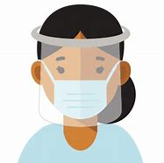 COVID-19

From the U.S. Department of Health and Human Services (HHS) Office on Women’s Health
For the latest COVID-19 guidelines, please visit:
Office on Women's Health | womenshealth.gov
Coronavirus Disease 2019 (COVID-19) | CDC
Choosing Safer Activities | CDC

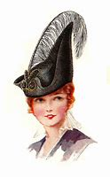 Career
September is International Update Your Resume Month!
Most essential workers in the United States are women. If you are experiencing changes in your routine – whether currently working from home or being asked to return to your workplace, you might be worrying about finances and quarantine fatigue. Additional worry about mental health and risk of exposure to COVID-19 have affected most of us.

We salute those of you who work in essential industries, including cleaning services, grocery and drug stores, farmer’s markets, transportation, federal, state and local government, active-duty U.S. Military and Reserves, teaching, U.S. Post Office, and other delivery businesses. We thank the region’s brave first responders and their equally brave families: medical personnel, firefighters, law enforcement, and City and County maintenance crews and volunteers – everyone!

If you are looking for employment: The City of Alexandria's Workforce Development Center (WDC), a partner of the American Job Center network, offers staffing solutions that provide businesses with employees who are skilled and ready to work. As a certified One Stop Center, WDC serves a variety of skill levels from those with advanced degrees and years of experience to those with limited education and experience. It provides services and resources for job seekers including access to the WDC Career Center, career readiness workshops, career assessments and customized hiring events. https://www.alexandriava.gov/WorkforceDevelopment https://www.vec.virginia.gov/alexandria
If you are a business looking for employees: The WDC provides a range of business services at no cost to businesses, including job placement, recruitment, labor market information and certified Business Services Specialists to assist in workforce planning. WDC operates the Virginia Initiative for Employment not Welfare (VIEW) Program, Workforce Innovation and Opportunity Act (WIOA - Adult Employment, Dislocated Worker and Youth and Young Adult), Supplemental Nutrition Assistance Program Employment Training (SNAPET), TeensWork! (public and private programs), Refugee Employment Program, Disability Employment and Veteran Services. https://www.vec.virginia.gov/alexandria
https://www.alexandriava.gov/WorkforceDevelopment
If you are looking for emergency child care: The Alexandria Emergency Child Care Collaborative supports all families in need of child care and works to match them with open providers. COVID-19 Emergency Child Care: Information for Parents and Providers | City of Alexandria, VA
The Basics
The 19th Amendment to the United States Constitution (Amendment XIX – often referred to an the “Susan B. Anthony Amendment”) granted American women the right to vote, a right known as women’s suffrage. The Amendment prohibits the states and the federal government from denying the right to vote to citizens of the United States on the basis of sex. When the Amendment was ratified August 18, 1920, it ended almost a century of protest. https://www.history.com/topics/womens-history/19th-amendment-1

National Key Dates:
- 1848: Seneca Falls Convention – National-level launch of the movement for women’s rights
- Following the Convention, the demand for the vote became a centerpiece of the women’s rights movement. Elizabeth Cady Stanton and Lucretia Mott, along with Susan B. Anthony and other activists, raised public awareness and lobbied the government to grant voting rights to women.
- August 18, 1920: Tennessee legislature ratifies 19th Amendment
- Tennessee becomes the last of the necessary 36 states to secure ratification.
- August 26, 1920: 19th Amendment officially certified by the U.S. Secretary of State
- U.S. Secretary of State Bainbridge Colby certified the 19th Amendment and made the adoption of the Amendment official. Every year on this date, we celebrate Women’s Equality Day in commemoration.
Virginia Key Dates
- November 27, 1909 - A group of women, including Ellen Glasgow, Mary Johnston, Kate Langley Bosher, Adèle Clark, Nora Houston, Kate Waller Barrett, and Lila Meade Valentine, found the Equal Suffrage League of Virginia.
- 1917-- Women suffragists force fed at the “Occoquan” Workhouse
- November 23, 1917 -- Suffragist prisoners released from Workhouse to attend hearing in Federal Court in Alexandria, VA Judge ruled those women protesters had been unlawfully imprisoned at Workhouse
- August 1920 - Virginia women gain the right to vote after the Nineteenth Amendment to the U.S. Constitution becomes law.
- 1924 - Kate Waller Barrett of Alexandria serves as a delegate to the Democratic National Convention.
- February 21, 1952 - The Virginia General Assembly ratifies the Nineteenth Amendment to the U.S. Constitution, thirty-two years after it became law.
Resources
- Virginia Museum of History and Culture https://www.virginiahistory.org/what-you-can-see/story-virginia/explore-story-virginia/1876-1924/virginia-and-women’s-suffrage
- Turning Point Suffragist Memorial Association https://suffragistmemorial.org/suffragist-memorial-site-surroundings/
- Women’s Suffrage Museum (Lucy Burns Museum) “From the White House to the Workhouse to the Franchise” https://workhousemuseums.org/history/importance-of-womens-suffrage/
- Encyclopedia Virginia “Woman Suffrage in Virginia” https://www.encyclopediavirginia.org/Woman_Suffrage_in_Virginia
- William & Mary (W&M) Women's Law Society “Women's Suffrage in Virginia” http://wmpeople.wm.edu/site/page/wmws/womenssuffrageinvirginia
- League of Women Voters of Fairfax Area (LWVFA) https://www.lwv-fairfax.org/
- League of Women Voters Centennial http://www.lwvnca.org/Centennial.html
- The National Women’s History Museum “Crusade for the Vote: Suffrage Resource Center”
https://www.crusadeforthevote.org/educational-resources
https://www.crusadeforthevote.org/partners
https://www.womenshistory.org/womens-history/online-exhibits
https://www.womenshistory.org/exhibits/creating-female-political-culture
- Women's Suffrage Centennial Commission https://www.womensvote100.org/about
- Suffrage Sisters media@womensvote100.org
- General inquiries | staff@womensvote100.org
- Virginia History https://wmpeople.wm.edu/site/page/wmws/womenssuffrageinvirginia
Alexandria Celebrates Women (ACW) recognizes the accomplishments and contributions of Alexandria, Virginia’s women of the past, present and future. The volunteer 501(c)(3) charitable non-profit organization acknowledges the distinguished history of Alexandria’s heroines while celebrating the empowerment of Alexandria’s modern woman. https://alexandriacelebrateswomen.com/
For more information contact Pat Miller at AlexandriaCelebratesWomen@gmail.com

