Aggravation Board Game Rules
LOBO Rules - Using Playing Cards
Object: The first person or team with all their marbles “home” wins.
Rules:
- Each player needs their own deck of playing cards with 2 jokers (54 cards).
- Each player shuffles and cuts their deck to see who goes first. Highest card wins.
- Player one turns over first card and play begins proceeding clockwise.
- In order to move a marble from your base to your out spot, you must draw a 6, Ace or Joker. You will then draw again and play your next card.
- Card Values: Cards 2,3,5 thru 10 = face value of the card; Ace, Joker and Face Cards = 1(these cards have a “Draw Again” value as well); Card 4 = Backwards 4, you must move your marble the number of spaces even if you land on your partners marble and send him or her to their base. If you cannot move any marble the number of spaces required, your turn ends and play moves to next player.
- Passing your own marble on the game board is not allowed.
- The number “4” card moves your marble backwards 4 spaces.
- “The Point” is the place on the board depicted on picture 1. If your turn ends on a “point”, on your next turn, you may jump your marble along the points and proceed down your final stretch, thus shortening your progress around the board.
- “The Middle” is the center point on the board. You can land on the middle only if your marble ends there. i.e. From your out spot, a “6” will move up the board 5 spaces then you can proceed to the middle. If you do not want to go to the middle, you may proceed around the board.
- To get out of the “Middle”, you must draw a face card, and ace or a joker. You can then exit the “Middle” to any “Point” on the board and then draw again.
- In order to move your marble into your “Home”, you must be able to move the marble the exact amount of spaces as you’re playing card, i.e. With 5 spaces from your last “Home” space, you must draw a 5 to move to that spot. A 6 or higher will not allow you to move in to your home. You may continue moving in to your “Home” with smaller cards, i.e. a 3 will move you up in to you “Home” with two spaces to go to your final spot. Two face cards or a 2 will then move the marble to its last spot.
Winning the Game: The first player or Team to move all of their marbles in to their “Home” WINS!!!
www.lobowoodworks.com

Strategies:
- If you get out then draw a 4, you will move backwards 4 spaces. You will then be almost home.
- Try to strategically move your marbles so that you can be in a position to either land on a “Point” to shorten your movement around the board or position yourself behind an opponent so that you can land on them on a later turn and send them home.
- If playing on teams, try to get one team member home. Once a team member is home, he or she continues to play, using his cards to help his or her teammates around the board.
Review:
- To Get Out: Ace, Joker or 6
- 4 always moves backwards
- Ace, Joker or Face cards advances your marble 1 space and are the only cards that can get your marble out of the middle.
- Ace, Joker,6 and Face Cards are “Draw Again” cards.
- You may not pass your own marble.
- You must move your marble even if it ends on a team members’ marble, sending them home, unless there are not enough spaces to move.
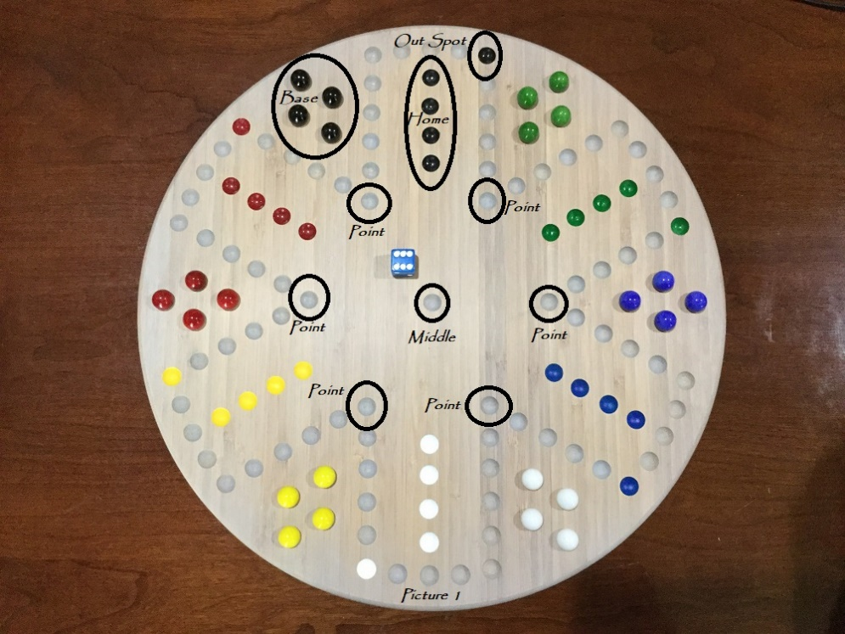
www.lobowoodworks.com

