# STUDENT’S PERSONAL DETAILS



**BANJI’S CLASS APPLICATION FORM**

*THIS APPLICATION FORM SHOULD BE COMPLETED BY THE PARENT OR GUARDIAN OF THE APPLICANT IN BLOCK CAPITALS.*

**EMAIL TO:** [**SCHOOLS***@***BANJIALEXANDER.COM**](mailto:SCHOOLS@BANJIALEXANDER.COM)

First name Surname

D.O.B

Male

Age Female

School Year

Address

Postcode

Home telephone no.

# Why do you want to join Banji’s Class? (Child’s response)

**First Contact**



**3. Parents/Guardians Details.**

**We require TWO emergency contacts**

Name

Mobile number

Email

Relationship to child

# Second Contact

Name

Mobile number

Email

Relationship to child

# Does your child have health issues we should know about for their comfort and safety?



**4. YOUR CHILD’S HEALTH**

Yes No

# 5. EDUCATIONAL INFORMATION

**Present school**

**Address of school**

**Please list any relevant qualifications or experience already gained.**



**6. PREVIOUS EXPERIENCE**

***(N.B. This is for information only - no previous experience is necessary.)***

# 7. SPECIAL NEEDS

**Does your child have any special needs we should be aware of? If YES, please attach details or give explanation below:**

# Please outline below any further information you would like us to have



**8. FURTHER INFORMATION**

**9. SIGNATURES**

**I support the above application to join Banji’s Class.**

**Parent/Guardian’s Name:**

**Parent/Guardian’s Signature:**

**Date:**



**10. PHOTOGRAPHY AND FILMING**

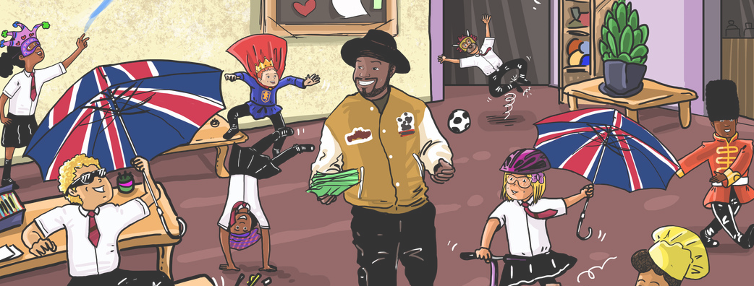

A big part of what we do involves media. During lessons, rehearsals, performances & other social activities, we will take photographs and videos of children in Banji’s Class.

Occasionally, we may use these photographs and videos for advertising purposes in various publications (e.g. local information guides, newspapers, magazines, and social media) as well as in our own publications and website.

We will follow current guidelines on the use of photographs of children on the internet, ensuring that photographs and videos do not have any personal information about any child attached to them. We are unable to offer any remuneration for any photographs used.

We ask that you discuss this with your child before signing on their behalf (if under the age of 13).

Please then sign and return the form below, showing you have read and understood the above information. **We are unable to process your application without this.**

# Parent/Guardian’s Consent



**PHOTOGRAPHY AND FILMING**

1. I understand that no personal information relating to my child will be associated with images and video footage taken in Banji’s Class without my prior consent.
2. I understand that all photographs, videos and audio recorded in Banji’s Class remain the property of S G Literacy.
3. I give consent for photographs and/or videos of my child/children taken in Banji’s Class to be used on our website and featured on the Banji’s Class’ social media sites (e.g. Facebook, Twitter, Instagram + YouTube etc). There will never be a name attached to the child’s photo.
4. I give consent for photographs and/or videos of my child/children taken in Banji’s Class to be used for advertising and publicity of Banji’s Class in printed and/or digital form. For example our flyers, banners and in magazines, + promo videos etc

# Name of child:

**Parent/Guardian Name**

**Signature Date**

**Please note that fees are payable on a termly basis and must be paid before the first day of term.**



**11. FEE - £180 PER TERM**

**PAYMENT DATES (ON OR BEFORE): TERM 1 : SEPTEMBER 22ND 2023 - £180 TERM 2: JANUARY 5TH 2024 - £180**

**TERM 3: APRIL 12TH 2024 - £180**

We allocate places on a first come, first served basis. On receipt of your child’s completed application form via email, you will receive an email response advising you on if your child has been allocated a place, or if they are on a waiting list.

Payment details will be shared via email. Payment must be made via bank transfer, with your child’s name as the reference. We are unable to add your child’s name to the term’s register until payment is received.

# Payment is non-refundable and covers 3hrs a week, 12 weeks a term, whether your child attends or not.

Children will attend 3 classes every weekend. Classes last for one hour.

We also offer a pay-monthly option, although this works out as more expensive, due to extra administrative fees (3 x £70 a month per term).