Northern Arizona Consolidated Fire District is hiring for:
Full-Time Firefighter EMT/Paramedic
Open until 5pm January 23, 2019
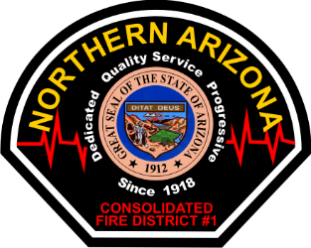
The full-time firefighter shall provide community risk reduction which includes responding to alarms and protecting life and property by performing firefighting, emergency medicine, hazardous control and other duties as assigned. Maintain emergency and firefighter equipment, apparatus and facilities. Uphold the district mission and contributes to an environment of teamwork and cooperation.
Minimum Qualifications:
- 18 years of age or older
- Highschool or G.E.D. equivalent
- Valid Arizona Driver’s license
- Arizona Firefighter I and II certification or equivalent
- Arizona Emergency Medical Technician
- Hazardous Materials First Responder Operations certification
- Ability to speak, read, and write the English language
- Meet insurability requirements of the District’s insurance carrier
- Completion of PHQ, FIRETEAM testing on National Testing Network
Desirable Qualifications:
- Experience in fire suppression and prevention principles
- Experience in emergency medical techniques
Compensation:
- $34, 629/year starting base pay; $9,000 annual paramedic stipend; $1,500 annual Haz-Mat Technician stipend.
Benefits:
- AZBCBS PPO or HDHP with HSA account. Vision, Dental, Life, PSPRS Retirement.
- Vacation accrual rate up to 15.03 hours per pay period (391 hours.)
Applications with contact information must be received by NTN or Fire Administration by January 23, 2019 @ 5:00 pm. Any applications received after this time will not be considered.
CONTACT: Battalion Chief Jason Scott or https://northernazfire.com for an application and job description
2470 Butler Ave, Kingman, AZ 86409; 928-757-5307

