**Northern Arizona Consolidated Fire District is hiring for:**

**Part-time Firefighter EMT/Paramedic**

**Open until 5pm January 25, 2019**

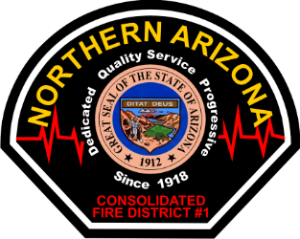

The part-time firefighter shall provide community risk reduction which includes responding to alarms and protecting life and property by performing firefighting, emergency medicine, hazardous control and other duties as assigned. Maintain emergency and firefighter equipment, apparatus and facilities. Uphold the district mission and contributes to an environment of teamwork and cooperation.

**Minimum Qualifications:**

* 18 years of age or older
* Highschool or G.E.D. equivalent
* Valid Arizona Driver’s license
* Arizona Firefighter I and II certification or equivalent
* Arizona Emergency Medical Technician
* Hazardous Materials First Responder Operations certification
* Ability to speak, read, and write the English language
* Meet insurability requirements of the District’s insurance carrier
* Meet minimum NACFD fitness standards

**Desirable Qualifications:**

* Experience in fire suppression and prevention principles
* Experience in emergency medical techniques

**Compensation:**

* EMT - $11/hr
* Paramedic - $13.25/hr

**Testing:**

Candidates that have completed the NTN PHQ will not be required to complete the NACFD physical agility test. All candidates will complete a peer panel assessment and if selected a Fire Chief interview.

Applications with contact information must be received by Fire Administration by January 25, 2019 @ 5:00 pm. Any applications received after this time will not be considered.

**CONTACT: Battalion Chief Jason Scott or** [**https://northernazfire.com**](https://northernazfire.com) **for an application and job description**

**2470 Butler Ave, Kingman, AZ 86409; 928-757-5307**