Northern Arizona Fire District
2600 E. Northern Ave, Kingman, AZ 86409
(928) 757-3151
website: www.northernazfire.com

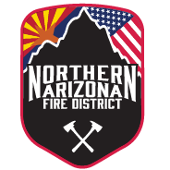

PUBLIC NOTICE

Notice is hereby given that the regular meeting of the Board of Directors originally scheduled for July 15, 2026, has been rescheduled.
The meeting will now be held on July 22, 2026, at 04:00pm at 2600 E. Northern Ave, Administration building.
This notice is posted in accordance with applicable public meeting laws and board policies.

Dated this 24th day of June 2026.

Fire Chief Brian Grant
Northern Arizona Fire District

Pursuant to A.R.S. § 38-431.02, notice is hereby given to the members of the Northern Arizona Fire District and to the general public.

