Thermo Scientific
ViewPoint Log Reporting Tool
User Handbook

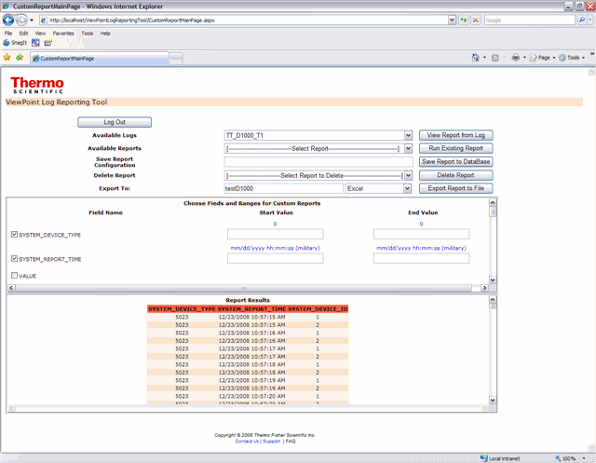
PART NO: SYS/HB/70881/050
ISSUE: 1.0
DATE OF ISSUE: May 2009

© Thermo Fisher Scientific, Inc. 2006. All rights reserved.
The information contained herein is the property of Thermo Fisher Scientific, Inc. and is supplied without liability for errors or omissions. No part may be reproduced or used except as authorized by contract or other written permission. The copyright and the forgoing restriction on reproduction or use extend to all the media in which this information may be embodied.

This page intentionally blank.
Table of Contents
1 Introduction 6
1.1 Purpose 6
1.2 Scope 6
1.3 Glossary 6
2 Overview 7
2.1 Viewpoint log reporting tool 7
3 Installation 8
3.1 Prerequisites 8
3.2 Install microsoft sql server 2005 8
3.3 Microsoft iis configuration 8
3.4 Install the microsoft .net 3.5 framework 8
3.5 Install the viewpoint log reporting tool 9
4 configuring Properties in IIS 13
4.1 Set up the start file 13
4.2 Configure the connection string 16
4.3 Checking the connection string 19
5 using the viewpoint log reporting tool 20
5.1 Connecting to the viewpoint log reporting tool 20
5.2 Creating and using custom reports 22
5.3 View custom report 26
5.4 ExPORT a custom report to a file 27
5.5 Save a custom report configuration to the Database 28
5.6 Run a previously configured custom report 29
5.7 Deleting a custom report 30

This page intentionally blank.

Introduction

Purpose
The purpose of this user handbook is to provide instructions on the installation and use of the Thermo Scientific ViewPoint Log Reporting Tool.

Scope
This handbook is intended to assist users by providing guidance through step-by-step instructions.

Glossary
Glossary of Terms and Acronyms
Term | Definition
LAN | Local Area Network — A computer network that spans a relatively small area. Most LANs are confined to a single building or group of buildings.
Markup Language | A markup language is a way of combining text and text formatting information. The most widely known markup language is HTML, Hypertext Markup Language, which is one of the foundations of the World Wide Web. (The term “markup” originally referred to markings made on proofs used in the publishing industry.
MS | Microsoft Corporation, provider of Microsoft Windows and Windows Mobile operating systems.
PC | Personal Computer — Any computer for use by one person, based on an Intel microprocessor, or on an Intel-compatible microprocessor.
TCP/IP | Transmission Control Protocol / Internet Protocol — A set of data transmission protocols developed in the 1970s to get data from one network device to another. It is now the de facto Internet standard set of protocols.
ViewPoint™ | ViewPoint™ — Thermo Scientific remote monitoring software system that provides real-time personnel and area monitoring. ViewPoint provides real-time access to data during routine operations or outages in the nuclear power industry, as well as in environmental, industrial, civil defense, and security monitoring applications. It can centrally process and analyze instrument and detector data, and can integrate detectors from the Thermo Scientific portfolio together with instruments from third-party vendors.

Overview

Viewpoint log reporting tool
The ViewPoint Log Reporting Tool provides the means to create reports through a simple user interface containing data from tables logged previously by ViewPoint with user defined selection criteria. The ViewPoint Log Reporting Tool has been designed to integrate with the ViewPoint Data Management Console, enabling the generation of reports from logged data.

This tool may be installed anywhere on a network provided that the ViewPoint Log Reporting Tool application PC can access the ViewPoint database, for example generated by the ViewPoint Data Management Console. The reporting tool itself can be accessed from any machine on the network via a web browser. This enables access to the tool via a web browser without any installation on PCs other than the application server itself.

The ViewPoint Log Reporting Tool also provides the facility to define custom reports and then previewing the report directly within the tool. Report configurations may be reused by naming the report and saving it such that it may be selected and re-run again. In addition to the ability to view the report and save the report for later use, it is also possible to save the report to a file formatted as XML or Excel. A date and time stamp is automatically added to the report each time it is saved to a file.

Installation

Prerequisites
To make the most from the ViewPoint Log Reporting Tool it is necessary to have a means to log ViewPoint data to a Microsoft SQL Server database. A recommended tool for logging ViewPoint data is the Thermo Scientific ViewPoint Data Management Console. Contact Thermo Fisher Scientific for more information.

Install microsoft sql server 2005
Install Microsoft SQL Server 2005 Express Edition with a user account for a system administrator so other users can be added or removed. If Microsoft SQL Server 2005 Professional Edition is already installed there is no reason to install Microsoft SQL Server 2005 Express Edition. The files ‘msxml6.msi’ and ‘SQLServer2005_SSMEE.msi’ can be found in the SQL Server Express directory on the installation CD. Install the msxml6.msi first.

Other versions of SQL Server Express can be found at the following location: <http://www.microsoft.com/Sqlserver/2005/en/us/express.aspx>.

Microsoft iis configuration
The Microsoft Windows XP operating system is provided with IIS (Internet Information Services). This tool must be installed BEFORE the .NET v3.5 Framework is applied. To install IIS, complete the following steps:
- Ensure the latest operating system service pack has been installed.
- Obtain a copy of the operating system installation CD since the IIS installation may require files from it.
- Using your mouse, left-click on the Start Menu.
- Select Settings → Control Panel
- Select Add/Remove Programs
- Select Add/Remove Windows Components
- Highlight ‘Internet Information Services’ but do not check the box.
- Select the ‘Details’ button in the lower right-hand corner of the screen
- Check the ‘World Wide Web Server’ Box. This will in turn select the other components it needs to run properly in the list
- Select ‘OK’
- Select ‘Next’

Install the microsoft .net 3.5 framework
The file ‘dotnetfx3.setup’ can be found in the NET 3.5 Framework Directory on the installation CD.

Install the viewpoint log reporting tool
Select and run the setup file located on the installation CD ‘$\Installer\setup.exe’. Follow the on screen instructions to install the service. Click the ‘Next’ button to continue the installation.

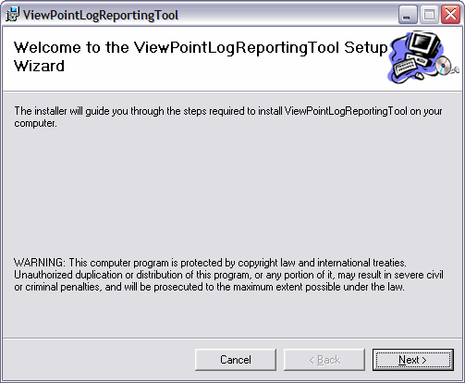

The default name for the virtual directory for this web application is ViewPointLogReportingTool. At this step of the installation you can change it if necessary. Click ‘Next’ to continue.

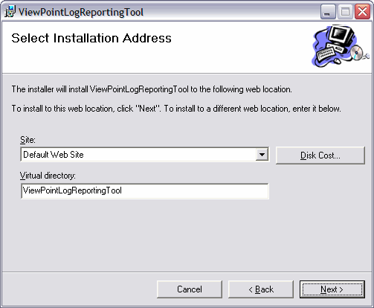

Click ‘Next’ to start the installation.

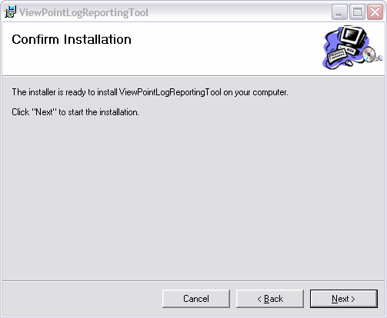

After the installation has completed click the ‘Close’ button.

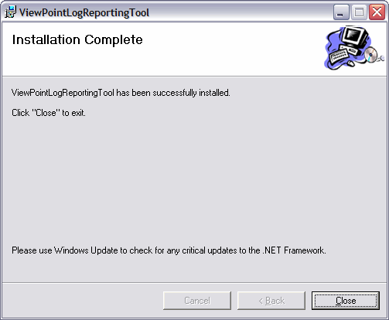

configuring Properties in IIS

Set up the start file
It is now necessary to configure the IIS (Internet Information Services) to enable the ViewPoint Log Reporting Tool to operate correctly.

First, click on ‘Start Menu’ – ‘Control Panel’ – ‘Administrative Tools’ – ‘Internet Information Services (IIS)’. Expand the Internet Information Services options to find the Web Site named ‘ViewPointLogReportingTool’ located within the ‘Default Web Sites’ subdirectory. Right click on the project and select ‘Properties’.

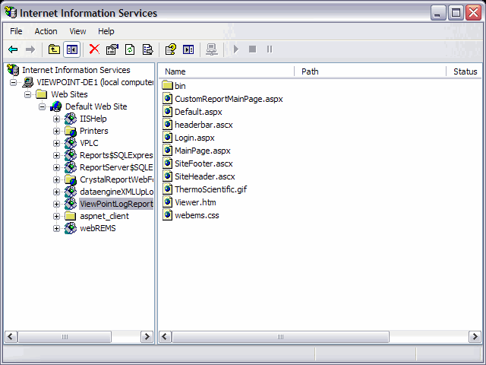
Click on the tab ‘Documents’ and then click the ‘Add’ button. Enter ‘Login.aspx’ in the top textbox. Click on the ‘Apply’ button and then the ‘OK’ button.

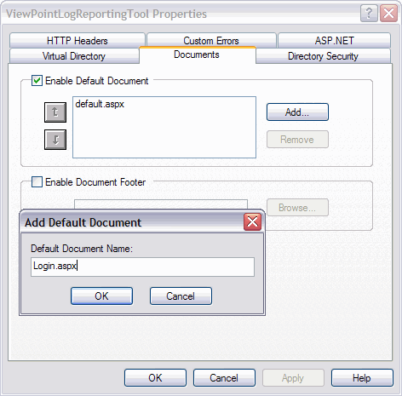

Use the arrow to the left of the textbox to move the ‘Login.aspx’ to the top.

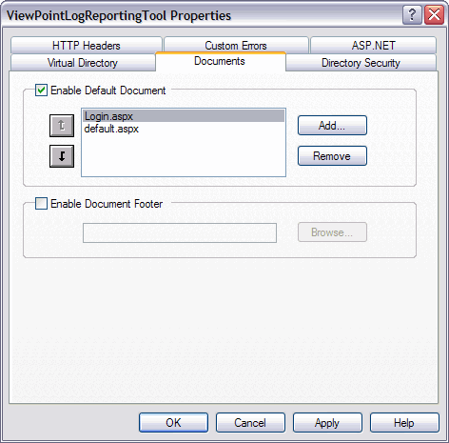

Configure the connection string
Once click on the tab ‘ASP.NET’ and then click the ‘Edit Configuration’ button.

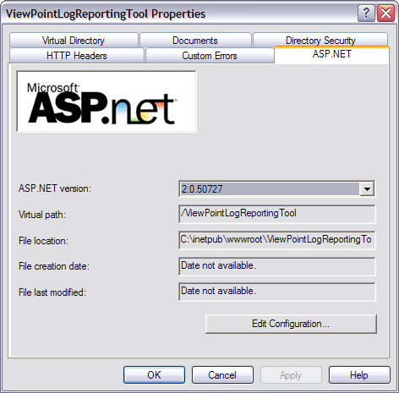

If you are using Vista, then locate and open Windows Mobile Device Center: Click on the ‘Add’ button in the upper panel.

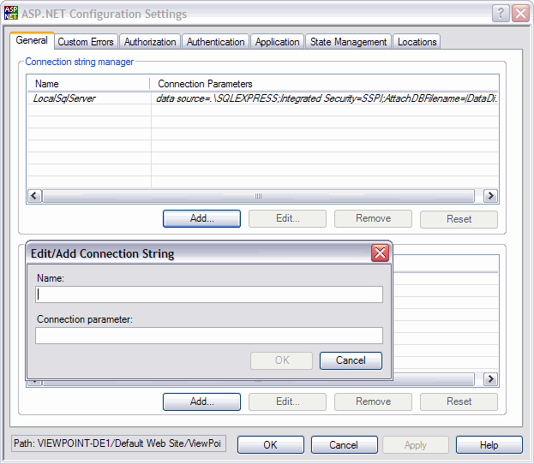

In the pop up box enter ConnectionString in the textbox for Name. Enter the appropriate string for the database to use in the textbox for Connection parameters.

The following is an example of a value for a connection string:

‘Data Source=ViewPoint-DE1\SQLExpress;uid=sa;pwd=Thermo;Initial Catalog=ViewPoint’

Where:
Data Source; refers to the SQL database to be connected to
uid; username for the SQL database connection (‘sa’ in example above)
pwd; password for the SQL database connection (‘Thermo’ in example above)
Initial Catalog; database name to be used (‘ViewPoint’ in example above)

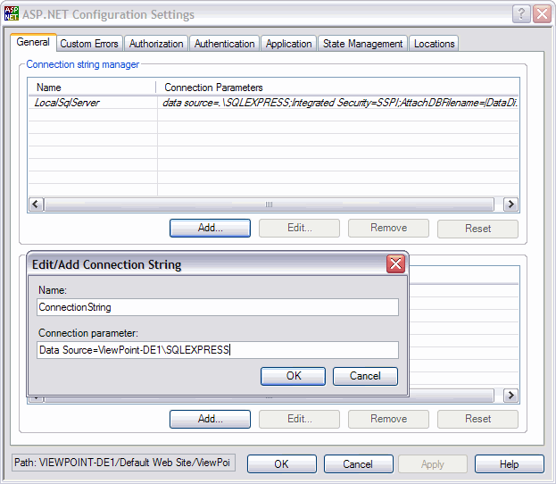

Checking the connection string
- To check the connention string navigate to the ‘web.config’ file installation directory ‘inetpub\wwwroot\ViewPointLogReportingTool’.

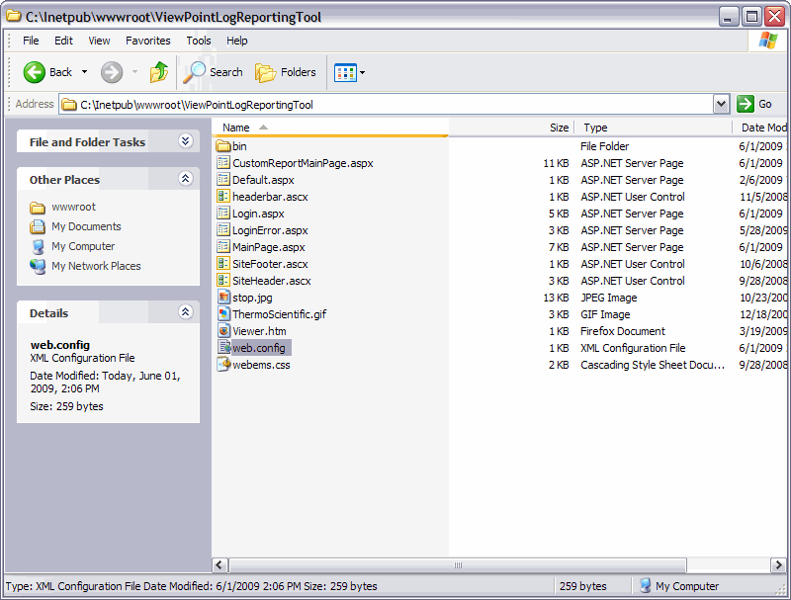

- Check the line “ConnectionString” to verify that it contains the credentials to the database. In the example below the ConnectionString is underlined.

<configuration>
<connectionStrings>
<add name="ConnectionString" connectionString="Data Source=VIEWPOINT-DE1\SQLEXPRESS;uid=thermo;pwd=thermo;Initial Catalog=TESTDB12_22_2008" />
</connectionStrings>
</configuration>

using the viewpoint log reporting tool

Connecting to the viewpoint log reporting tool
LAN and Database access:
- The computer must have a network connection or the ViewPoint database must be stored on the local PC with the ViewPoint Log Reporting Tool.
- The user must have permission to access the database and privileges to make changes to the database. Ask the database administrator set up a new use account and grant privileges.
Start the application and connect to the database. Direct the web browser to the URL ‘http://localhost/ViewPointLogReportingTool/Login.aspx’ and enter the following login credentials:
- DataSource: Enter either the network IP address or the server name where the ViewPoint database output has been stored.
- DataBase: Enter the name of the database from which to create the custom reports.
- User Name: Enter the user name for the database containing custom reports.
- Password: Enter the password for the database connection.
Click the ‘Login’ button to continue the login process.

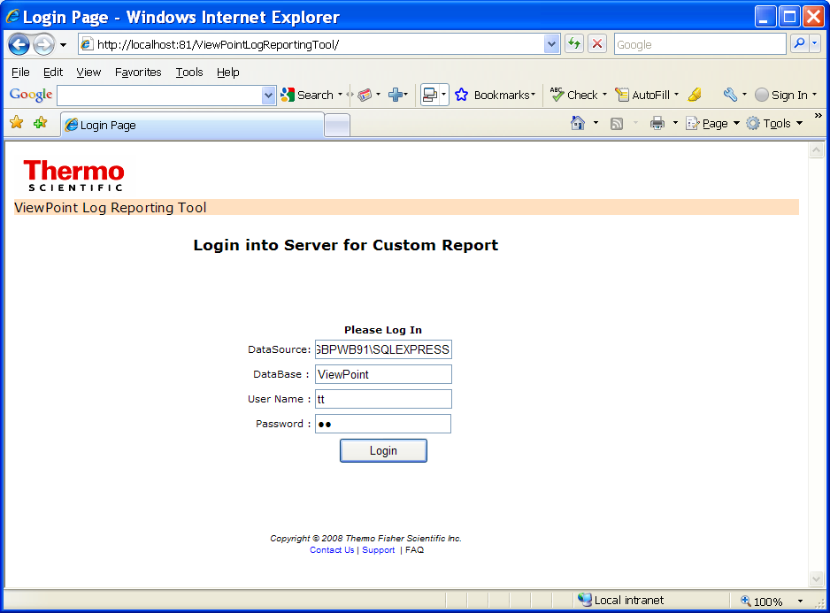
After entering the login credentials to the database, the following page will appear.

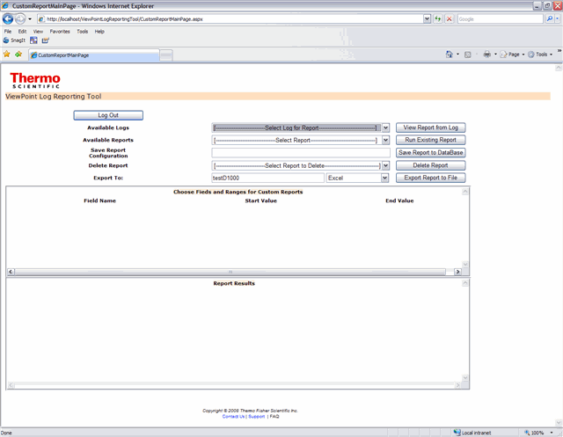

Creating and using custom reports
To create a new custom log; select a Log from the drop down list ‘Available Logs’.

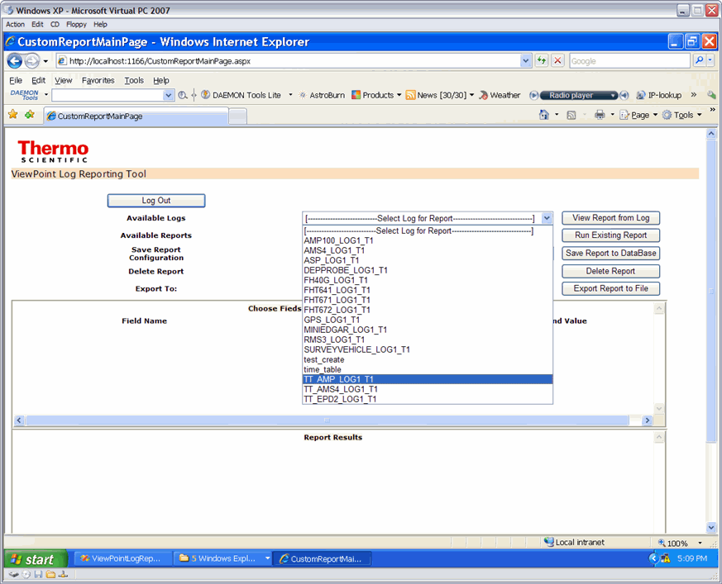
When the log is selected, the fields in that report populate the upper panel.

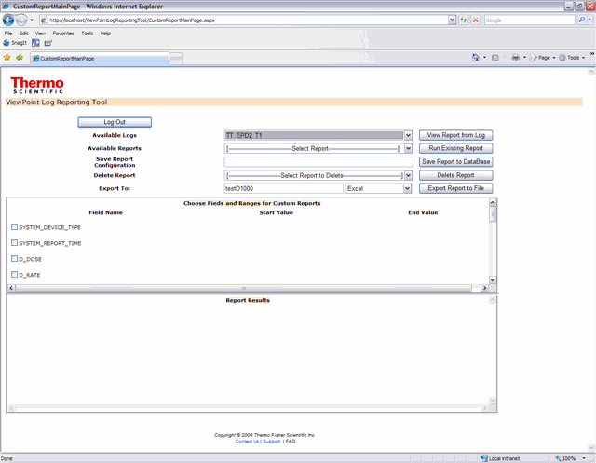

Select the fields for the report by clicking the checkbox next to the ‘Field Name’. When the checkbox is checked if the field has a range two textboxes will appear to the right and an example of the formatting for the data type will appear on top of the textboxes.

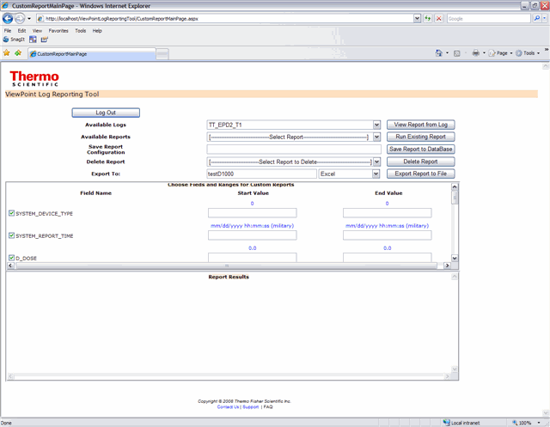
If the field is an item in a set with no range, then only one text box appears.

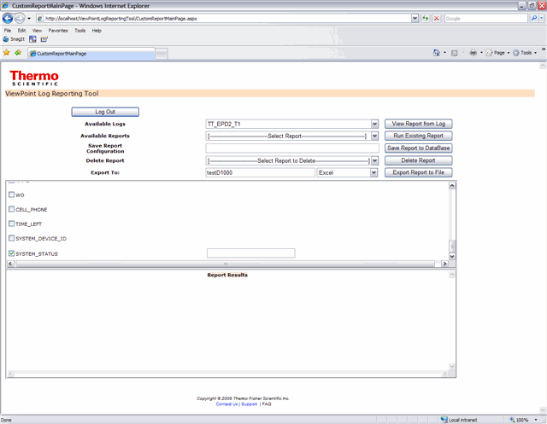

View custom report
To view a custom report that has just been configured, click on the View Report button and the resulting report is shown on the lower panel. There are scroll bars and pagination for easier reading.

ExPORT a custom report to a file
The resulting report can be saved to file of type XML or Excel.

Select the format for the file from the drop down list on the on the right side of at the bottom of the page.
- Create a directory to store the reports at the location ‘C:\ViewPointLogReports’
- Enter a name for the report in the textbox.
- Select the format for the report from the dropdown list.
- Click the ‘Export Report to File’ button to export the file.
- The report will be saved in the folder ‘C:\ViewPointLogReports’

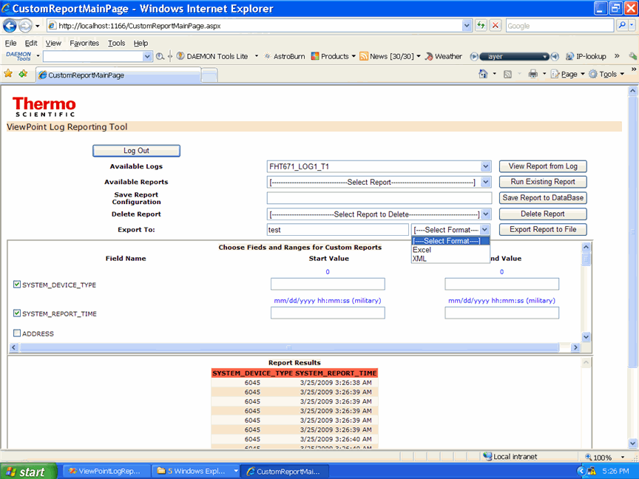

Save a custom report configuration to the Database
After a custom report has been configured it can be saved so that it can be automatically run without any additional setup.
- Fill in the textbox to the left of the button ‘Save Report to Database’ with the name for the new report.
- Click the ‘Save Report to Database’ button to save the report.

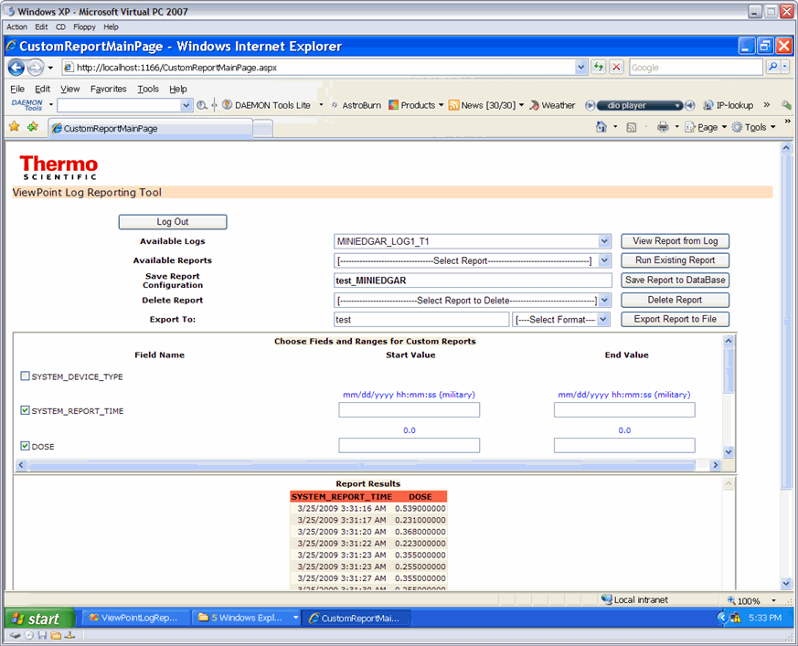

Run a previously configured custom report
- Choose the custom report from the drop down list.
- Click the ‘Run Report’ button to see the report.
- (optional) If the report should be exported to a file, follow section 5.4 in this manual.

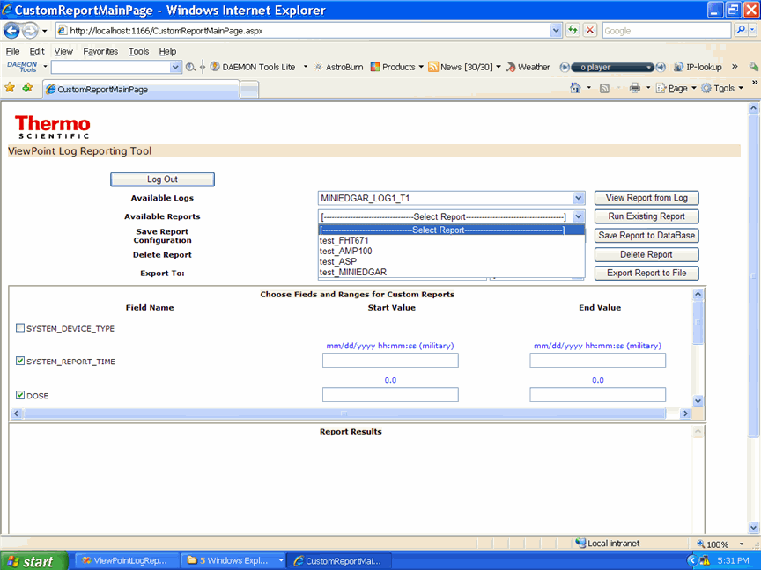

Deleting a custom report
If a custom report is no longer required, it can be deleted from the dropdown list.
- Select a report to delete from the dropdown list to the left of the ‘Delete Report’ button.
- Click the ‘Delete Report’ button.

