Martha Jenkinson Scholastic
Chess Tournament, April 29th, 2023
T. H. Rogers School 5840 San Felipe St. Houston, 77057
Hosted by Chess Masters of Houston
Chief Tournament Director-NTD Franc Guadalupe

ONLY 500 entries, First come first serve.
*5 rounds - Swiss System, Game-25 min; delay 5 sec, US Chess-Rated *Advanced USCF - ADULTS MAY ENTER 4 rounds, Game-40; d5 *$22, pay by check to:
Chess Masters of Houston, mail check to Chess Masters of Houston, 9660 Hillcroft Street, Suite 326, Houston, Texas,77096.
Online Registration is $25 https://chessmastersofhouston.com/products/throgers-chess-tournament2023
8:30am for announcements. First Round starts promptly at 9:00am.*Lunch after 2 rounds is about 11:30am. There will be plenty of food for sale, support the school and save your parking spot.
*Check entries https://chessmastersofhouston.com/p/entries-for-tournament to verify your entry.
*Bring your own chess sets and clock (if you have one). There will be a concession at the tournament to sell all
chess items. *Volunteers are always appreciated to clean
Up at the end.
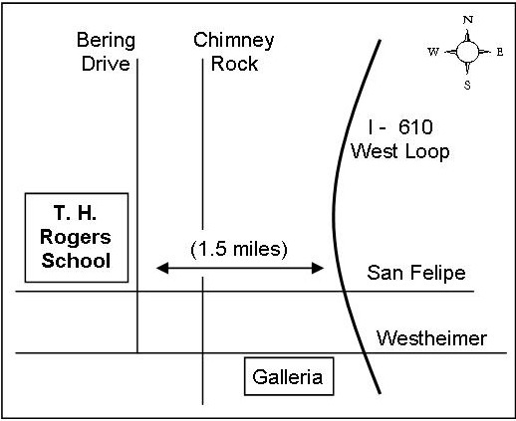
Team Rooms will be provided to 16+ players from the same school. Skittles room will be the cafeteria. Game analysis will be provided for all students.
AWARDS: Trophies to top 10 in each section in additional trophies to 3 plus scores. School awards will be determined by combining the best 4 player records in all sections. Team trophies to top 5 teams in Elementary and Middle, top 3 High School.
Tiebreak: Solkoff then Modified Median. US Chess membership is required. To obtain your US Chess membership for the first time or to renew it, there are special rates available for players in grades K-12, for one year at $9.83, here’s the link:
http://www.dallaschess.com/getuscfgrpmem.htm
========================================================== cut and mail =============================== TOURNAMENT ENTRY FORM – April 29th, 2023
CHECK ONE: Advanced/Adult Section Game/40; d5__ Beginner through Intermediate Section Game/25; d5__
Last Name _______________________________________First Name _______________________________MI_____ .

USCF ID Number____________________________________Expires__________________Rating______________

.
School________________________________________________________________Grade_________ M F Player

Address_____________________________________________City___________________Zip__________

Birthdate_________________Telephone_______________eMail__________________________________ Circle

requested BYES: RD 1 2 3 4 5 (First one @ ½ pt. - others @ 0 pts.)

