Steps to help prevent the spread of COVID-19 if you are sick

**Follow the steps below:**  If you are sick with COVID-19 or think you might have it, follow the steps below to help protect other people in your home and community.

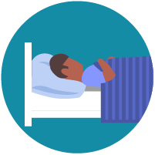

Stay home except to get medical care

* **Stay home:** People who are mildly ill with COVID-19 are able to recover at home. Do not leave, except to get medical care. Do not visit public areas.
* **Stay in touch with your doctor**. Call before you get medical care. Be sure to get care if you feel worse or you think it is an emergency.
* **Avoid public transportation:** Avoid using public transportation, ride-sharing, or taxis.

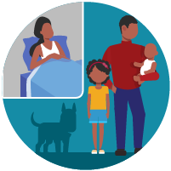

Separate yourself from other people in your home, this is known as home isolation

* **Stay away from others:** As much as possible, you should stay in a specific “sick room” and away from other people in your home. Use a separate bathroom, if available.
* **Limit contact with pets & animals:** You should restrict contact with pets and other animals, just like you would around other people.
  + Although there have not been reports of pets or other animals becoming sick with COVID-19, it is still recommended that people with the virus limit contact with animals until more information is known.
  + When possible, have another member of your household care for your animals while you are sick with COVID-19. If you must care for your pet or be around animals while you are sick, wash your hands before and after you interact with them. See [COVID-19 and Animals](https://www.cdc.gov/coronavirus/2019-ncov/faq.html#2019-nCoV-and-animals) for more information.

[If someone in your home is sick](https://www.cdc.gov/coronavirus/2019-ncov/hcp/guidance-prevent-spread.html#precautions)

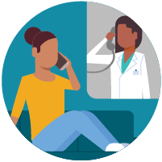

Call ahead before visiting your doctor

* **Call ahead:** If you have a medical appointment, call your doctor’s office or emergency department, and tell them you have or may have COVID-19. This will help the office protect themselves and other patients.

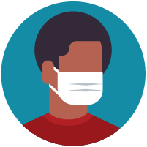

Wear a facemask if you are sick

* **If you are sick:** You should wear a facemask when you are around other people and before you enter a healthcare provider’s office.
* **If you are caring for others:** If the person who is sick is not able to wear a facemask (for example, because it causes trouble breathing), then people who live in the home should stay in a different room. When caregivers enter the room of the sick person, they should wear a facemask. Visitors, other than caregivers, are not recommended.

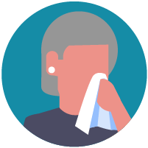

Cover your coughs and sneezes

* **Cover:** Cover your mouth and nose with a tissue when you cough or sneeze.
* **Dispose:** Throw used tissues in a lined trash can.
* **Wash hands:** Immediately wash your hands with soap and water for at least 20 seconds. If soap and water are not available, clean your hands with an alcohol-based hand sanitizer that contains at least 60% alcohol.

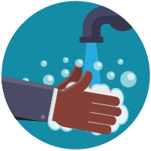

Clean your hands often

* **Wash hands:** Wash your hands often with soap and water for at least 20 seconds. This is especially important after blowing your nose, coughing, or sneezing; going to the bathroom; and before eating or preparing food.
* **Hand sanitizer:** If soap and water are not available, use an alcohol-based hand sanitizer with at least 60% alcohol, covering all surfaces of your hands and rubbing them together until they feel dry.
* **Soap and water:** Soap and water are the best option, especially if hands are visibly dirty.
* **Avoid touching:** Avoid touching your eyes, nose, and mouth with unwashed hands.

[Handwashing tips](https://www.cdc.gov/handwashing/)

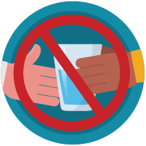

Avoid sharing personal household items

* **Do not share:** Do not share dishes, drinking glasses, cups, eating utensils, towels, or bedding with other people in your home.
* **Wash thoroughly after use:** After using these items, wash them thoroughly with soap and water or put in the dishwasher.

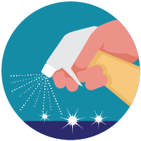

Clean all “high-touch” surfaces everyday

Clean high-touch surfaces in your isolation area (“sick room” and bathroom) every day; let a caregiver clean and disinfect high-touch surfaces in other areas of the home.

* **Clean and disinfect:** Routinely clean high-touch surfaces in your “sick room” and bathroom. Let someone else clean and disinfect surfaces in common areas, but not your bedroom and bathroom.
  + If a caregiver or other person needs to clean and disinfect a sick person’s bedroom or bathroom, they should do so on an as-needed basis. The caregiver/other person should wear a mask and wait as long as possible after the sick person has used the bathroom.

High-touch surfaces include phones, remote controls, counters, tabletops, doorknobs, bathroom fixtures, toilets, keyboards, tablets, and bedside tables.

* **Clean and disinfect areas that may have blood, stool, or body fluids on them**.
* **Household cleaners and disinfectants:** Clean the area or item with soap and water or another detergent if it is dirty. Then, use a household disinfectant.
  + Be sure to follow the instructions on the label to ensure safe and effective use of the product. Many products recommend keeping the surface wet for several minutes to ensure germs are killed. Many also recommend precautions such as wearing gloves and making sure you have good ventilation during use of the product.
  + Most EPA-registered household disinfectants should be effective. A full list of disinfectants can be found [hereexternal icon](https://www.epa.gov/pesticide-registration/list-n-disinfectants-use-against-sars-cov-2).

[Complete disinfection guidance](https://www.cdc.gov/coronavirus/2019-ncov/community/home/cleaning-disinfection.html)

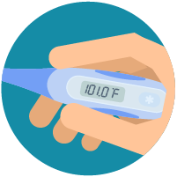

Monitor your symptoms

* **Seek medical attention, but call first:**Seek medical care right away if your illness is worsening (for example, if you have difficulty breathing).
  + **Call your doctor before going in:**Before going to the doctor’s office or emergency room, call ahead and tell them your symptoms. They will tell you what to do.
* **Wear a facemask:** If possible, put on a facemask before you enter the building. If you can’t put on a facemask, try to keep a safe distance from other people (at least 6 feet away). This will help protect the people in the office or waiting room.
* **Follow care instructions from your healthcare provider and local health department:**Your local health authorities will give instructions on checking your symptoms and reporting information.

alert icon

**Call 911 if you have a medical emergency:**If you have a medical emergency and need to call 911, notify the operator that you have or think you might have, COVID-19. If possible, put on a facemask before medical help arrives.

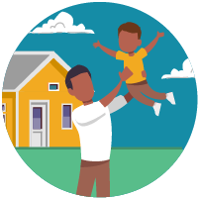

How to discontinue home isolation

* People**with COVID-19 who have stayed home (home isolated)**can stop home isolation under the following conditions:
  + ***If you will not have a test***to determine if you are still contagious, you can leave home after these three things have happened:
    - You have had no fever for at least 72 hours (that is three full days of no fever without the use medicine that reduces fevers)  
      AND
    - other symptoms have improved (for example, when your cough or shortness of breath have improved)  
      AND
    - at least 7 days have passed since your symptoms first appeared
  + ***If you will be tested*** to determine if you are still contagious, you can leave home after these three things have happened:
    - You no longer have a fever (without the use medicine that reduces fevers)  
      AND
    - other symptoms have improved (for example, when your cough or shortness of breath have improved)  
      AND  
      you received two negative tests in a row, 24 hours apart. Your doctor will follow [CDC guidelines](https://www.cdc.gov/coronavirus/2019-ncov/hcp/disposition-in-home-patients.html).

In all cases, **follow the guidance of your healthcare provider and local health department.** The decision to stop home isolation should be made in consultation with your healthcare provider and state and local health departments. Local decisions depend on local circumstances.

Additional information for healthcare providers: [Interim Healthcare Infection Prevention and Control Recommendations for Persons Under Investigation for 2019 Novel Coronavirus](https://www.cdc.gov/coronavirus/2019-ncov/infection-control.html).