Symptoms

**Call your doctor:**If you think you have been exposed to COVID-19 and develop a fever and symptoms, such as cough or difficulty breathing, call your healthcare provider for medical advice.

Watch for symptoms

Reported illnesses have ranged from mild symptoms to severe illness and death for confirmed coronavirus disease 2019 (COVID-19) cases.

The following symptoms may appear **2-14 days after exposure.**[**\***](https://www.cdc.gov/coronavirus/2019-ncov/symptoms-testing/symptoms.html?CDC_AA_refVal=https%3A%2F%2Fwww.cdc.gov%2Fcoronavirus%2F2019-ncov%2Fabout%2Fsymptoms.html#f1)

* Fever
* Cough
* Shortness of breath

*This is based on what has been seen previously as the incubation period of [MERS](https://www.cdc.gov/coronavirus/mers/index.html)-CoV viruses.

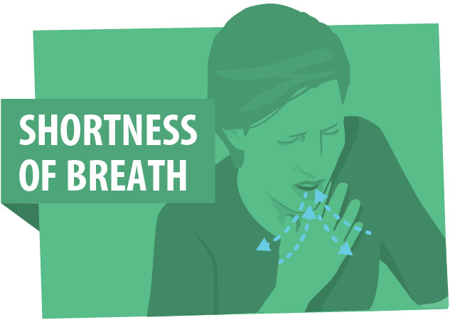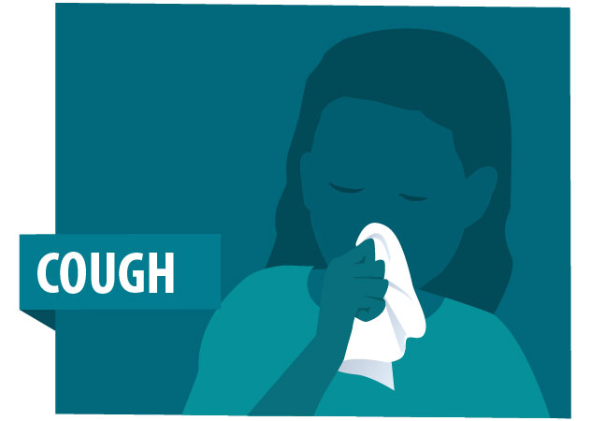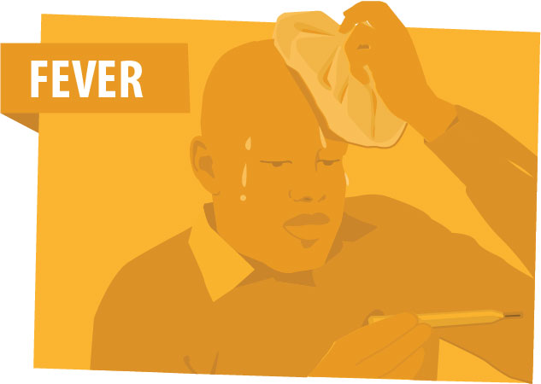

If you develop **emergency warning signs** for COVID-19 get **medical attention immediately**. Emergency warning signs include*:

* Difficulty breathing or shortness of breath
* Persistent pain or pressure in the chest
* New confusion or inability to arouse
* Bluish lips or face

*This list is not all inclusive. Please consult your medical provider for any other symptoms that are severe or concerning.