Trout in the Classroom Wraps up Another Successful Year in Charlottesville Area Schools!

By: James “Chubby” Damron
President- Thomas Jefferson Chapter of Trout Unlimited
Trout in the Classroom Coordinator for the C’ville Area
June 2018

Trout in the Classroom programs in Charlottesville area schools recently concluded the 2017-18 session with 5 of the 6 schools that participated stocking fingerling Brook Trout this spring. When the program gets underway typically the first week of October each year the classes receive a delivery of Brook Trout eggs from the VDGIF that range from 200- 250 in number.

On the day of delivery the eggs are typically within a week of hatching and the eyes and tails of the soon to hatch Brook Trout are quite evident in the viable eggs. The eggs are placed in an egg basket which is just a plastic tray with the sides and bottom cut out and the holes covered with vinyl screen which is glued to the sides and bottom of the container with non- toxic waterproof silicone aquarium sealer.

The egg basket is suspended on wire, paper clips or whatever is on hand and works at the moment and is clean and won’t corrode in the water to hang the basket so that the top is just above the water line. The eggs are placed in the egg basket for a couple of reasons, to keep the eggs visible as they hatch so students can observe the process and to be better able to see and remove non –viable eggs which if left in the tank unnoticed could decay and cause harmful bacteria to enter the system and threaten the rest of the stock.

The tank is a 55 gallon aquarium which is equipped with a chiller which is either a drop in type or inline system that circulates water through the tank over refrigeration coils, a filter system that contains an element tray set up with charcoal and ceramic filtering elements in a series of 5 or 6 baskets, and an electric and a back-up battery operated aerator to infuse more oxygen into the system.

The filtration system has variable speeds so that the flow can be set to mimic the flow of water over the eggs in the basket as they start to hatch. This would be a similar scenario to a natural stream situation where the eggs are laid in redds at the tails of gravely pools where constant stream flow and oxygen is washing over the eggs and keeping silt from settling and smothering them as they mature toward hatching.

Tanks are best set up in a room where the sun will not shine in on them and not over or under a heat or a/c source so as to not adversely affect the tanks water temperature. Although not always done on the bottom it is advisable to cut to size sections of ½ foam insulation board and have them available to wrap around the tank and tape in place in case of a power failure or to help maintain the desirable temperature if the room conditions require it.

Many times this is not used but for 20 bucks it’s a good amount of extra protection for the tank if for nothing else to help shade it as in a normal environment the trout are able to find shade and cover when needed from the sun’s warmth. If kept under the correct light conditions the growing Brook Trout will have good coloration and be easy to observe in the tank environment. You’ll see they are perfect little versions of beautiful Brook Trout that live in our mountain streams.

One of the most important things I let the participating classes know each fall when we deliver eggs is to remind them if they haven’t already done so it’s time to ride out to the North Fork Moorman’s River with a clean, dry 5 gallon bucket and top and a small zip lock bag of ice.

Taking the bucket out into the stream flow in a shady area where the water is running well for the time of year (early October so it’ll be low) they need about a gallon of water, several in-stream rocks in the 2-4 inch across range and a handful of gravel or two.

They do not wash the rocks off, whatever is stuck to them needs to be there, they are placed in the bucket with the small bag of ice floating in the gallon of water to help maintain the cool water level until they get back to the tank. Once back at the tank they put the rocks, gravel and water into the tank and immediately they have infused all the natural organisms and bacteria from a high quality Native Brook Trout stream into their tank environment and gotten the process off to a great start.

From this point on the soon to be/and or hatching eggs are monitored daily and the water temperature is watched to be sure it remains in the low 50’s during the process and maybe edges toward 54 or 55 degrees by the time they are released the following April. Water quality checks are also conducted and recorded to maintain favorable PH and other water chemistry parameters so that when changes start the fix can be administered and clear up any problems before they affect the trout’s health.

Since the water quality of the tank is closely monitored when subtle changes occur a fix can be administered and the source dealt with to ensure the continued livelihood of the trout. The filtration system filter baskets and elements are cleaned or replaced occasionally typically when changes are seen occurring in the water quality checks.

Upon delivery as said, the Brook Trout eggs are just a couple of days to a week from hatching with eyes and tails evident in the living eggs. Once they begin to hatch they somewhat unfold revealing a little trout head, a fat, round yolk sac of an abdomen which they feed from for the first several days and a whip like little tail making them all of about ¾ of an inch long.

The alevin’s as they are called at this stage are left in the egg basket for the first several days to two weeks so they can be better observed in this stage as they tend to settle into the bottom of the tank and disappear into the gravel if not kept in the basket. During the process of hatching which could take several days to have all the eggs that are going to hatch do so each day any eggs that have clouded, show signs of a yellow or whitish fuzz on them or have not fully hatched and show signs of not being alive are removed so bacteria and diseases don’t develop.

The alevin’s will feed off their yolk sacs and mainly be clumped together on the bottom of the egg basket at first and soon as the yolk sacs are absorbed they’ll begin to look up and start swimming to the surface. This is the sign to start giving a little pinch of starter food to them and coax then to start feeding on it on the surface.

Another point not already listed that is important the egg basket is typically suspended at the opposite end of the tank from the filtration system inlet. This set up allows the filtration speed to be set as to mimic the flow of stream water over the eggs in a natural environment while keeping it at a level that will not work the newly hatched alevins too much while they get strong enough to free swim in the tank.

Once they are feeding well and swimming in the egg basket they can be released into to the tank and from this point on with the infusion of food into the tank the alevins are now also excreting their waste so it is important to closely monitor the water quality from this point on. Changing the filter elements with an extra set so there’s no rush to disassemble, clean and get the system running again is the preferable way so that with a busy schedule the clean and reload of filter elements can be an easier process to handle when needed.

From the time the eggs arrive and hatch until their release the following April as fingerling Brook Trout the students will have six months to observe the trout grown and become miniature versions of the adults they’ll hopefully mature into having reached 2 ½ to 3 ½ inches in length by the release date.

The typical numbers it seems most classes end up with each year at release time is somewhere between 50-70 little trout in that typical size range mentioned above. In the 55 gallon tank habitat this number seems to be what can viably cohabitate in the environment they are provided with. Learning to feed the correct amount as to not have left overs to decay is important as is recognizing when to change out the filter system and keep the system clean but not sterile and keep the trout well fed and growing.

In cases where the surviving trout numbers are far less, say half we’ve seen them actually grow larger with less competition with some reaching as much as 4 ½ inches by the release date. Several years ago one of our participating classes held over a male and when the eggs arrived that October for the next session this guy had reached six inches by his first birthday!

He knew those eggs and the just hatched alevins were in that egg basket and he tried his best to jump into it and was constantly head butting the basket trying to get at them. We finally put a barrier in the tank to separate them but the monster Brookie kept trying to jump over the barrier and ramming into it so we were afraid he’d either get to them one night when no one was around or knock himself out while trying so he was taken out to the North Fork of the Moorman’s and released where he could be a real trout.

He was a beautiful trout and had you caught him out there one day in the short 3 years he had left if he was one of the lucky ones you would have never known he hadn’t been born there in the first place. These are a good quality Brook Trout although not the native strain the stream contains they help fill a void in the lower reaches of the North Fork of the Moorman’s River where the habitat is still recovering from the devastation of a millennium class flood back in June of 1995.

This year marked the 9th year in the program for the Charlottesville Day School and also their 9 th consecutive successful year in raising Brook Trout! Including this year’s 80 Brookie’s released CDS has released well over 700 Brook Trout in the NF Moorman’s over the years. This year 4 of our 6 participating schools stocked their trout on the NF with a total of approximately 370 fingerling Brook Trout averaging about 3 inches in length. One class had equipment failure and the other chose to release elsewhere.

For the coming year it looks as though we’ll have 6 participating again as one new one will come on board and one will continue its’ every other year with the program in its curriculum. Hope is we’ll be able to build up one per year as we can get funding to get the equipment needed to set up more programs.

It costs about $1000 for the equipment package to get started and the following years as long as the equipment lasts the costs are minimal for filter elements and other misc. supplies that typically only run about $50 per year going forward.

Please pass the word in to those you may know in the teaching field that TJTU is looking to help more area schools get involved. TIC is part of the VEA Environmental Sciences Education approved curriculum and there are training sessions for interested teachers through Mary Baldwin University typically each summer and the concept is known out there in the local teaching world. It’s typically a matter of having teachers and science departments in our local schools know we are there to support them and how to contact us to help them get started. The sooner we can forge more partnerships and add this exciting opportunity in more area schools the better so we reach as many as possible in the quest to continue to conserve, protect and restore our cold-water fisheries and their habitats while e
\ucating the cold water conservationists of tomorrow.

Trout in the Classroom can be further explored on the Virginia Council of Trout Unlimited website at vctu.org

Native Brook Trout

A Brief Bio

In the wild, the Native Brook Trout here in Virginia begin spawning in October and the average female at let’s say 8 inches in length lays about 100 eggs. In comparison the same size Rainbow can lay 1000 so it’s easy to understand how the Rainbows can quickly push Brook Trout out of the picture in a stream with the right chemistry that also favors Rainbow Trout reproduction.

Native Brook Trout in the typical mountain stream here in Virginia and in similar scenarios across their native range live 4 years and hopefully will reproduce successfully twice. Like Rainbows and Browns, Brook Trout too will live longer in the right situations such as in larger river systems and in lakes.

While attending a UVA Environmental Sciences Dept. lunch time seminar several years ago one of the speakers stated that in a typical wild trout stream environment only about 5 % of the eggs will produce a trout that will reach maturity. Each year the population turnover averages are such that in a best case scenario about 55% of the population is lost due to natural causes so it’s apparent that our native and wild trout populations face not only big odds in nature but in many cases add to that the influence of man and it’ easy to understand why we need to help then in every way we can to help preserve them.

In watersheds where Native Brook Trout reside in many cases they’ve been pushed upstream into the very headwaters in many places because of man’s presence in the environment. Man’s presence in the environment can range anywhere from homes and their accompanying septic systems in the lower elevations, to gravel or paved roads along-side them that allow runoff to enter. Run off from gravel roads infuses silt mainly, but paved roads if too close can heat up the run-off water and infuse it with petroleum by products all of which are detrimental to the viability of a native or wild trout stream.

Once man’s presence in a watershed reaches the 10% level Native Brook Trout have begun to show a very noticeable decline in population and once over 15% infiltration has been achieved they begin to completely disappear from affected sections of the stream. (apprx. numbers need to confirm but close from best remembrance)

The point is Brook Trout require cold, clean water that has the right balance of nutrients and a food base that will support the best case scenario for their reproduction needs to sustain their populations. Add to the fact many watersheds struggle with the effects of acidic fallout and precipitation along with man’s infiltration in the watersheds and across many states in the region the Brook Trout have really suffered.

Here in Virginia we are fortunate with the majority of our over 1800 stream miles of Native Brook Trout streams found within the Shenandoah National Park and the George Washington and Jefferson National Forests where they are protected from man and development. That’s more stream miles of Native Brook Trout water than all the states in the southern and central Appalachian’s combined. That includes GA/SC/NC/TN/MD/WVA/PA making Virginia the best Native Brook Trout stronghold south of the New England region.

Coldwater conservation efforts here in Virginia have worked and are continuing to work with several partners working to keep the process going. The Va. Dept. of Game and Inland Fisheries, Trout Unlimited, the National Forest Service and others along with research through state universities keeps tabs on the status of our cold-water fisheries and points the efforts needed to protect them in the right direction.

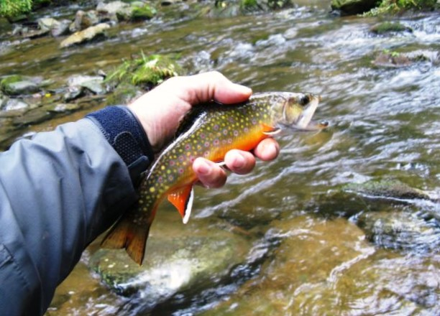

Above- Native Brook Trout- North Fork of the Moorman’s River Note caudal fin- large and well defined colors, crisp spotting and rich colors
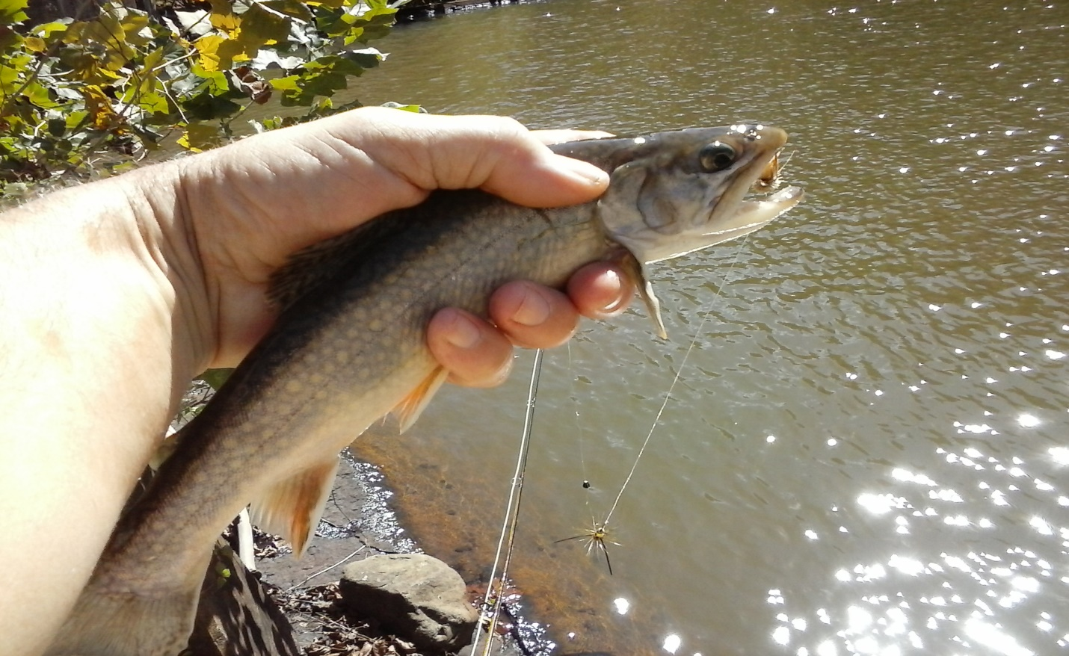

ABOVE - Stocked Brook Trout from the Stilling Pool below Sugar Hollow Reservoir September 2017
Washed out colors due to warm/cloudy water. This trout although a stocked variety has grown out well shaped fins. Once water cools and clears in fall the color will return.

BELOW- VDGIF Stocked Brook Trout caught in lower NF Moorman’s River Note- Differences between native/non-native Brook Trout See fins not large or defined in shape or color
Typical wormy markings on back are larger and less defined. Back is a deeper olive than the Native Brook Trout No red spots with blue halos or very vague. 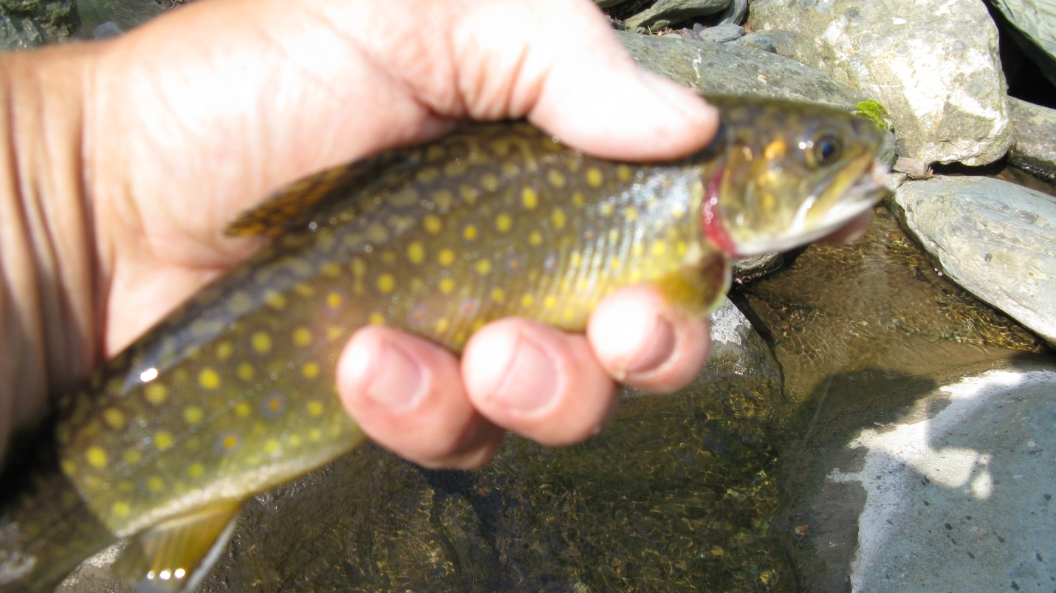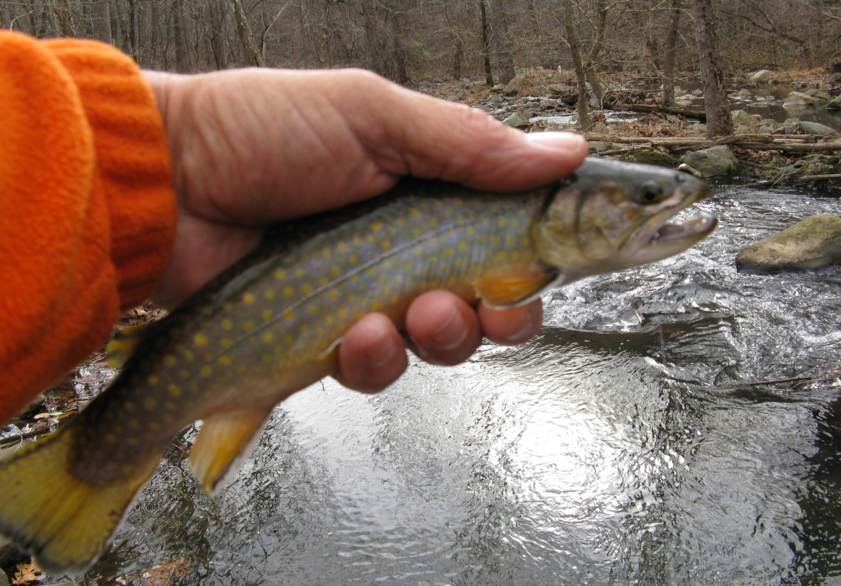
Above- Stocked Brook Trout from Moorman’s Special Regs from VDGIF stockings in reservoir

