A SILVER ANNIVERSARY…….
WATCHING A STREAM IN RECOVERY

By- James “Chubby” Damron
June 26, 2020

It had been a particularly rainy Spring that year not only here in Virginia but all across the country in those areas prone to such weather. The winter had been a snowy one across the upper Midwest and the heavy snowpack had swelled the Mississippi River drainage from Minnesota to the Gulf of Mexico and all the drainages that feed it.
Flood waters persisted well into Summer and around here it was rainy too and the streams and rivers ran well but we had not experienced anything like we were reading about further west of our region. Around here if you were a trout fisherman good spring flows are a welcome as they help keep fishable flows in our trout streams up thru June extending our Spring fishing another month.
The week leading up to the anniversary I’m writing about here was another rainy one in our area and I remember it well as it was one of those months and years that sticks in your memory with several life affecting events occurring. When the heavy rain settled in across the area that night it seemed to just be another rainy one but the next day when the news came out for some of us it revealed a disaster that is still talked about today.
June 27, 1995 was the date and on that fateful day a storm cell formed and stalled over the Blue Ridge Mountains in the Moormans’ River watershed and dumped not inches but feet of rain down upon the tranquil place we all love and know as Sugar Hollow. The same day a similar but unrelated storm cell formed over the Rapidan River watershed in Madison and Greene Counties just to our north and the results we later learned were much the same.
For the Sugar Hollow area the North Fork Moorman’s River above Sugar Hollow Reservoir bore the brunt of the storm’s fury as the stream at that time of year under normal conditions would have been flowing at only about 25 cubic feet per second (CFS). Although no official rainfall totals or CFS numbers are available for the event the rainfall was estimated at over 22 inches in just a 6 hour period and the normal 25 CFS stream flow surged to over 15,000 CFS at its height.
A staggering and devasting number for such a small watershed to endure and the event was eventually listed as a millennium class flood, one that could only be expected to happen once every 1000 years or so. Remembering what the area looked like before the razing it took that night and seeing what it has evolved to now after 25 years tells me that the event was probably more like a 5000 year class flood or even greater.
The reason I say this is because if you had seen the area before the flood and knew what the raging waters moved in my mind I couldn’t see that happening anytime in recent history say going back to the time of Christ and maybe as far back as the written history of Egypt in the 2-3 thousand years before him.

Page 2
The huge boulders that lined the stream banks that are gone had been there much longer than that in my mind and likely were deposited way back in history in these old worn down mountains many of which were volcanoes a million or more years ago. When I first saw the area after the event I was devastated and never imagined the damage would be so great.
The people who lived below the reservoir were heavily affected by the flood and their properties sustained much damage as did the stream bed of the Moorman’s River mainstem below the reservoir. Many lost vehicles, many had their driveways washed out leaving them stranded on the opposite side of the river from the road and had their yards and homes in some instances damaged from the heavy rain and erosion.
I remember the news stories of the event, the pictures and the tv video and although it was just a look through a window of sorts at the big picture that you had to go see for yourself to take it all in. The pictures I saw of the reservoir’s surface completely covered in logs and debris and the muddy look of what water you could see was enough for me and I decided I’d wait to go visit as I felt as if I’d personally took a hit. Reports later stated that all trout in the lower mile were extricated, lost, flushed into the reservoir and likely killed in the onslaught if not by the muddy, silt filled waters that took much time to settle. It was hard to imagine such a catastrophe but came to light once you saw the aftermath.
The large trees that once lined the stream banks were gone, swept into the reservoir taking with them the shade that they provided to the NF and their roots which help the hold the rocky soil along the banks in place. Further up the mountain on the west side of the NF landslides slid down the slopes exposing bare rock that probably had never seen the light of day at least in millions of years.
Big Branch a tributary stream coming in from the west and a popular hiking and swimming destination about 1.5 miles up the trail from the parking lot had it share of damage too and today the rock faces of the waterfall are still bare from the loss of the large trees that surrounded it being swept into the NF.
It was probably 3 years before I did go back up there on the North Fork to look around, I was busy in those years with family and a small business and didn’t get to trout fish much at all so that was part of it. The other part was hearing the stories of what it was like then compared to the memories I had dating back to my early years and I felt it had to heal as did I before I saw it again.
On my first trip up back up to the North Fork Moorman’s arriving in the parking lot along the lower NF it was immediately apparent that other than recognizing the parking lot things were much different. By this time the huge old trees that surrounded the parking lot were old and dying and many were already gone. Today only their huge stumps remain and unfortunately they have become collection points for those who care enough to pick up after their pets but not so much to carry it home for disposal. They leave their multi-colored little doggie bags on these stumps along with their trash and unwanted clothing for others to remove. Another major concern is the diapers often found with these baggies at the stump and along the streams there of which could be leading to the contamination of the areas water supply with fecal coliform bacteria.
A few steps from the truck to the stream’s edge was all it took for me to see what I had dreaded, all that I remembered from before that night in June 1995 was gone and I knew then that neither I or anyone in

Page 3
many generations to come would ever see the NF Moorman’s evenly remotely as we did before that fateful day.
The first thing I noticed was the old bridge abutment on the south bank of the NF was gone, a spot that was a great holding place for trout and had always been a favorite spot of mine to fish. Although I caught many trout there one that rose to take a dry fly, a Royal Wullf to be exact on a June morning in the late 1970’s was one I’ll always remember.
The seventeen inch Brown that rose from the shadows by the abutment and took my fly will never be forgotten, the only camera I had to document the moment was the one in my head and the image remains there today. Memories of the many days I spent there with my Dad, brothers and friends trout fishing together still linger in my mind and every time I’m up there they come back and make me smile. From that spot in those days I caught wild Brown’s, Native Brook Trout, and stocked Rainbows the NF Trout Slam for those times!
I can remember those early mornings back in those days fishing the reservoir and seeing all the dimples on the surface as the trout rose to eat bugs from the surface wishing I could reach them with a cast. I can still feel that cool morning air and the atmosphere around me as I sat there signing a song from the times in my head waiting for a trout to bite.
The big pool at the confluence of Pond Ridge Branch was gone, it in those days stretched all the way across the river to the gauging tower that somehow still stands, the bend in the river there likely kept the brunt of the heavy flood waters off it and saved it. One day when I was about 11 and there with my Dad, I remember walking up to the pool to see the huge Rainbows lying on the bottom of the deep, clear pool and the half dozen guys trying to catch them.
One had landed one and had it in one of those old Styrofoam coolers you still see in convenience stores today and it curled from top edge to top edge, all the that trout that could fit in there and I still see that beautiful trout alive and looking at me somehow asking me please let me go. I wanted to and other than stocked trout in those days and the Walleye we caught at times in nearby places and a few panfish for Mom or Granny I seldom kept a fish after that and never do anymore. It had to have been 24 inches and 6 pounds and up till then the only trout I had seen like that was in pictures in outdoor magazines.
I even lost my taste for fish eventually and I am often asked why do I fish and never eat them? For me it is a sport, a pastime and a position I choose to take in a pastime that takes me away from everyday life. I don’t need them to help with my nutritional needs, and do I love shrimp and can eat them by the pound but that is pretty much all that I eat that lives in water.
A couple more memories I’ll share one of which includes a huge boulder on the south bank that guarded a big, deep pool with others that were huge but not as near as massive. Charlie Taylor and I were there one day in our high school years and coming back downstream after fishing up thru the area he came down the south side as I walked on the north side.
Charlie walked up on top of the damp, lichen and moss covered boulder that had been in that spot for probably a million years or more and when he reached the top he slipped and let out a whoop as I watched

Page 4
him come feet first down probably 15 feet to hit the cold water of the NF! He ended up neck deep in the
pool! We laughed about that for a long time afterwards and I’ll bet he still remembers it too! Those rubber, lug soled hip waders we wore in those days did well but the felt soles of the future should were going to make a difference and cut down on the slips and falls on the slick rocks of our trout streams in the times to come.
Another day Charlie and I were walking out in much the same manner and coming upon a fallen log he went to the left and being 16 or so I just hopped up on it and a frog croaked and jumped off the log causing me to hesitate and not jump off the log. A good thing too because if I had hit the ground on the other side of that log without looking there lay a Timber Rattler 4 feet long or so and as big as my arm ready to take that frog or bite me had I landed on him.
Taught me a lesson I still try to remember today, always look before you put your hands and feet anywhere in these parts, Rattlesnakes and Copperheads love to hunt along these rocky stream banks in certain times of the year so be careful in these mountains!
Another Timber Rattler encounter from the NF in those days was in the same area as one day I came upon a nice pool to make a cast and something moved just below me along the waters edge. A flat slab of rock the size of a sofa lay jutting out over the pool with a nice deep pocket underneath that could hide trout. Under the rock I could see the 6 or 7 Brook Trout holding in the shadows unaware that above them was a big Rattler slowly sneaking up on them.
Yes, a Rattlesnake hunting trout, they do it just like water snakes, I’ve seen it and although probably not a common sight never think they aren’t along the banks of trout streams once the air is warm and they are highly active. I watched as the Rattler eased over to the edge so he could see into the pool and after just a few seconds of planning I guess, he suddenly shot into the stream straight as an arrow and grabbed a trout by the head and was back on the rock he launched from in just seconds!
The trout was struggling as the Rattler positioned himself to eat it and I picked up a rock about the size of my palm threw it from the 20 feet I stood away and hit the snake about 6 inches behind the head! He dropped the trout which quickly flopped back into the stream and swam away as the Rattler sat there unharmed but somewhat confused as to what had happened and then quickly disappeared under a rock!
Getting back to that first visit after the flood a walk up the streambed told the story, all the huge rocks that formed the beautiful plunge pools that held Native Brook Trout and Wild Browns were gone along with the large trees that shaded the stream in summer. The NF no longer had any cover to hide trout and very few large rocks remained in the stream.
The stream bottom upstream for quite some ways was nothing but gravel and cobblestone with virtually no cover to hide a trout. It was very disheartening to see and then I felt as though the river would never again at least in my lifetime come close to being what it was and be a worthwhile place to fish. I walked away saddened but soon had a thought come to mind that helped.
Not long afterwards once involved with Trout Unlimited and the Thomas Jefferson Chapter I talked with VDGIF about the possibility of a restoration project in hopes something could be done. Their response was that as long as there were unstable, eroding banks along the stream that a restoration project

Page 5
below the Shenandoah National Park where it would be possible due to the National Park policies would not be effective and be under constant change.
The National Park Service policy on stream restoration within the SNP and other similar scenarios is that if an issue is caused by a natural occurrence such as the Flood of June 1995 then nature itself would repair it in its’ own time unless there is a danger to persons or property downstream. I understood this and agree but it didn’t do much to help my favorite Native Brook Trout stream and soon I made myself a promise.
From that point on I’d plan to visit and fish thru the lower NF Moorman’s in that lower 1 mile section from the reservoir up to the third trail crossing on the stream at least a couple times a year and watch it recover as time passed. I decided to take pictures to keep the process in mind as it happened and hope that in my lifetime the NF would recover its ability to hold trout on year round basis. Native Brook Trout as they are the trout that evolved there should be there as they have been for the last ten thousand years or so.
Since the NF was stocked by VDGIF below the park boundary in the spring there were always a few Rainbow’s around to be caught but they either migrated to the reservoir or upstream once flows dropped and warmed under the summer sun. The sun no longer blocked by a tree canopy missing for the first time ever or at least in recent history or maybe even dating back to the end of the Ice Age made the section too warm in summer. With no place to hide the stocked trout or the Natives that ventured downstream occasionally never seemed to stick around for long.
As I’ve watched the NF recover over the past 25 years, a generation’s amount of time and about a third of an average lifetime for people it has been a long but actually fast passing time frame in my mind. During the first 5 years not much changed, the stream banks were obviously eroding and the tree saplings that appeared along the banks started taking hold. Those Sycamore’s you see now along the streambanks are working to hold the soil around the stream and stabilize it as the erosion continues and will for some time.
After 10 years those Sycamore’s were getting some height and strength but still not large enough to shade the lower NF as it needed but, it was slowly moving that way. At the 20 year anniversary of the flood the Native Brook Trout were beginning to be more common in the lower mile and the Sycamore’s from opposite banks along the river were reaching out to meet each other over the stream!
Over these past 5 years those now 25 year old Sycamore’s have made big strides in shading the NF effectively and each year that passes it just gets better. Places where just a couple of years ago fly casting was easy and unhindered the tree cover is now low enough to make side arm casts the only the way to cast and in some spots you can hardly cast at all! This too will change as the tree canopy grows even taller in the coming years and those Sycamore limbs are higher off the stream’s surface.
Those eroding banks over the years have exposed many large rocks and boulders that with each passing rain and high water event slide down even closer to the stream’s edge. Places in the stream that had no large rocks for trout cover now have them as if they just magically appeared! What were once long, flat
sections of cobblestone lined riffles are now broken into plunge pools again and the NF looks like a mountain trout stream again!

Page 6
It has been an amazing thing to watch and it continues still and will for many years to come. There are still areas the tree canopy has a long way to go to become effective again but those fragmented areas are slowly getting smaller and the good sections of the river are reconnecting themselves the way nature does it on its own.
Slowly and seemingly methodical in nature the natural way of things has brought the NF’s recovery to this point and it takes time, but it can and does happen. Too slowly for humans it seems as our lives are short compared to the age of time itself but patience pays off I now can see the difference a quarter century makes and know the NF is well on it’s way back to being what it was a generation ago.
Today as the NF Moorman’s flows off the east slope of the Blue Ridge from its origins up on Pinestand Mountain as it has done for thousands upon thousands of years Native Brook Trout live there year round from its headwaters nearly down to its confluence with Sugar Hollow Reservoir. The numbers and the size of the Brook Trout down in these lower reaches still has a way to recover to its former glory but it is getting there and yes, I did live long enough to see and experience it.
As said the Brook Trout are there where they are supposed to be again and their numbers will hopefully continue to grow as the stream continues to recover. Below the stream trail crossing on the NF that leads to the SF Moorman’s there’s still much to be regained to help the stream environment. That area is still open in places, lacks the large rocks and the bank gradient around it to help it naturally recover. Here is where man can maybe step in at some point and push things along and hopefully I can write about that someday.
Today as we approach the 25 year anniversary of the Flood of June 27, 1995 I find another problem is affecting the NF, the SF and the upper Moorman’s River mainstem below the dam as well and this time it’s not Mother Nature doing what she does in the natural way.
Now it’s the people who visit there that has me and many other people including other anglers, those that hike, picnic and swim and the people downstream who live in Sugar Hollow to worry as the traffic increases in the warmer months.
As the number of visitors to Sugar Hollow, the reservoir and the streams grows the number of un-caring visitors is growing too. The gravel road along the reservoir is deteriorating rapidly with the increased traffic as are the riparian areas along the road that help hold the soil and help keep silt from getting into the watershed.
Heavy human traffic many with their dogs along are soiling the area with human and canine waste that is not being disposed of correctly if even at all and this is going to eventually lead to the contamination of the watershed with fecal coliform bacteria above levels safe for human use. Waste from native animals in the ecosystem the environment can handle, human and domesticated canine waste is not
natural to the environment so along with the watershed being home to the State Fish of Virginia, the Native Eastern Brook Trout it is the headwaters source for the water supply for the City of Charlottesville and urban Albemarle County.
These two factors affecting the environment in Sugar Hollow are quite concerning to me and many others as both can be detrimental to our my/our health and well- being. These two problems are the most likely to get notice from the authorities and get something done to help ease the problems.

Page 7
The effect on the native Brook Trout is not only about the bacteria affecting water quality which needs to be in a pristine state for them to survive but about how other man-made problems affect them too. There are many areas where people like to swim and cool off in the summer months up there where people have been damming up the streams and removing the in-stream rocks that trout need for cover and safety from predators. Constructing these bathtubs as I call them, or swimming pools also can block the passage of the Native Brook Trout and other Native species of fish from being able to move up and downstream as conditions demand.
By late summer and early fall we’re in the driest time of the year and stream flows are at their lowest. These dams holding back water also are likely to trap trout and other fish and could lead to easy predation and death from low flows and warming water temperatures and under oxygenated water. Native Brook Trout begin spawning in early October and these structures can keep them from reaching spawning areas and lost spawning opportunities can lead to a population crash quickly since these beautiful little “Salmon of the Fountains” only live 4 years in these type streams and lay about 100 eggs per spawn.
With the natural turnover of wild populations resulting in about a 55% loss in numbers each year due to natural factors, the 45% of the trout population left over to re-populate the stream needs every break when an average of only 5% of the eggs laid will result in a trout surviving to maturity able to spawn. When things go wrong it doesn’t take but a couple of bad years to see a dramatic drop in trout populations. Add people’s adverse effect on a Native Brook Trout stream and those percentages can drop substantially and with the odds nature already gives them we need to help out when necessary and be aware of what we are doing while out enjoying these type of places.
Litter, broken glass, damaging streamside trees and vegetation along with the afore mentioned issues are going to be the downfall of the trout populations and the water quality of the Moorman’s River Watershed and if not already happening it is soon to come. Please be aware of what you do while visiting the Sugar Hollow area both above and below the dam and how it could affect the environment there.
Pack out what you pack in, clean up after your pets and pack it out. For human waste follow the guidelines for proper deposit and disposal such as doing your business away from the stream far enough the runoff will be filtered out in the sandy, gravely soil. Pick up a few pieces of trash others have left behind and don’t be afraid to speak up and/or turn in those who treat the area and anywhere in our great outdoors with disrespect.
My fear is as written earlier if problems continue and water quality and trout populations are adversely affected the access to the area could be closed off entirely or partially both of which are unacceptable to me when there are solutions to the problem.
I love Sugar Hollow like I own it and I’m an advocate for it, the people who live there, the trout, other creatures and plant life that call it home and I hope we can sommehow get everyone to understand what’s at stake. I’ve been fishing there for over 50 years now and plan to do so as Iong as I physically can. My Grandson learned to trout fish there and still does with me and I want his children and grandchildren as well as everyone to be able to do the same should they decide to.
Whether you fish, hike, swim or picnic there please pass the word and help save this beautiful place and those just like it. Anniversaries take time and work to come about and enjoy and this Silver Anniversary
Page 9
won’t have much meaning to most but to me and many others it is important and I may not have the time left to watch another recovery take place.
Thanks for reading this and please pass it along, sooner or later I hope it will make a difference and I can visit Sugar Hollow and those places like it that I love and respect like I own them as everyone else should and see an environment loved, respected and protected by man and not being damaged. We’ll never reach everyone or get everyone on board, but every little bit helps, one piece of trash at a time, one day at a time, I know we can get there.
If you hear of an old guy with a gray beard carrying a fly rod and walking with a cane out there and telling people like it is, that’ll be me. Please join me there’s a lot at stake for the river, the trout, our water supply and our freedom to visit such places.
I hope I live to see the next 25 years and watch the NF continue to recover and just maybe by the time that next big milestone comes around 50 years after that fateful night in 1995 it will be a true Golden Anniversary. The NF will have survived and recovered fully and when this story is then told the scars still seen today will have vanished from the watershed.

All rights to the story and photos reserved by the author, James “Chubby” Damron
June 26, 2020

THE COLLECTION STUMP

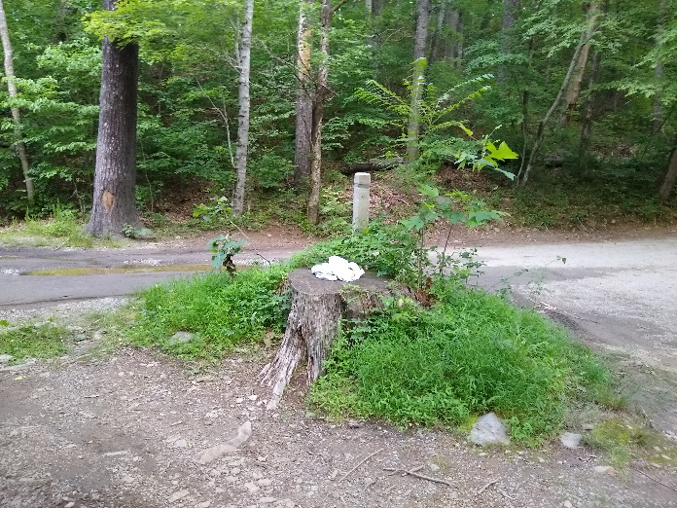
TRICK OR TREAT?
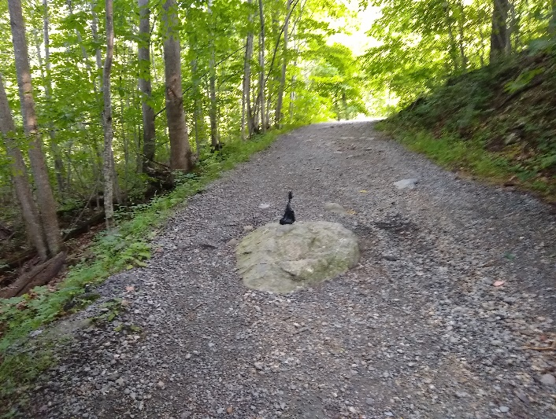

EVIDENCE OF NETTING FOUND IN MANY PLACES/ ROPE TIED TO LOGS, TREE ROOTS ETC
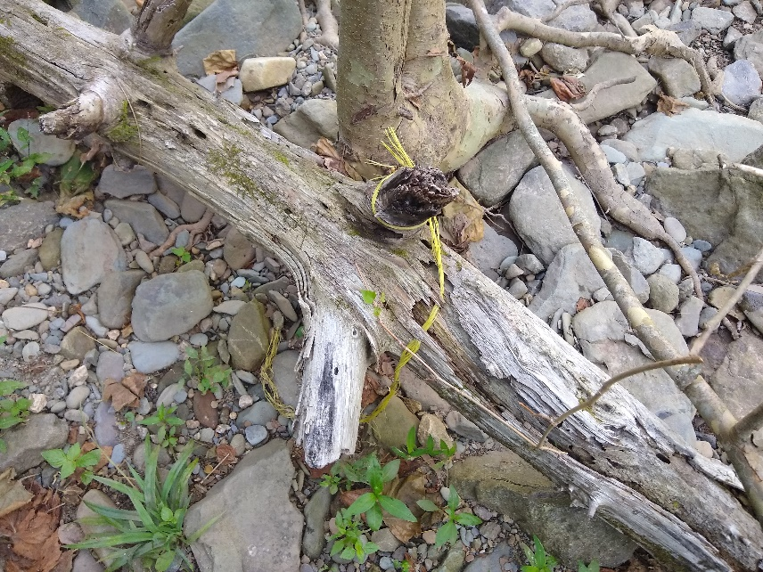
NF NATIVE BROOK TROUT
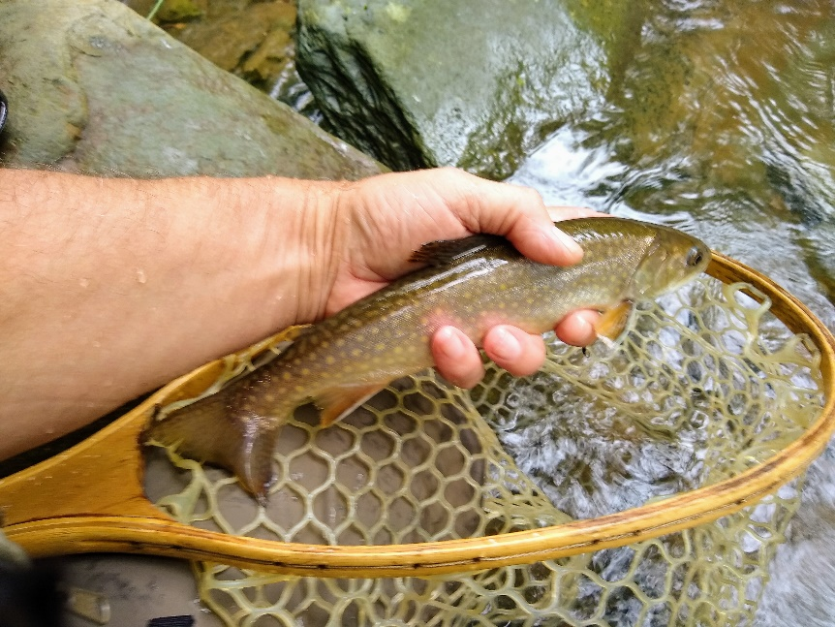
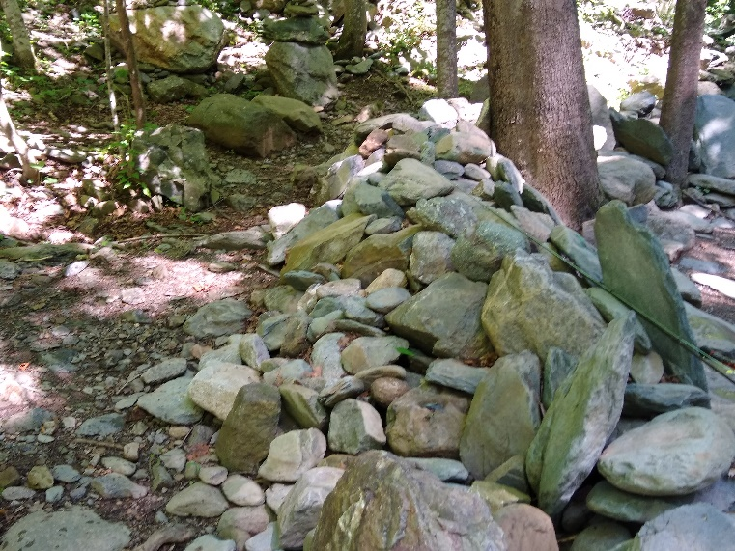
POOL JUST BELOW 2ND CROSSING SWIMMING HOLE ALL LARGE ROCKS HAVE BEEN REMOVED
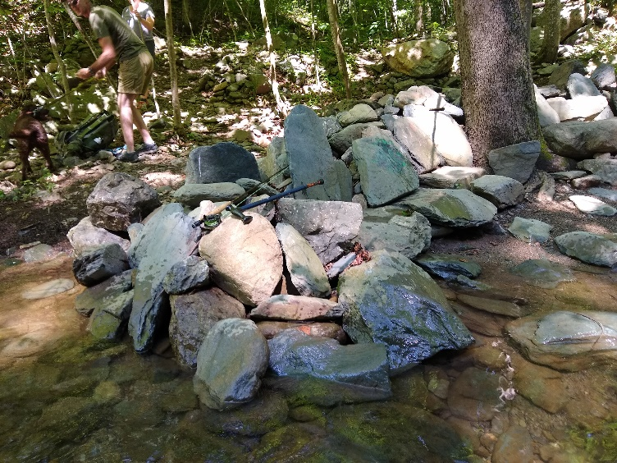
SAME POOL -ROCK SEATS
ALL ROCKS REMOVED – NO TROUT
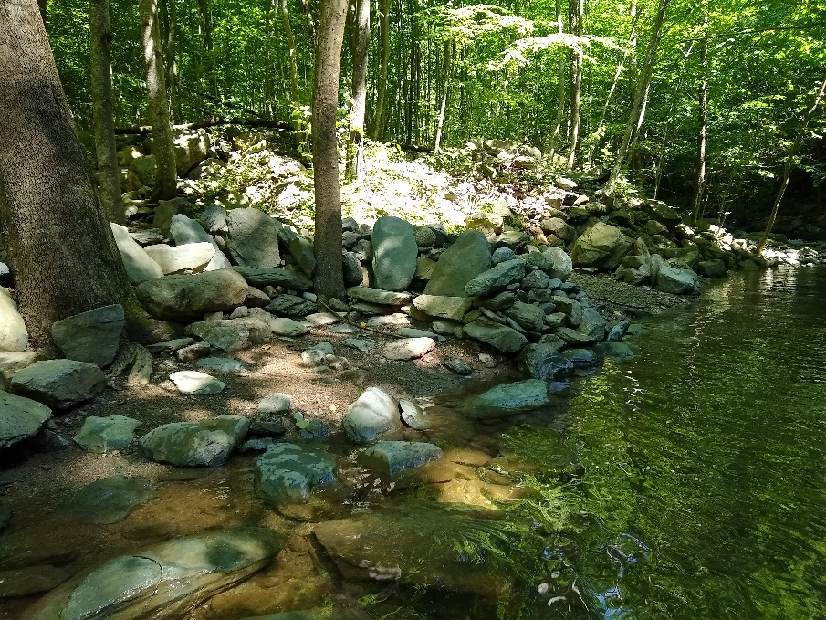
JUST ABOVE 2ND CROSSING SWIMMING HOLE – NEW ROCK WALL BEING BUILT