The following story was written in early September of 2015 after a late August trip to Spring Run in Bath County, Virginia. You may remember it as it was included in an email Newsletter that Fall.

CHAPTER I:
One of Those Days or What the Hell is that, A CARP?

Ever since we had returned from Wyoming back near the end of July I had been saying I’d find a weekday and sneak off fishing somewhere with the guys and finally I found a day or to be exact made myself take one and just did it. I hadn’t fished much since the annual trip had passed, only once to be exact which ain’t much since I usually get into fishing terrestrials on Mossy Creek and my other summer favorites just as soon as I’ve settled down and gotten back to the regular stuff in life outside of Wyoming.
I came back pretty tired this year, we all did as we may have been on vacation but we were also on a mission and that mission required our full attention and it sure got it. We were on the road early every morning headed to the stream or even better put, streams of the day putting in a full day out in pursuit of the Wyoming Cuttslam for 15th time and this year we had another milestone to conquer to as well.
This year John, Roger and I also achieved the Master Angler level of the Wyoming X-Stream Angler Program by visiting and or fishing at least 7 different streams that have in-stream water flow rights established protecting them from over use from irrigation and thus protecting the habitat and the trout. We did 12 streams this year in the X-Stream program of the 20 we fished in doing the Cuttslam again. We would have done the ‘Slam twice again this year as we usually do but we decided to do something different one day and not go after the Bonneville’s a second time. Anyway I guess where I’m going is we had a full fishing trip driving over 1000 miles during the quest from our bases of operation in Alpine, WY, and Cooke City, MT. When you include the air miles it was a 5000 mile, 10 day adventure that kept us busy every day we were away.
So, I guess I did need a break after all that so I didn’t feel too bad not going for the next month after we returned. It was often too hot and bright some of the day’s when I coulda went, my hip’s been acting up and there’s other excuses but finally I had to get back out there and pick on the trout here at home for a change.
Last Friday was the day I finally chose to get away and John and I made plans to meet at my place and go from there off to one of our favorite streams about 2 hours west if here. This particular stream is one of those that more often than not will find you leaving at the end of the day with a memorable experience that urges you to return there again and again. It’s not one of those places where the numbers of trout you land impress you but one where on some days a half dozen or so is a great day.
Half a dozen? Not a big number, how impressive is that some may be thinking at this point but I’ll tell you this much I’ve had days when my best 6 trout laid end to end would measure over 120 inches. That’s quite a possibility there and no you don’t always catch a 20 incher but you’ll most likely see one and possibly more if they are out in the open feeding as they sometimes are. Good numbers of healthy 14-18 inch trout are present and even if you don’t land that 20 incher, a day of trout of the before mentioned “smaller size” ain’t too damn bad anywhere.
You may also have noticed I’ve just said trout instead of naming a species and that’s because you’ll find Brown’s, Rainbows, Brook Trout and we occasionally land a Tiger Trout, the Brown/Brook Hybrid there which gives us essentially the Virginia Grand Slam on Trout. Throw in White Chubs and Suckers, and an occasional Smallmouth and Rock Bass that also like the cold water environment and there’s plenty of fish life in the stream along with a healthy dose of aquatic insects to feed them all.
John was meeting me at my house and we’d head out from there on Friday morning and when the phone rang about 7 am as I was rushing around making sure I had everything and it was John I’m like it’s unusual for him to be running late on a fishing day! Well, turns out he got only a couple miles away from home and had engine trouble and barely made it back to the house. I told him I would pick him up and out the door I went and was soon on the road.
At the first stop sign I looked into the dash and realized I hadn’t gotten gas the night before and made a detour for that stop and finally I was headed in the right direction. I picked John up and running late as we were we decided to go with our original plan and make the two hour drive, it’d be worth it and there’s a backup stream nearby and other options if we needed them. Another quick stop for a bite to eat along the way and soon we were passing by our backup stream which looked good so we were feeling good with just minutes to our destination.
The low tire pressure light came on just after the backup stream was crossed and I’m thinking its ok it’s just that tire that every couple of months loses a little air and everything is ok. Well, couple more miles and we’re heading down the access road, about ¼ mile to the stream off the main road and I knew before we‘d gone 100 feet a tire was definitely low.
Yep it was half flat when we stopped at the parking area and I said what the hell, let’s go fish and I’ll change it later when I decide to take a midday break. A truck pulled up as were getting ready and it was the manager for the Coursey Springs Hatchery who saw our dilemma and offered to help. He said he’d bring the guys and a compressor back over and check it out or at least help us change it. Thanking him for his hospitality saying we’d fish till lunch and take a break to change the tire we finished rigging up.
We walked down to the stream to look at a section that we always check first as it can tell you how the rest of the stream will look. And yes it looked good as we slowly approached and looking into the clear, cold flow the trout were there, lots of them and a couple of particularly big ones were holding in the seams.
One big Rainbow caught my attention and I unhooked the size 14 Sowbug tied to a 5x fluorocarbon tippet on a 10 foot leader. John spoke up,” What the hell is that? A carp?” “Whatever it is its big”, he said about the fish lying just downstream out of my sight. I remember saying something like “Could be”, “probably came in out of the Cowpasture to cool off as I concentrated on the big trout just below me drifting my fly down in hopes I’d see that big mouth open.
On about the third cast he took, the hook was set and the 2 foot Rainbow shot upstream under a weed mat and came straight up on the other side through the surface with a loud splash and the thin tippet snapped like thread under the weight of the 6 pound trout. “Shit John! “I said as I looked his way as he looked toward mine to see what the commotion was all about. He was a big one, couldn’t do anything about that, close quarters, heavy cover, way it goes sometimes I said as I sat down in the cool grass to re-tie.
I lit a cigar as I tied on a 2 foot piece of 5x and another Sowbug thinking it was going to be a good day and taking a few puffs as I looked for the next trout to cast to just to get it together and be ready. Slowly I stood up and picked another big trout to pick on and made a couple of casts before I saw a movement in the stream out of the corner of my eye. Something moved into sight just below me in a seam, just the head at first and then a big fish came into full view in the seam from John’s direction.

Had carp on my mind I guess and made another cast to a Trout as I told John the Carp was coming my way. He’s sitting here just below me in the open now. I made another cast as the big fish sat there in place slowly finning in the tail of the pool below me. Focusing on it and thinking a big Carp on a fly would be fun and with it now being closer it soon slid over about a foot and opened its huge mouth to take something in the drift and the mouth I saw wasn’t on no Carp!
The mouth as said was huge and not like a Carp and the side view it gave me showed the tell-tale spots of a Brown Trout and I remember saying “John it’s a huge BROWN, ITAIN’T NO CARP!” I made a cast and drift towards the trout all the time thinking was a trout this big going to eat such a small fly or would I need to show him something else? The Brown was only about 20 feet away so seeing the sowbug drift toward him was easy and on the 3rd drift his big mouth opened I set the hook and I think he was as surprised as I was when the hook hit him and he shook that big head and turned downstream giving me a good side view of what I had on.
“John I got him” I yelled as the trout slowly swam downstream violently shaking his head and with a little pressure I had him on the surface with about 20 foot of line between us as I moved to get in the stream and block him from getting above me in the heavy cover. Hoping I’d get John in below him and we’d corral him and all I had to do is keep his head up and out of the cover. Quick thinking I thought, experience and a lotta luck would land him that is if he’ll fit in the net.
Well, as quickly as it happened it was over, the big guy thrashed to the surface spraying water as he violently shook his head and suddenly with a shake and lunge he ripped free and disappeared into the weeds. Shit! Standing there with the limp line lying on the water with John wide eyed looking my way. That’s the way it goes sometimes and yep it was one of those days.
I’ve caught some big trout and seen some big trout but I’ve never seen such a Brown anywhere here in Virginia or anywhere for that matter except in the Green River in Utah. Having had such a good look at him in the clear water from such a short distance my best guess is he’d go 30 inches and weigh better than 10 pounds. What the hell, let’s go with 12 pounds as he was at least 12- 14 inches deep in the body and his tail was huge, tip to tip 10 inches. His snout instead of somewhat rounded and slightly pointed was blunt as if he’d ran into a wall and wide, it looked to be about an inch and a half wide and that mouth was wide enough to swallow a small cantaloupe.
I know, early to bed, early to rise, fish like hell and make up lies, well I didn’t go to bed early or get up very early for that matter and although I like a good story as well as anyone I wouldn’t pass anyone a line of bullshit when it comes to a monster trout. Anyway even though I had a great day landing a good number of good sized trout including 2 rainbows that went 20 inches or a little better and a big kipe jawed male Brook Trout that weighed over 3 pounds and measured about 18-19 inches. None of those big trout seemed big compared to Ol’ George as John so named him. Not the big one lost early that day or even the 5 pound plus Rainbow that pulled the hook out in the weeds at days end.
The backup stream didn’t get to see us that day as we stayed and kept a look out for Ol’ George in case he came back out to play. Never saw him again but I did see something else that made things even more interesting late in the afternoon as the shade brought by the fading day crept over the stream. From a weed covered undercut just above me another huge Brown slowly appeared and moved into a feeding lane briefly giving me a good look and a couple casts before he slowly returned to the cover he came out of. Not as big as Ol’ George, but big just the same, 25 inches 7-8 pounds, plenty big but nothing like Ol’ George.
I went back to the car to get something to eat and drink later that morning telling John I’d go ahead and get the spare out and get ready to change the tire. After eating I quickly just went ahead and changed the tire and got it over with as it was an easy job. Not long after John joined me to eat the guys from the hatchery showed up to help and we thanked them and told them about the big trout. Finishing up our conversation and lunch we went back out on Spring Run in case the big ones continued to show themselves and give is a shot.
It was a long ride home in the dark, running slower than usual on that undersized spare tire they put on vehicles now a days thinking and talking about that big trout and plans to return. What I’ll do next time I get a shot and how I’ll win the fight.
Yep, it certainly was one of those days, one to remember with more lessons learned and the next time someone says “What the hell is that? A carp? Remember it could be a helluva trout so be ready and even if it turns out to be a carp then hey, big fish on a fly rod, it’s all good.
Next day I got a new set of tires and realized I now have a new mission in the game of trout fishin’ me and Ol’ George gonna go another round one day and next time I’ll take the win.

Chubby Damron
September 2015

CHAPTER II
Chapter II was written in July 2019 but is taken from what occurred on May 2, 2017.

1 FOR 6
Not a good batting average but a good score on Spring Run
On May 2, 2017 just a few days before I was to go in for a major spine surgery John, Tim and I headed off to Spring Run in hopes of catching some of the big trout that live there. Likely my last trip out for a while, several weeks or months probably and I was certainly hoping for a good day of fishing but a good day with good company would suffice even if the fishing didn’t pan out.
After we arrived and rigged up I headed over to the usual spot I check first and then up to the spot just above the little tributary and saw that along with several nice trout there were also a few rather large ones holding on the better spots around cover. I began casting to the closest big one letting the Sow Bug hit upstream above him and allowing it to sink to the right level as it approached the feeding trout.
Get the drift right and you hit him in the mouth, he takes and the fight is on and hopefully you’ll be able to land him for a quick picture or two before targeting the next trout in the section. Well, I immediately just nipped the largest trout closest to me and stuck his lip just enough he felt it. Another cast and good drift to him was ignored so I looked to another trout to let him settle down.

The next trout I cast to not quite as large as the first I targeted but still big it took the Sow Bug and put up a great fight including a couple of jumps. A couple of pics and the beautiful 22 inch Rainbow of about 4 pounds swam back under the weeds to rest. Soon another nice Rainbow was caught in the 18 inch class, a smaller one and when the next large trout was hooked, one about 20 inches or so upon sliding him into the net I took my camera out too quickly to cut it on and dropped it in the stream face down on the lense in 3 inches of water before I could loop the strap over my wrist as I usually did.
As quick as I picked the camera up I had hoped it would have survived the fall but it did not and after many years of excellent service taking thousands of pictures mostly of trout, trout streams and their environments and other such associated stuff my old partner was done for.
Sitting the camera on the bank the water slowly trickled out of it as I fished and soon it came to me then that I would not get any pics the rest of the day unless Tim was nearby. I continued to fish and out there in front of me in the better spots there were several large trout feeding away just like the many others lined up in the deep, clear seams in the weeds.
I started picking on the closest big trout to me and within a few casts I had hooked another big Rainbow every bit of 2 foot long which put up a hard fight and eventually pulled out the hook. Going back to picking on the big ones later on another big Rainbow was hooked over 2 foot long, 8 pounds easy and he broke me off.
Just as well I guess, I fooled them but it certainly would be nice to land one of the larger ones and have a working camera. I caught some nice trout that morning, mostly hard fighting fish running 14 to 18 inches with a few at or just over 20 inches. Mainly I would target the big ones and when they started ignored my offerings which would be a Size 14 Sow Bug or the same size Crane Fly Larva in either cream or tan. I would switch off to the “smaller trout” catch a couple and then go back to the big ones after they had settled down a few minutes..
I know you’re thinking what a tale and it’s about to get bigger and you’re right although it’s no tall tale! Up to the point we were just about ready to take a lunch break I ended up hooking 5 large trout from that pool all that were over 25 inches long! No stuff, I really did and I lost them all due to them either pulling out the hook or snapping me off on the 5x fluorocarbon tippet I was using.
I landed several nice trout as said, 14- 18 inches, a couple about 20 and a couple about 22 and definitely had a great morning but those big ones that got away and no camera with me to get a pic of any was a little disappointing. It would just be fishing story, no pics or witnesses to back it up, another one of those days.
As the lunch break got closer Tim appeared just downstream below me and I told him what had been happening so come on over and try these big ones out. He said he needed something to drink and headed up to the car as another couple of anglers arrived and came down to the stream. One of them came in just below me and was fishing just upstream of the bend below me and worked up towards the tributary I was just above.
After a few minutes of casting to another huge trout I stuck the big Rainbow on the Sz 14 Cream Crane Fly Larva and another big fight was on! The huge trout shot upstream as far as he could jumping much higher than you would think and the tippet held each time the slab of a trout hit the water!
The guy below me yelled over “Got a big one on?” Yeah was all I could say as I had to keep focused on keeping that big trout out of the logs, rocks and weeds. Every large piece of good cover had a big trout holding by it and each time the big Rainbow I was fighting tried to get under one of these spots the sometimes even bigger trout in residence would come out and chase him away effectively helping me out.
The huge Rainbow kept pulling hard and running up and downstream as far as the deep pool would allow which wasn’t far in either direction. I just had to keep his head up and out of anything that he could wrap around and break me off. Holding on I was able with the help of those 5 other huge trout I had hooked earlier in the day keep the big Rainbow in the open out of the snags and finally he was tiring. Soon I slid him in the net and man it was a big one was all I could think looking over hoping to see Tim on the way over.
Standing there in the stream knee deep with the big Rainbow in the net I yelled over to the young guy below me to please help out and go up to the car and get Tim for me. Saying my camera was dead and I had a big Rainbow in the net and Tim was at the car barely 100 feet away just up the embankment above us and I needed a picture of this one! He said sure and quickly trotted up the bank and got Tim who was soon there on the spot.
After taking several pictures I released the Rainbow back into the cold flows of Spring Run ending up 1 for 6 on huge trout for the day which was good enough. Thanking Tim for the pics we walked backed up to the car to take a break talking about the trout. It was a big Rainbow, and well over 2 feet long and its weight was the most distinctive thing about it.
After John met up with us at the car and we finished our break we decided to go ahead and head over to the Bullpasture River to finish off the day as we usually do when in the area. We had a good time on the Bullpasture that afternoon with everyone catching nice Browns and Rainbows that ran 11- 16 inches.
Riding home I was certainly looking forward to seeing those pictures so I could get a good estimate of its actual length and weight together. We stopped for pizza on the way home and there while sitting around talking about it did I begin to realize just how big it really was. After Tim sent the pictures I took time to look them over well and re-live the moment using the net in the pictures, my observations and memory to come up with some numbers for the Rainbow.
Well, here it is, he was as best as I can estimate from the pictures, using my hand to judge its length that day and the net and the clasp on it also as a guide I’d say every bit of 29 inches long. In a picture unless you get the right angles to see the body size of a trout correctly it’s hard to judge the body thickness to estimate its weight. This trout was nearly 8 inches deep and was thick as well with a very solid feel to it in my hands.
In another description I said it felt like holding a ham in your hand as it was so solid and dense it was noticeably heavier than the typical trout and made me wonder just how big a couple of those that got away actually were? 29 inches long and I was afraid to say 10 pounds so to be conservative when I sent in the trophy fish certification application I listed it at 28 inches and 9 pounds.
And it was the smaller of those huge trout I stuck there that day! Being there at the right time has paid off over the years and fortunately it was “one of those days”.
Chubby July 2019

chapter iii
AS THE WORLD TURNS…………………………..
Turn the clock forward a few years and another day at Spring Run in late May of 2019 and the above story would add another chapter to the ongoing saga of Ol’ George and what has now become a quest to catch the largest Trout in Virginia.
In the days leading up to a trip over to Spring Run with Bill Lucia and George Newcomb on May 29, 2019 I was certainly looking forward to it as I never seem to get over there enough each year. Having severe sleep apnea I never get much uninterrupted sleep so seldom is it that I sleep sound enough or long enough to dream but, a couple nights before we were to head over I had a something, not a dream but what I guess I’d call an awakening to a realization that I was going to catch a big trout.
A short dream or premonition maybe, I had no recollection of being in a certain place or even what happened. I had a notion, a premonition I guess that I was going to catch a big trout. That’s it, it just came to me I was going to catch a big trout, didn’t know where, didn’t know when or what type but, but I was confident it was going to happen and I felt that way as I went through the day before we left.
Catching a big trout at Spring Run happens regularly, there are a good number of 18-22 inch trout in there and some are pretty hefty so landing a big trout in this class is a good possibility. Since on Spring Run the opportunity is common so I just started to assume it would happen on the Bullpasture River where we usually finish up the day after a morning at Spring Run.
The Bullpasture is a great trout stream but often can be too high to fish effectively in the Spring. Knowing the flow was up slightly and the approach to a big trout would be easy it seemed like a great possibility and yes I’ve caught and lost some big ones there.
Riding over talking with the guys that morning I didn’t even think about the dream or whatever it was and upon arriving and rigging up I made my way over to the upper section of Spring Run just below the furthest point you can fish. Getting into position and looking into the stream to spot a trout to cast to my eyes immediately went to the big trout holding in a spot mid-stream about 25 feet below me.
The big trout was sitting there in a slot in the weeds its mouth opening and closing every few seconds as it ate something in the drift. There were many trout to choose from but this one was the biggest and the closest with just a few other trout nearby that could go for my fly and spook him so I stripped out line to get my distance and got ready to cast.
George had just walked up streamside just below the little tributary that dumps into Spring Run below the Hatchery there and I remember telling him the trout are here. I had my usual fly on for Spring Run, one that should be obvious that the trout feed on with the vast numbers visible in the stream.
A simple pattern, a weighted size 14 Sow Bug that I tie and fortunately I had put on a new 9 foot 4x leader the night before and not realizing it until what happened in the next few moments had passed and I had time to think about did I realize that new leader probably was my saving grace that morning.
I was fishing my 9 foot 6 inch 5 wt. rod, with 4 wt. double taper line. A good big trout combo as it’s proved to be over the years and today a big test was on its way. Stripping out line to estimate the length I needed to reach the big trout that although was big didn’t stand out as particularly large compared to others I had caught there but that thought would change in just a moment.
Not wanting to change positions and possibly spook him it I made maybe half a dozen casts letting the fly hit the water upstream a little further each time until I got the distance thus the sink rate right and on that last downstream drift to the big trout I watched the Sow Bug hit him right in the mouth and in that same instance the big trout shot upstream as I set the hook and the fight was on! The trout shot upstream past me and came up out of the water like a Tarpon shaking its head about 15 feet in front of me with such a splash George could see and hear the commotion from where he was below me.
As fast as the big trout hit the water from the jump that put his head as high out of the stream as I stood on the bank at the stream’s edge he was out again just as high thrashing the water like crazy as he crashed back into the stream with water flying. I remember thinking wow the tippet held as all this was happening and this was a huge trout, a Brown and not the Rainbow I thought upon the first high tarpon like jump it had made!
Quickly the trout took off down and across the stream toward a root ball and with the rod held high to keep his head up I applied a lot more pressure to turn that trout than I thought my leader had in it but it held. Lord help me with this one is all I can remember saying to myself as I waded in to follow the trout and better fight him.
The trout took off downstream as far as the deep seam in the weeds would allow and he turned and quickly came back toward me shaking his head and pulling harder than I can explain. This was one strong ass trout and my back was hurting as I put the pressure on to keep him close to me and out of the weeds and snags.
The reel drag got a workout and it worked and soon the trout made another run downstream and came back as if it were to give up and swim into the net I was holding there in hopes he would and in hopes he would fit in it. He must have did that to get a look at what had him and that look put him another flurry of head shakes and short, strong runs around the pool.
The fight continued for a few more minutes as the big trout circled the deep, open water in front of me and by this time George had made it over and Bill still up near the car could hear the yelling and splashing going on up there and quickly made his way to the place we were.
The big Brown went downstream one more time down deep as the pool would allow shaking his head trying to shake out my fly out and pulling with an amount of pressure a trout fisherman isn’t used to feeling. It was a hard fight and having the back and hip I do I was feeling it by the time the big trout gave up and slid into the net.
Thank you Lord and Holy Shit was about all I could say as I then realized what I had landed as the Brown struggled in the net. I reached in took my leader and grabbed the Sow Bug stuck in the tough part of the upper lip a spot that held him and thankfully I had put that new leader on the night before!
George and Bill took the pictures of the Brown that I had to hold tight with my thumb in its mouth to control so we could get the pictures. The result was a thumb that was covered in abrasions and bleeding pretty good by the time the trout was released. The guys took plenty of pictures and we contemplated its length and weight and while holding her in the current it started to sink in just how big the Brown was.
After holding the Brown in the current to allow her to get it together and swim away on her own she finally swam slowly away out in front of me about 10 feet or so and sat there tail wavering gills working and she wobbled a bit a couple times showing she was still tired so I waded over reached in up to my elbows put my hands under her belly and picked her up.
George and Bill were still watching as I brought her back to where I could stand comfortably to continue to revive her. After a few more minutes I thanked her again as she swam away slowly and went into the weeds to rest. It wasn’t but a few minutes and there she was again wallowing around in the pocket in the weeds she had tried to hide in so I waded over again reached in and got her out of the spot and she swam away up under the weed mat under cover to rest.
I waded out of the stream and hooked up my fly and went up the bank telling the guys to get in there and catch some trout which they did. I was exhausted, my thumb was scraped up and bleeding pretty good not deep just many little punctures and scratches coupled with blood thinners and you’d think I’d cut an artery.
A paper towel and a little pressure stopped the bleeding quickly, band aids applied and back to business in a few minutes. My back was hurting more than usual, still under the effects which I always will be from kyphoscoliosis, degenerative joint and disc disease and otherwise widespread arthritis I felt as though I had just reeled in a wildcat.
My arms ached, my chest hurt and I was a little uncomfortable and woozy as I get tired easy and that Brown pulled so hard it was unbelievable. The head shakes I could feel all the way down the rod into my hand and down my arm into my shoulder. I was still getting over a fall while fishing a couple weeks before and I felt like that Brown got the best of me, I may have won the tug of war and the match but that trout won the performance vote and got in more than his share of punches too.
It then hit me then the reason for the chest pain, last year I had fallen and in an attempt to catch myself which I did I twisted and strained the ligaments in my rib cage coming from my stiff reconstructed spine around to the spot at the bottom of your sternum. This cartilage/bone piece is called the xyphoid process and it’s where the ligaments and tendons from the rib cage all attach in the front.
I had also sometime after my spine surgery developed diastasis recti, which is a separation of the stomach muscles. In my case it is from the bottom of my sternum down to the navel which also adds to the pain and tightness in my chest if I do something strenuous. I had a cortisone/steroid injection there in hopes of helping with the pain last year which did work and fighting that big Brown re-aggravated it and it took me a few minutes to realize that’s what it was afterwards.
I left the guys to fish the spot and worked my way downstream to see what I could find in some of the good holding spots downstream. Guess I’ll be back in for another injection if the soreness doesn’t go away soon was on my mind as well as what caused it as I fished slowly downstream around the bend. Picking at the seams in deep runs and holes around cover I didn’t see any trout so after taking a break sitting along the bank in the cool shade of a Bath County morning I turned around and headed back upstream.
I saw nothing on the return heading back upstream to the upper pool with Bill and George where I stopped and fished just below them. The trout were hungry and we caught several each enjoying the morning until the trout got wary and stopped feeding. We all caught Brooks, Rainbows and Browns that morning and 4 of the Rainbows I caught out the several I landed went around 3 or 4 pounds that were really strong fish but didn’t come close to that first trout of the day.
Taking a break off our tired legs for some lunch back in the parking lot we packed it up and headed to the Bullpasture River just a few miles up the road. It was then I thought about the dream or premonition whatever it was. I had just caught a Brown that was getting bigger the more I thought about it so I guess I was wrong as it wasn’t likely I’d catch a bigger one on the Bullpasture although 20 inch trout are there and I’ve caught them.
Well the Bullpasture didn’t give up any 20 inchers that day but the nice Browns and Rainbows 11-15 inches we did catch were great and all in all if you took away the big one it was still a great day on the two streams and it was shared with great company.
On the ride home I got to relax in the backseat and I was thinking about that Brown as we drove along talking. How much did it weigh? I had a good estimate on the length about 28 or 29 inches easy and the depth of its body was deeper than my hand is long which from my middle finger tip to the crease at my wrist on the palm side is 8 inches. The trout was really thick as well, side to side it was as wide as my hand too it had quite a large circumference, it was as big around as it was long and the thickness went far back into the tail section.
It wasn’t elliptical shaped that’s for sure, streamlined but with a big, broad, strong body and similar sized Stripers don’t fight that hard. The strength was amazing and I’m not nearly as strong as I was a couple years ago I’ll admit but that Brown hurt me and I still feel it.
Something came to mind as we got closer to home I thought about our cats and it hit me that Teddi, the largest of the two females Judy and I have we had just recently weighed and she’s 12 pounds. I’m close to those cats and several times a day I’m picking them up they’re in my lap so I know what 12 pounds feels like. That trout was definitely more than 12 pounds.
Looking around online you’ll find several sites that give a formula for estimating the weight of fish if you have the length and circumference. You can also choose trout and in some cases even Brown Trout to help filter the results and if you have time please check it out and see what I found.
The numbers these formulas come up with are wide ranging and a couple of them don’t account for the circumference being so large. Take a look at the pics I’ll post on the chapter website and the numbers and tell me what you think. Send me an email thru the chapter at thomasjeffersontu@gmail.com with your thoughts if you like.
I started looking online for pictures of Brown Trout weighing 12-14 pounds to compare it to and then on the Va. Dept. of Game and Inland Fisheries website I found the pictures of the Un-Official Virginia State Record Brown Trout which was caught in the Smith River by William W. Neese on June 22, 1979.It was weighed un-officially in at 18 pounds and 11 ounces.
The Official State Record Brown Trout was caught on May 24, 1990 in the South Fork Holston River by Mike Perkins and weighed in at 14 pounds and 12 ounces. Two huge Virginia Brown’s! On a catch and release stream I had no way to officially weight that Brown and even on a stream I could have kept it in the chance it could be a record I would have still released her.
Anyway it was a trout for my record book, even if it was listed with a star beside it to me that would only mean it was special and it was! I t was quite the experience and I’ll never forget it and two good friends were there to share in it too. You can check out the state record trout and other fish on the VDGIF website in the Trout Guide Section under Trophy Fish at: dgif.virginia.gov
It wouldn’t surprise me to run across another trout like that in Spring Run again. I’ve seen them and I’ve fought them and now I’ve even chalked up a win in the monster trout division! Going there? Tie on a new 9 foot leader tapered to 4X. Tying on tippet? Use fluorocarbon only. Use Sow Bugs on strong, heavy curved scud hooks, make sure they’re sharp, tie good knots and re-tie often. Get a good drift and that’s the recipe.
I’ll be looking for my next chance every time I go there and such shots are few and far between as I know but I’ll keep trying for my next biggest trout and maybe even the biggest trout in Virginia.

Chubby July 5, 2019

Since that August day back in 2015 I’ve thought about ‘Ol George a lot especially since I landed a Rainbow of 29 inches and 9 pounds by my best estimate there in May of 2017. That Rainbow was a helluva trout but the smaller of 5 huge trout I hooked that day.
It was good to land that big Rainbow that day but the ones that got away like ‘Ol George and those others make you think just how big was it? It was quite obvious after landing that Rainbow that ‘Ol George was much bigger than my original estimate and even more so after I walked away from Spring Run back on May 29 of this year.
‘Ol George is now a trophy beyond imagination and yes we fishermen are known to stretch things a little but believe me I wouldn’t do that, not in the case of something as important as this is to me. That Brown from August 2015 was a huge trout, huge by anywhere standards and now after the May 29 Brown was landed and evaluated I’d have to say that ‘Ol George was 20 pounds.
I’d assume he’s gone now, a trout that old was near the end I’m sure and likely 8 to 10 years old. I heard a story about a huge Brown being found dead at Spring Run last year and it supposedly was, would have been a State Record.

He’s out there………
Chubby July 5, 2019

Pictures below are from the Virginia Dept. of Game and Inland Fisheries website.
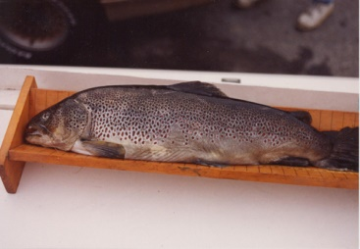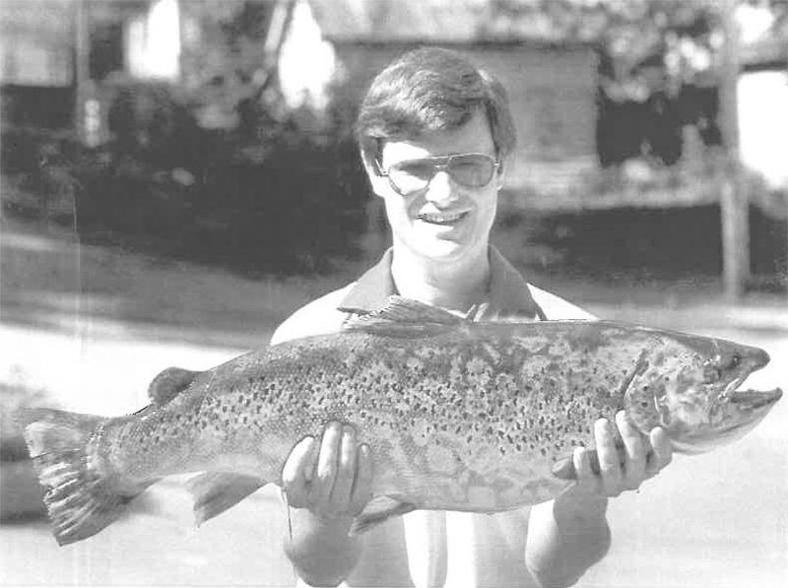
Above Left– Official State Record Brown Trout 14 lbs/12oz
Above right- Un- Official State Record Brown Trout 18 lbs / 11 oz

BELOW:
POSSIBLY THE 2ND LARGEST BROWN TROUT CAUGHT IN VIRGINIA?
SPRING RUN MAY 29, 2019
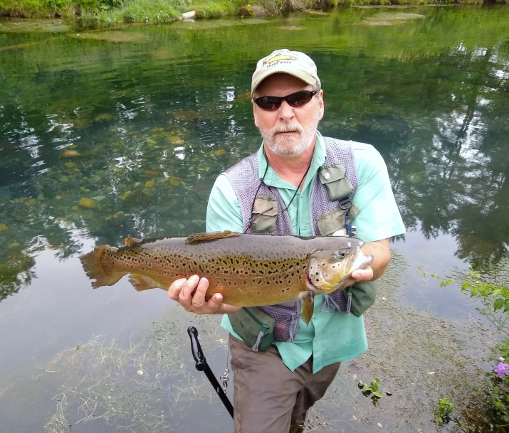
29 INCHES LONG/26-28 INCH CIRCUMFERENCE
ESTIMATED WEIGHT?- 14 POUNDS PLUS? 15 MAYBE?
BELOW- SPRING RUN RAINBOW MAY 2, 2017
LENGTH 28 INCHES 9 POUNDS (ESTIMATED WEIGHT) VIRGINIA CITATION
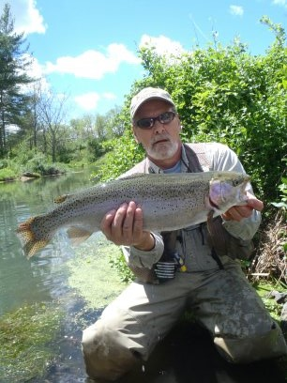
SPRING RUN RAINBOW MAY 2014
SZ 14 SOW BUG ON 5X FLOUROCARBON

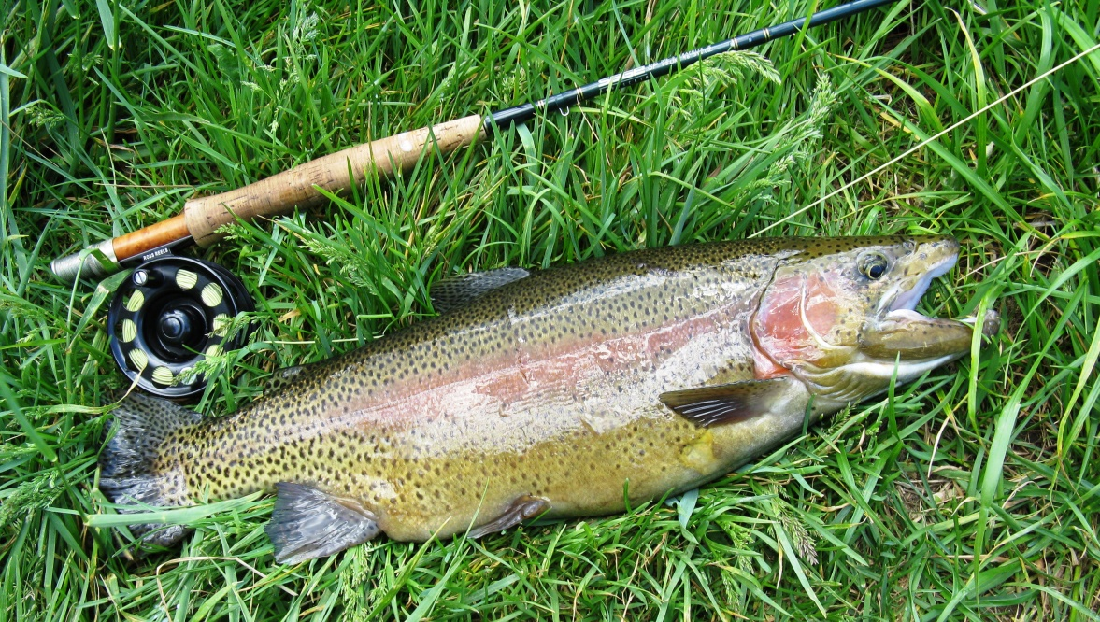

CHAPTER IV…………………………………………..COMING SOON……………………………………..

