CHUBBY’S MOORMAN’S MIDGE SIZE 22 CIRCA 2002

IMITATES MIDGES AND SMALL BWO’S

HOOK- SIZE 22 DRY FLY HOOK OF YOUR CHOICE
THREAD- OLIVE 6/0
BODY- 4-5 STRANDS OF BROWN PHEASANT TAIL
HACKLE- 3 INCH PIECE OF NATURAL GRIZZLY HACKLE – SMALL

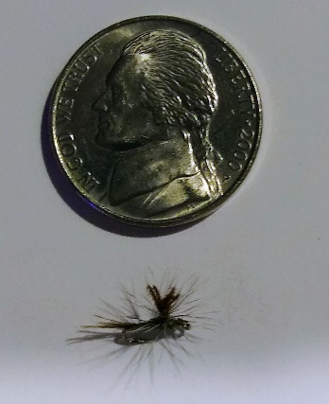

RECIPE:
1- START THE THREAD ABOUT 1/8 INCH BEHIND THE EYE AS SHOWN IN PIC 1
2- ATTACH 4-5 STRANDS OF BROWN PHEASANT TAIL FIBERS AS SHOWN IN PIC 2 WITH A SHORT TAIL STICKING PAST THE HOOK BEND
3- WRAP THE THREAD UP THE SHANK TO THE STARTING POINT OVER THE PT FIBERS, KEEP THE ABDOMEN THIN AS SHOWN IN PIC 3
4- STAND THE END OF THE PT FIBERS UPRIGHT TO FORM THE HACKLE POST AS SHOWN IN PIC 4
5- START THE HACKLE WRAPS AS SHOWN IN PIC 4 AND USE 3-4 CLOCKWISE WRAPS TO FORM THE WING
6- TIE OFF WITH 3 HALF HITCHES OR WHIP FINISH AND TRIM POST TO ABOUT 3/16 INCH TALL

PIC 3 TOP LEFT BELOW
PIC 4 TOP RIGHT BELOW
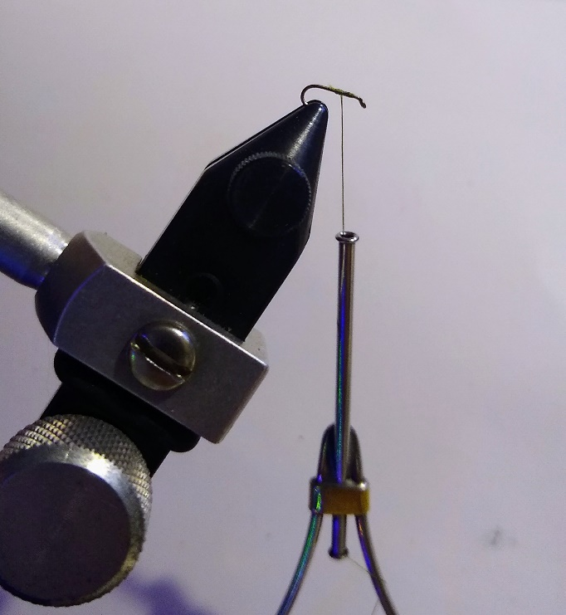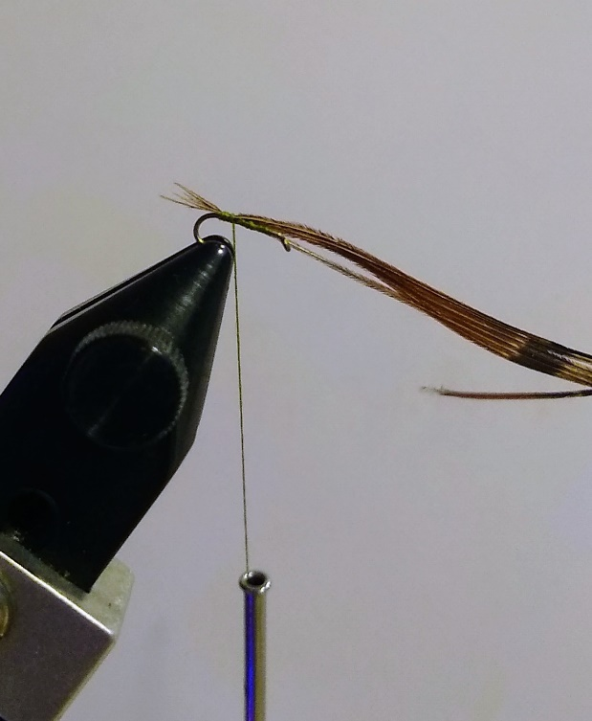

PIC 4

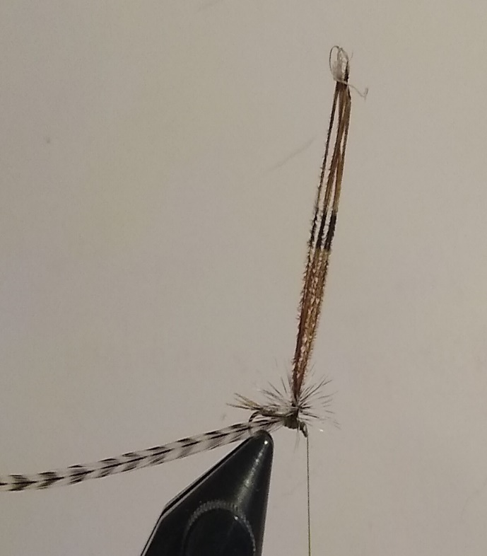

CHUBBY’S SPARKLE MIDGE EMERGER SIZE 22 CIRCA 2001
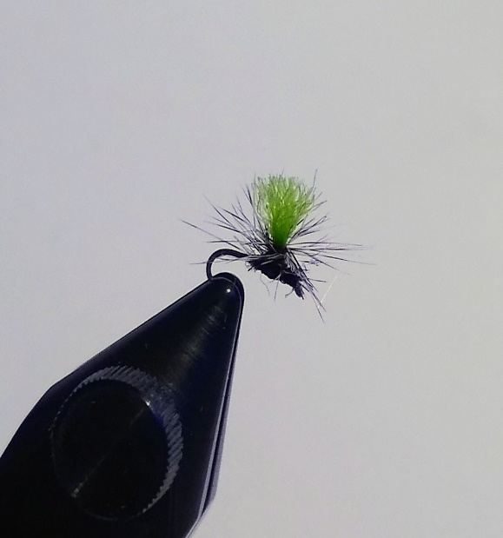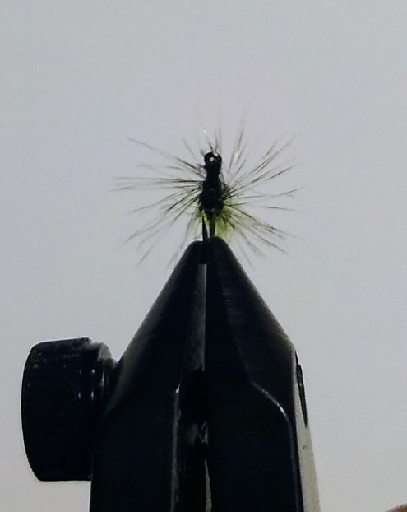

MATERIALS:
HOOK- SIZE 22 DRY FLY HOOK OF YOUR CHOICE (ALSO TIED IN SZS 24/26)
THREAD- BLACK OR OLIVE 6/0
POST- 3/16-INCH-THICK STRAND OF FLOURESCENT GREEN ANTRON YARN
HACKLE- 3 INCH PC OF NATURAL GRIZZLY HACKLE- SMALL

RECIPE:
1-START THE THREAD ABOUT 1/8 INCH BEHIND THE EYE AND WRAP THE HOOK SHANK AS THINLY AS POSSIBLE RETURNING TO THE STARTING POINT AS SHOWN IN PIC 1
PIC 1
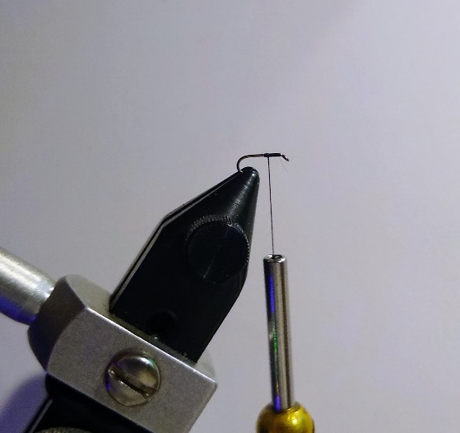

2-TAKE A 3/16 INCH THICK PC OF FLOURESCNCENT GREEN ANTRON ATTACH TO THE HOOK AT THE POINT THE THREAD IS STARTED AND AFTER SECURING IT WITH THREAD WRAPS STAND THE ANTRON UP TO FORM THE POST AS SHOWN IN PIC 2
3- PREP AND ATTACH A 3 INCH PC OF NATURAL GRIZZLY HACKLE AS SHOWN IN PIC 3, A SLIGHTLY OVERSIZED HACKLE FOR THE 22 HOOK IS OK
PIC 2 LEFT BELOW
PIC 3 RIGHT BELOW
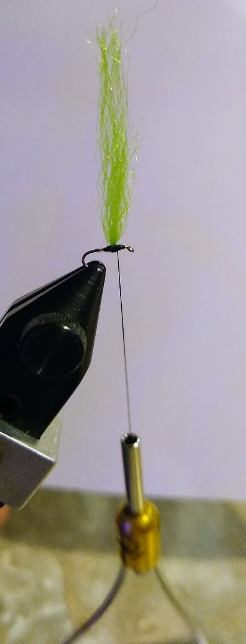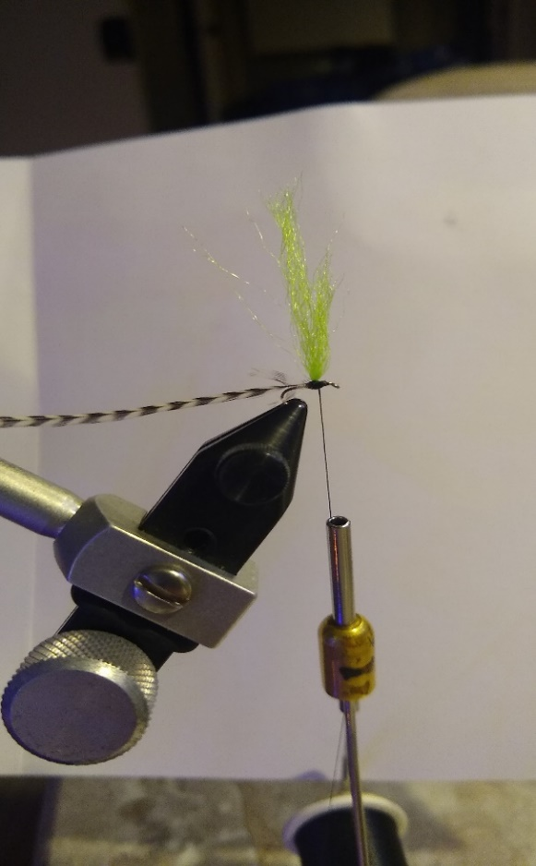
CHUBBY’S HACKLE MIDGE SIZE 22- NOT SHOWN
PIC COMING
THIS PATTERN IS JUST AS IT SAYS, A HACKLE MIDGE

DRY FLY HOOK-SIZES 22/24/26
1- USING THE COLOR OF THREAD NEEDED TO IMITATE THE MIDGES YOU ARE TYING START THE THREAD ABOUT 1/8 INCH BEHIND THE EYE AND ONLY COVER THAT AREA AS SHOWN IN PIC 1 ABOVE FOR THE SPARKLE MIDGE EMERGER.
2- AS IN PIC 2 ABOVE SHAPE THE THORAX WITH THREAD WRAPS
3- ATTACH THE HACKLE TO THE THORAX AND WRAP CLOCKWISE 3-4 WRAPS FINISHING JUST BEHIND THE EYE CATSKILLS STYLE, TIE OFF AND TRIM EXCESS MATERIALS. IN LOWER FLOWS WITH PICKY TROUT TRIM THE BOTTOM OF THE HACKLE OFF SO THAT THE FLY SITS FLUSH TO THE SURFACE.

