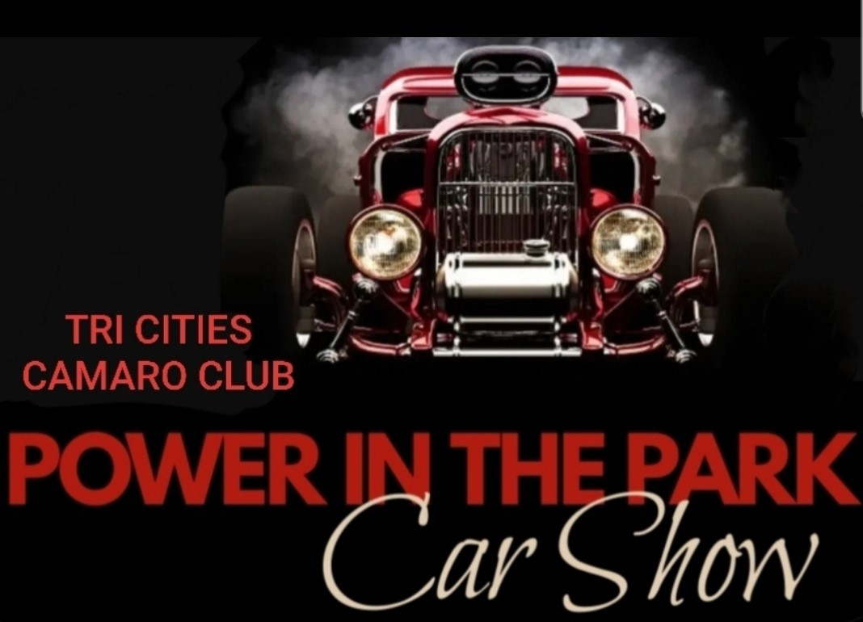

**ENTRY $20.00** COLUMBIA PARK, KENNEWICK

SUNDAY, SEPTEMBER 21, 2025

ALL CARS, TRUCKS, MOTORCYCLES WELCOME

NAME:

ADDRESS:

CITY: STATE: ZIP:

EMAIL: CELL#

YEAR/MAKE/MODEL:

FEATURES/COLOR:

CLUB AFFILIATION:

**T-SHIRT $25** S_____ M_____ L_____ XL_____ 2XL_____ 3XL_____

CHECK HERE IF “WOMAN DRIVEN/WOMAN OWNED”

CHECK HERE IF “TEEN DRIVEN”

CHECK HERE IF POWER WHEELS OR REMOTE CONTROL

In consideration of the acceptance of the right to participate, entrants, participants

and spectators, by execution of this entry form, release and discharge the City of

Kennewick and the TriCities Camaro Club from any and all known and unknown

damage, injuries, judgements and/or claims from any cause whatsoever that may

be suffered by any entrant to his/her property or being at this event. I also consent

to the use of pictures and names taken in connection with this event for publicity,

advertising or commercial purposes (including newspapers, radio, magazine,

television and any/all forms of social media).

SIGNATURE DATE