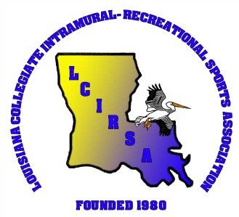**LCIRSA State Tournament**  
 **Official Information**

|  |
| --- |
| Sport: |

|  |  |  |
| --- | --- | --- |
| Name: | | School: |
| Address: | | |
| Phone: | Age: | Year in school: |
| Intramural Experience: | | |
|  | | |
| Off-Campus Experience: | | |
|  | | |
| State/National Experience: | | |
|  | | |
| TShirt Size: | | |
|  | | |

|  |  |
| --- | --- |
| **Official's Certifications** | |
| High School Association: | How long? |
| College Association: | How long? |
| Officiating Strengths: | |
|  | |
| Officiating Weaknesses: | |
|  | |

If more than one official is being sent from your school, please assign a rank to this person with "#1" being the best. _____