|  |  |  |
| --- | --- | --- |
| **Thursday – April 26, 2018** | | |
| **11:00am** | Kent Adams Golf Tournament | Oak Knoll Country Club |
| **2:00pm** | Gnarly Barley Brew Tour | Gnarly Barley Brewing Co. |
| **7:00pm** | Directors’ Dinner | Brady’s |
| **8:30-10:00pm** | LCIRSA Networking opportunity | Brady’s |
| **Friday – April 27, 2018** | | |
| **9:00am-12:00pm** | Tournament Registration | Victory Lounge - Strawberry Stadium |
| **10:00am-12:00pm** | LCIRSA Business Meeting | Victory Lounge - Strawberry Stadium |
| **12:00pm-1:30pm** | Directors’ Lunch (deadline for registration) | Salty Joe’s |
| **1:30pm-2:00pm** | LCIRSA Business Meeting | Victory Lounge - Strawberry Stadium |
| **2:00pm-3:00pm** | Tournament Committee Meetings | Victory Lounge - Strawberry Stadium |
| **2:00pm-5:00pm** | Fitness Roundtable | Pennington Center Room 107 |
| **5:00pm** | Basketball Officials Clinic/Meeting  (**All** basketball officials must attend) | Pennington Center Room 108 |
| **5:00pm** | Softball Officials Clinic/Meeting  (**All** softball officials must attend) | Pennington Center Room 107 |
| **5:00pm** | Soccer Officials Clinic/Meeting  (**All** soccer officials must attend) | Pennington Center Conference Room |
| **6:00pm** | Basketball Captains Meeting | Pennington Center Room 108 |
| **6:00pm** | Softball Captains Meeting | Pennington Center Room 107 |
| **6:00pm** | Soccer Captains Meeting | Pennington Center Conference Room |
| **Saturday – April 28, 2018** | | |
| **8:00am** | Basketball Officials Round-Up | Pennington Center |
| **8:00am** | Softball Officials Round-Up | North Oak Park |
| **8:00am** | Soccer Officials Round-Up | Soccer Field |
| **9:00am** | Basketball Pool Play Begins | Pennington Center |
| **9:00am** | Softball Pool Play Begins | North Oak Park |
| **9:00am** | Soccer Pool Play Begins | Soccer Field |
| **Sunday – April 29, 2018** | | |
| **8:00am** | Basketball Officials Round-Up | Pennington Center |
| **8:00am** | Softball Officials Round-Up | North Oak Park |
| **8:00am** | Soccer Officials Round-Up | Soccer Field |
| **9:00am** | Basketball Elimination Tournament Begins | Pennington Center |
| **9:00am** | Softball Elimination Tournament Begins | North Oak Park |
| **9:00am** | Soccer Elimination Tournament Begins | Soccer Field |

**Deadline for Team Registration is Friday, April 27 at NOON.**

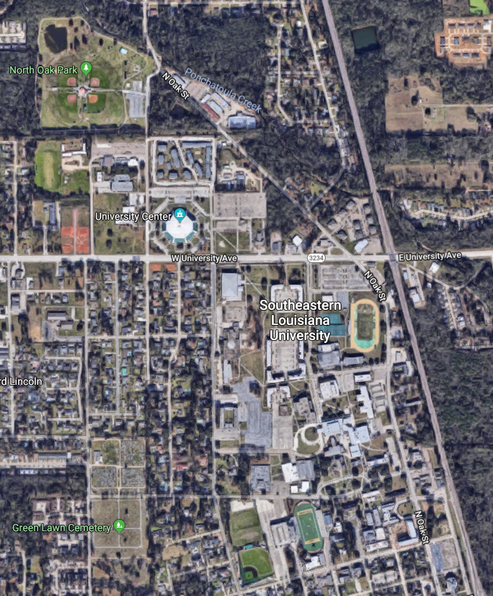

**N GENERAL PERSHING ST.**

**TORNADO DRIVE**

**SOCCER FIELD**

**VICTORY LOUNGE/PARKING GARAGE**

**PENNINGTON CENTER**

**NORTH OAK PARK**

* Pennington Center address is 1350 N General Pershing St. Hammond, LA 70402
* North Oak Park address is 2699 N Oak St, Hammond, LA 70401
* Soccer Field is on Tornado Drive – Tornado Dr. is a loop, the soccer field is on the NW corner.
* Victory Lounge/Strawberry Stadium is on Western Ave, Hammond, LA 70401
  + Park in the parking garage adjacent to the football stadium, take the elevator to the 5th floor.
* Oak Knoll Country Club address is 45246 Country Club Rd. Hammond, LA 70401
* Gnarly Barley Brewery address is 1709 Corbin Rd, Hammond, LA 70403
* Brady’s address is 110 SW Railroad Ave, Hammond, LA 70403
  + Brady’s is on the left side of Railroad Ave – park across the street next to the railroad tracks.