AP GOVERNMENT AND POLITICS: 2019 Review

Exam Date: May 6th at 7:30 am
Congratulations! You’ve made it through your AP U.S. Government course and are now ready to prepare for the AP Exam. These tips and strategies should help you in the final days or weeks before taking the exam. Remember that preparing for the Exam is a bit like training for a marathon--you won’t do as well if you wait and cram a lot of training into the day before the Exam. Working at a reasonable pace from now until test day will pay off in the end.

The Format of the Exam: Let’s begin by looking at a breakdown of how the AP US Government
Exam is structured:
Questions | Time allowed | Percentage of grade
55 multiple choice | 1 hour & 20 minutes | 50%
3 free response and Argumentative Essay | 1 hour & 40 minutes | 50%

The questions on the test will cover topics from the whole course. However, in the multiple-choice section, you’ll find that certain subjects come up more often:
Subject Percentage of the Test Government Institutions 35 to 40%
(Congress, presidency, courts, bureaucracy)
Political Behavior of Individuals 10 to 20%
(political culture, public opinion, voting)
Political Behavior of Groups 10 to 20%
(political parties, elections, interest groups, PACs, and mass media)
Constitutional Foundations 5 to 15%
(federalism, checks & balances, separation of powers, theories of democracy)
Civil Liberties and Civil Rights 5 to 15%

There are 15 Required Supreme Court Cases:

Marbury v. Madison
McCulloch v. Maryland
Schenck v. US
Brown v. Board of Ed (1954)
Baker v. Carr
Engel v. Vitale
Gideon v. Wainright
Tinker v. DesMoines
NY Times Co. v. US
Wisconsin v. Yoder
Roe v. Wade
Shaw v. Reno
US. v. Lopez
McDonald v. Chicago
Citizens United v. FEC

Required Documents:

The Declaration of Independence
The Articles of Confederation
The Constitution of the United States
Federalist #10
Brutus #1
Federalist #51
Federalist #70
Federalist # 78
Letter from a Birmingham Jail

Unit 1: Foundations of American Democracy
The U.S. Constitution arose out of important historical and philosophical ideas and preferences regarding popular sovereignty and limited government. To address competing states’ visions for the allocation of governmental authority, compromises were made during the Constitutional Convention and ratification debates, and these compromises have frequently been the source of debate and negotiation in U.S. politics over the proper balance between federal and state power and between liberty and social order.
A balance between governmental power and individual rights has been a hallmark of American political development.
Explain how democratic ideals are reflected in the Declaration of Independence and the Constitution.
The U.S. government is based on ideas of limited government, including natural rights, popular sovereignty, republicanism, and social contract.  The Declaration of Independence, drafted by Jefferson with help from Adams and Franklin, provides a foundation for popular sovereignty, while the U.S. Constitution drafted at the Philadelphia Convention and led by George Washington, with important contributions from Madison, Hamilton, and members of the “Grand Committee,” provides the blueprint for a unique form of political democracy in the U.S. | Define:  natural rights  popular sovereignty  republicanism  social contract
Explain how models of representative democracy are visible in major institutions, policies, or debates in the U.S.

Representative democracies can take several forms along this scale:

Define:
Participatory democracy

Pluralist democracy

Elite democracy

Discuss the five Madisonian Principles of a representative democracy that continue to be reflected in contemporary institutions and political behavior.
Define and provide an example:
Federalism

Popular Sovereignty

Checks and Balances

Separation of Powers

Limited Government

The Constitution emerged from the debate about weaknesses in the Articles of Confederation as a blueprint for limited government.
Explain how Federalist and Anti-Federalist views on central government and democracy are reflected in U.S. foundational documents.

Madison’s arguments in Federalist No. 10 focused on the superiority of a large republic in controlling the “mischiefs of faction,” delegating authority to elected representatives and dispersing power between the states and national government. | What is a faction?  What is the source of factions?  How are factions controlled?
Anti-Federalist writings, including Brutus No. 1, adhered to popular democratic theory that emphasized the benefits of a small decentralized republic while warning of the dangers to personal liberty from a large, centralized government. | Why were the Anti-Federalists reluctant to sign the new Constitution?
Explain the relationship between key provisions of the Articles of Confederation and the debate over granting the federal government greater power formerly reserved to the states.

In other words, identify the problems in the Articles of Confederation and how they were corrected in the Constitution.

Compromises deemed necessary for adoption and ratification of the Constitution are represented by the:
Great (Connecticut) Compromise

Electoral College

Three-Fifths Compromise

Compromise on the importation of slaves

The Constitutional Basis of Federalism: Although the term federalism is not found in the Constitution, it is clearly defined in the enumerated, concurrent and reserved powers of the national and state governments.

Interstate relations: Describe the general obligations that each state has to every other state under the Constitution.
The Commerce Clause & the Elastic Clause have played key roles in the expansion of Federal power. Be able to give examples.
Enumerated powers

Implied powers

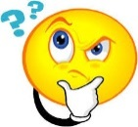
Inherent powers

Reserved powers

- Full Faith and Credit Clause

- Privileges and Immunities Clause

- Extradition

The Constitution creates a complex competitive policy-making process to ensure the people’s will is represented and that freedom is preserved.
Explain the ideas represented in Federalist No. 51

Explain the implications of separation of powers and “checks and balances” for the U.S. political system.
Federalism reflects the dynamic distribution of power between the national and state governments.
Explain how societal needs affect the constitutional allocation of power between the national and state governments.
10th Amendment v. 14th Amendment
The distribution of power between federal and state governments to meet the needs of society changes, as reflected by grants, incentives, and aid programs, including federal revenue sharing, mandates, categorical grants, and block grants.
Fiscal Federalism: Define and provide an example for each.
Remember categorical grants have increased federal power because the states must comply with the regulations.

Grants-in-aid

Categorical Grants

Block Grants

Mandates

Explain how the appropriate balance of power between national and state governments has been interpreted differently over time.
Dual Federalism

Cooperative Federalism

The interpretation of the 10th and 14th Amendments, the commerce clause, the necessary and proper clause, and other enumerated and implied powers is at the heart of the debate over the balance of power between the national and state governments.

Commerce clause

The necessary and proper clause

The balance of power between the national and state governments has changed over time based on U.S. Supreme Court interpretation of such cases as:

McCulloch v. Maryland

United States v. Lopez

Key Federalism Legislation:

Unfunded Mandates Reform Act

Supplemental Nutrition Assistance Program

Temporary Assistance for Needy Families (TANF)

National Voter Registration Act (Motor Voter Act)

Clean Air Act

Americans with Disabilities Act

Brady Bill

No Child Left Behind Act

Unit 2: Interactions Among Branches of government
Because power is widely distributed and checks prevent one branch from usurping powers from the others, institutional actors are in the position where they must both compete and cooperate in order to govern.
The republican ideal in the U.S. is manifested in the structure and operation of the legislative branch.
Describe the different structures, powers, and functions of each house of Congress. | Senate | House of Representatives
The Senate is designed to represent states equally, while the House is designed to represent the population. | How is representation decided in the Constitution?
Different chamber sizes and constituencies influence formality of debate. | Senate | House of Representatives

Did you know: The enumerated and implied powers in the Constitution allow the creation of public policy by Congress, which includes:

- Passing a federal budget, raising revenue, and coining money
- Declaring war and maintaining the armed forces
- Enacting legislation that addresses a wide range of economic, environmental, and social issues based on the Necessary and Proper Clause
Explain how the structure, powers, and functions of both houses of Congress affect the policy making process.
Though both chambers rely on committees to conduct hearings and debate bills under consideration, different constitutional responsibilities of the House and Senate affect the policy-making process. |  | Identify and explain the four types of congressional committees:
Chamber-specific procedures, rules, and roles that impact the policy making include:
(Make sure you understand these procedures and their impact Define where necessary).

Number of chamber and debate rules that set the bar high for building majority support:

Roles of Speaker of the House, party leadership, and committee leadership in both chambers:

Filibuster

Cloture

Role of Rules Committee, Committee of the Whole, and discharge petitions in the House

Treaty ratification and confirmation role of the U.S. Senate

Congress must generate a budget that addresses both discretionary and mandatory spending, and as entitlement costs grow, discretionary spending opportunities will decrease unless tax revenues increase or the budget deficit increases. |  | Define and provide an example:  Discretionary spending  Mandatory spending
Pork barrel legislation and logrolling affect lawmaking in both chambers. |  | Define and explain:  Pork barrel legislation  Logrolling
Explain how congressional behavior is influenced by election processes, partisanship, and divided government.

Congressional behavior and governing effectiveness are influenced by:
(Define and Explain)

Ideological divisions within Congress

Gerrymandering

Redistricting

Reapportionment

Elections that have led to a “divided government”

Congressional refusal to confirm appointments of “lame duck” presidents of the opposite party

Different role conceptions of … as related to constituent accountability in each chamber:

Trustee model

Delegate model

These issue are partially addressed by such Court decisions:

Baker v. Carr

Shaw v. Reno

The presidency has been enhanced beyond its expressed constitutional powers.
 | Explain how the president can implement a policy agenda.  Presidents use powers and functions of the office to accomplish a policy agenda. Discuss the formal and informal powers of the president represented by: |  | Informal Powers |  | Formal Powers
Explain how the president’s agenda can create tension and frequent confrontations with Congress. |  |  | Cabinet  Ambassadors  White House Staff
Discuss the how the potential for conflict with the Senate depends upon executive appointments including:
Senate confirmation is an important check on appointment powers, but the president’s longest lasting influence lies in life-tenured judicial appointments. |  |  | Explain this statement:
Summarize Federalist No. 70
Term-of-office and constitutional-power restrictions, including the passage of the 22nd Amendment, demonstrate changing presidential roles. |  |  | 22nd Amendment
Discuss how the communication impact of the presidency can be demonstrated through such factors as:

- Modern technology, social media, and rapid response to political issues

- Nationally broadcast State of the Union messages and the president’s bully pulpit used as tools for agenda setting

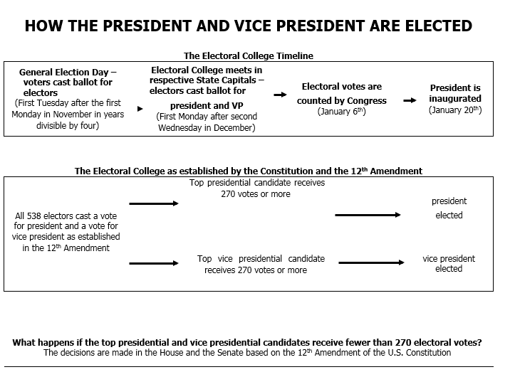
The federal bureaucracy is a powerful institution implementing federal policies with sometimes questionable accountability.
Explain how the bureaucracy carries out the responsibilities of the federal government.
Tasks performed by departments, agencies, commissions, and government corporations are represented by:
Explain how the bureaucracy interacts with the president and congress by:
- Writing and enforcing regulations

- Issuing fines

- Testifying before Congress

- iron triangles

Define and explain how political patronage, civil service, and merit system reforms all impact the effectiveness of the bureaucracy by promoting professionalism, specialization, and neutrality. |  |  | civil service  merit  Pendleton Act
Explain how the federal bureaucracy uses delegated discretionary authority for rule making and implementation.
 | Discretionary and rule-making authority to implement policy are given to bureaucratic agencies such as:  - Department of Homeland Security Department of Transportation  - Department of Veterans Affairs Department of Education  - Environmental Protection Agency  - Federal Elections Commission (FEC)  - Securities and Exchange Commission (SEC) |  | Independent Executive Agency  Define:  Example: | Independent Regulatory Commission  Define:  Example |  | Government Corporation  Define:  Example:
Explain how Congress uses its oversight power in its relationship with the executive branch.
Oversight and methods used by Congress to ensure that legislation is implemented as intended are represented by:

Committee hearings

Power of the purse

Discuss: As a means to curtail the use of presidential power, “congressional oversight” serves as a check of executive authorization and appropriation.
Explain how the president ensures that executive branch agencies and departments carry out their responsibilities in concert with the goals of the administration.

Explain the extent to which governmental branches can hold the bureaucracy accountable given the competing interests of Congress, the president, and the federal courts.

Judicial Branch: The design of the judicial branch protects the court’s independence as a branch of government, and the emergence and use of judicial review remains a powerful judicial practice.
Explain the principle of judicial review and how it checks the power of other institutions and state governments.

The foundation for powers of the judicial branch and how its independence checks the power of other institutions and state governments are set forth in:
The Supreme Court is insulated from public opinion

Article III of the Constitution

Federalist No. 78

Marbury v. Madison (1803)

Explain how the exercise of judicial review in conjunction with life tenure can lead to controversy about the legitimacy of the Supreme Court’s power.
Precedents and stare decisis play an important role in judicial decision making. | Define:  Stare Decisis  Precedent
Discuss how ideological changes in the composition of the Supreme Court due to presidential appointments have led to the Court’s establishing new or rejecting existing precedents.

Controversial or unpopular court decisions can lead to challenges of the court’s legitimacy and power which Congress and the president. Discuss how the President and Congress can change unpopular decisions…

future appointments

legislation changing the Court’s jurisdiction refusing to implement decisions

Constitutional Amendment

Political discussion about the Supreme Court’s power is illustrated by the ongoing debate over judicial activism versus judicial restraint. |  | Define and provide an example:  Judicial Activism |  | Define and provide an example:  Judicial Restraint
Explain how other branches in the government can limit the Supreme Court’s power.
What are the functions of amicus curiae briefs?

What is the difference between:

majority opinion

dissenting opinion

concurring opinion

Define:

Writ of Certiorari

Rule of Four

COURT | NUMBER OF COURTS | NUMBER OF JUDGES | JURISDICTION | POLICY IMPLICATIONS
District Court
Courts of Appeal
Supreme Court

Unit 3: Civil Liberties and Civil Rights
Through the U.S. constitution, but primarily through the Bill of Rights and the Fourteenth amendment, citizens and groups have attempted to restrict national and state governments from unduly infringing upon individual rights essential to ordered liberty and from denying equal protection under the law. Likewise, it has sometimes been argued that these legal protections have been used to block reforms and restrict freedoms of others in the name of social order.
Provisions of the U.S. Constitution’s Bill of Rights are continually being interpreted to balance the power of government ant the civil liberties of individuals.
Explain how the U.S. Constitution protects individual liberties and rights.

The U.S. Constitution includes a Bill of Rights specifically designed to protect individual liberties and rights.
Describe the rights protected in the Bill of Rights.

1st Amendment

2nd Amendment

4th Amendment

5th Amendment

6th Amendment

8th Amendment

9th Amendment

10th Amendment

Explain the extent to which the Supreme Court’s interpretation of the First and Second Amendments reflects a commitment to individual liberty.
The interpretation and application of the First Amendment’s establishment and free exercise clauses reflect an ongoing debate over balancing majoritarian religious practice and free exercise, as represented by such cases as: | Engel v. Vitale  Wisconsin v. Yoder
The Supreme Court has held that symbolic speech is protected by the First Amendment, demonstrated by | Tinker v. Des Moines Independent Community School District
Efforts to balance social order and individual freedom are reflected in interpretations of the First Amendment that limit speech, including: | Time, place, and manner regulations  Miller Test  Schenck v. US- Clear and Present Danger Test
In New York Times Co. v. United States (1971), the Supreme Court bolstered the freedom of the press, establishing a “heavy presumption against prior restraint” even in cases involving national security. | prior restraint
Explain how the Supreme Court has attempted to balance claims of individual freedom with laws and enforcement procedures that promote public order and safety.

Mapp v. Ohio- Exclusionary Rule

4th Amendment- Protection against warrantless searches & collection of meta data

Patriot Act

Freedom Acts:

Gideon v. Wainright

Court decisions defining cruel and unusual punishment involve interpretation of the Eighth Amendment and its application to state death penalty statutes. | Furman v. Georgia  Atkins v. Virginia  Roper v. Simmons
Protections of the Bill of Rights have been selectively incorporated by way of the Fourteenth Amendment’s “due process” clause to prevent state infringement of basic liberties.
Explain the implications of the doctrine of selective incorporation.
The doctrine of selective incorporation has imposed limitations on state regulation of civil rights and liberties as represented by: | Barron v. Baltimore  Gitlow v. NY  McDonald v. Chicago
Explain the extent to which states are limited by the due process clause from infringing upon individual rights. | 5th Amendment  6th Amendment  Miranda Rule
The Court has on occasion ruled in favor of states’ power to restrict individual liberty, as for example, which speech can be shown to increase the danger to public safety. | Example:
While a right to privacy is not explicitly named in the Constitution, the court has interpreted the due process clause to protect the right of privacy from infringement.  The interpretation of the due process clause has been the subject of controversy: | Due Process  Roe v. Wade
The 14th Amendment’s “equal protection clause” as well as other constitutional provisions have often been used to support the advancement of equality.
Explain how constitutional provisions have supported and motivated social movements. | Civil Rights Movement  (Letter from a Birmingham Jail) |  | Women’s Rights Movement |  | LGBT Rights Movement
Civil rights protect individuals from discrimination based on characteristics such as race, national origin, religion, and sex; these rights are guaranteed to all citizens under the due process and equal protection clauses of the U.S. Constitution, as well as acts of Congress. | Rational Basis |  | Intermediate Scrutiny |  | Strict Scrutiny

Public policy promoting civil rights is influenced by citizen-state interactions and constitutional interpretation over time.
Explain how the government has responded to social movements.
The government can respond to social movements through court rulings and/or policies.

Brown v. Board of Education

The Civil Rights Act of 1964

Title IX of the Civil Rights Act Amendments (1972)

The Voting Rights Act of 1965

Explain how the Court has at times allowed the restriction of the civil rights of minority groups and at other times has protected those rights.

(Consider state laws & Supreme Court holdings)
The debate on affirmative action includes justices who insist that the Constitution is colorblind and those who maintain that it forbids only racial classifications designed to harm minorities, not help them. |  | Bakke v. California
Unit 4: American Political Ideologies and Beliefs. American political beliefs are shaped by founding ideals, core values, linkage institutions, political parties, interest groups and the media.
Did you know that polls repeatedly report that a majority of Americans disapprove of the job Congress is doing?
Explain the relationship between core beliefs of U.S. citizens and attitudes about the role of government.
Explain how cultural factors influence political attitudes and socialization.

Public opinion is measured through scientific polling, and the results of public opinion polls influence public policies and institutions.
Describe the elements of a scientific poll.

Public opinion data that can impact elections and policy debates is affected by such scientific polling types and methods as: | opinion polls  tracking polls  entrance and exit polls
Explain the quality and credibility of claims based on public opinion data.
Explain the relationship between scientific polling and elections and how policy debates are affected by the:
- Importance of public opinion as a source of political influence in a given election or policy debate

- Reliability and veracity of public opinion data

Widely held political ideologies shape policy debates and choices in American policies.
Explain how ideologies of the two major parties shape policy debates.  America’s political culture does support economic opportunity, it does NOT support economic equality | Democratic Party | Republican party
 | Economic:  Social:  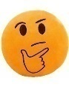 | Economic:  Social:
Explain how U.S. political culture (e.g., values, attitudes, and beliefs) influences the formation, goals, and implementation of public policy over time.

Unit 5: Political Participation
Governing is achieved directly through citizen participation and indirectly through institutions (e.g., political parties, interest groups, and mass media) that inform, organize, and mobilize support to influence government and politics, resulting in many venues for citizen influence on policy making.
Factors associated with political ideology, efficacy, structural barriers, and demographics influence the nature and degree of political participation.
Describe the voting rights protections in the Constitution and in legislation and be able to explain how this increased voter participation.

15th Amendment

17th Amendment

19th Amendment

24th Amendment

26th Amendment

Discuss how structural barriers, political efficacy, and demographics can predict differences in voter turnout in the U.S., and the following can influence voter turnout among democracies worldwide:

Define: political efficacy

- National versus state-controlled elections

- Voter registration laws and procedures

- Voting incentives or penalties or fines

- Election type (mid-term or presidential)

Discuss the demographic characteristics and political efficacy or engagement are used to predict the likelihood of whether an individual will vote.
Discuss the factors influencing voter choice include:

Party identification and ideological orientation

Candidate characteristics

Contemporary political issues

Religious beliefs or affiliation, gender, race and ethnicity, and other demographic characteristics

Political parties, interest groups, and social movements provide opportunities for participation and influence how people relate to government and policy-makers.
Linkage institutions are channels that allow individuals to communicate their preferences to policy-makers.

Identify the four linkage institutions and provide an example for each one.

Explain the function and impact of political parties on the electorate and government.

The functions and impact of political parties on the electorate and government are represented by:
- Mobilization and education of voters

- Party platforms

- Candidate recruitment

- Campaign management, including fundraising and media strategy

Explain how parties have adapted to candidate-centered campaigns, and their role in nominating candidates has been weakened

Explain how the structure of parties has been influenced by:

Regional realignments

Campaign finance law

Changes in communication and data-management technology

Citizens United v. FEC

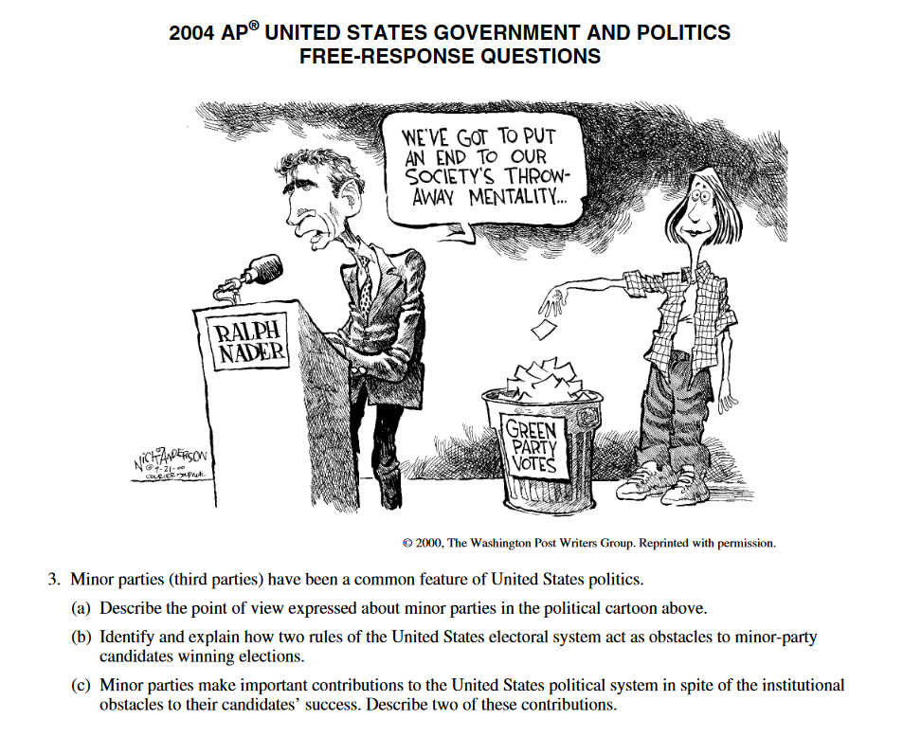
Explain how structural barriers impact third-party and independent-candidate success.

Explain: In comparison to proportional systems, winner-take-all voting districts serve as a structural barrier to third-party and independent candidate success.
Discuss the role Interest groups play in policy making.

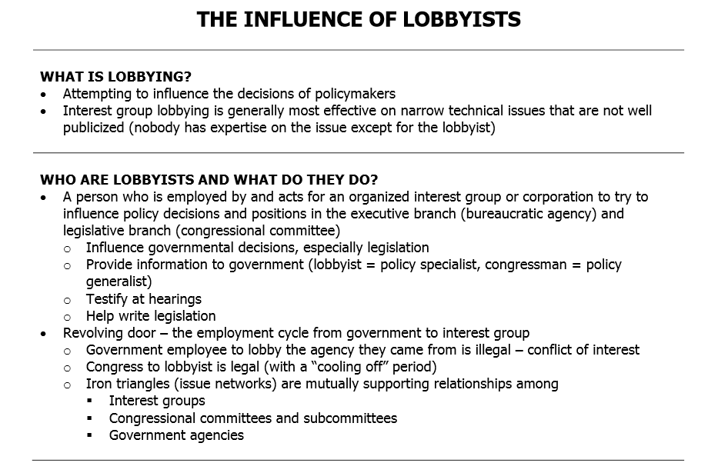
In addition to working within party coalitions, interest groups exert influence through long-standing relationships with bureaucratic agencies, Congressional committees, and other interest groups; such relationships are described as “iron triangles” and issue networks and they help interest groups exert influence across political party coalitions.  Draw and example to illustrate your point. | Discuss the role of an iron triangle in policy making.
Explain how variation in types and resources of interest groups affects their ability to influence elections and policy making.

Discuss how Interest group influence may be impacted by:
- Inequality of resources

- Unequal access to decision makers

- “Free rider” problem

Explain how various political actors influence public policy outcomes.

Provide an examples of Single-issue groups, ideological/social movements, and protest movements form with the goal of impacting society and policy making.

Be sure to know the difference between monetary policy and fiscal policy. Monetary policy refers to the money supply and interest rates. Fiscal policy refers to taxing and spending policies. Both the executive and legislative branches share responsibility for fiscal policies.

The impact of federal policies on campaigning and electoral rules continues to be contested by both sides of the political spectrum.
Explain how the different processes work in a U.S. presidential election. The process and outcomes in U.S. presidential elections are impacted by:

Incumbency advantage phenomenon

Open primaries

Closed primaries

Caucuses

Party conventions

General (presidential) elections

The Electoral College

Evaluate the extent to which the Electoral College facilitates or impedes democracy.
Explain how the winner-take-all allocation of votes per state (except Maine and Nebraska) under the setup of the Electoral College compared with the national popular vote for president raises questions about whether the Electoral College facilitates or impedes democracy.
Explain how the different processes work in a U.S. Congressional election.

Explain how campaign organizations and strategies affect the election process.
Federal legislation and case law pertaining to campaign finance demonstrate the ongoing debate over the role of money in political and free speech, as set forth in:

Buckley v. Valeo

Bipartisan Campaign Reform Act of 2002 (McCain Feingold Act)

Citizens United v. Federal Election Commission

Discuss the debates have increased over free speech and competitive and fair elections related to money and campaign funding (including contributions from individuals, PACs and political parties).

The various forms of media provide citizens with political information and influence the ways in which they participate politically.
Explain the media’s role as a linkage
institution.

Discuss the media’s use of polling results to convey popular levels of trust and confidence in government can impact elections by turning such events into “horse races” based more on popularity and factors other than qualifications and platforms of candidates.
Explain how increasingly diverse choices of media and communication outlets influence political institutions and behavior.

Top 10 Acts of Congress

1. Civil Rights Act of 1964

2. The Voting Rights Act of 1965

3. The Clean Air Act (1970)

4. The War Powers Resolution (1973)

5. The Budget & Impoundment Control Act of 1974

6. The Federal Election Campaign Act (1974)

7. Americans with Disabilities Act (1990)

8. Welfare Reform Act (1976)

9. No Child Left Behind Act (2001)

10. USA Patriot Act (2001)

This Versus That
1. Nomination vs. General Election
2. Primary vs. Caucus
3. Closed Primary vs. Open Primary
4. Liberal vs. Conservative
5. Democrat vs. Republican
6. Major Party vs. Third Party (not the same as Independent)
7. Realignment vs. Dealignment
8. Reapportionment vs. Redistricting
9. Political Parties vs. Interest Groups
10. Judicial Restraint vs. Judicial Activism
11. Original Intent vs. “Living” Constitution
12. District Courts vs. Supreme Court
13. Appellate Jurisdiction vs. Original Jurisdiction
14. National Government vs. States’ Rights
15. Dual Federalism vs. Cooperative Federalism
16. Block Grants vs. Categorical Grants
17. Full Faith & Credit vs. Privileges & Immunities
18. Writ of Certiorari vs. Writ of Habeas Corpus
19. Civil Liberties vs. Civil Rights
20. Equal Protection Clause vs. Due Process Clause
21. Establishment Clause vs. Free Exercise Clause
22. Separation of Powers vs. Checks and Balances
23. Nomination vs. Confirmation
24. Impeachment vs. Conviction (Removal)
25. Formal Amendment vs. Informal Amendment
26. Proposing an Amendment vs. Ratification of an Amendment
27. Necessary & Proper Clause vs. Commerce Clause
28. Delegated Powers vs. Reserved Powers
29. Delegated Powers vs. Implied Powers
30. Enumerated Powers vs. Inherent Powers
31. Formal Powers vs. Informal Powers
32. Executive Agreement vs. Executive Order
33. Office of Management and Budget vs. Congressional Budget Office
34. White House Staff vs. Executive Office of POTUS
35. Congressional Caucus vs. Nominating Caucus
36. Congressional Caucus vs. Congressional Committee
37. Majority Leader vs. Majority Whip
38. President of Senate vs. Senate President Pro Tem
39. Casework vs. Pork Barrel
40. Standing Committee vs. Conference Committee

