Applying the Models of Democracy

LOR-1.B. Explain how models of representative democracy are visible in major institutions, policies, events, or debates in the U.S.

For this activity, you will see a series of images, quotations and scenarios. For each, you should identify which of the models of democratic government is most visible and explain why you chose that model. You will work with the people in your table group to complete this activity.

The models you will identify are: participatory model of democracy, pluralist model of democracy or elite model of democracy (if you believe that hyperpluralism is an option, you may also choose that model)
- A political cartoon is a type of drawing used to present opinions, comments, or criticisms of a situation, person, or event. Cartoons help us understand information by presenting it in a visual and memorable way. Cartoonists use many different techniques to achieve their goals:
  - Caricature - exaggerating one or more physical features - a large mouth to show someone who often speaks out on an issue.
  - Symbols - using a recognizable item to communicate an idea - an elephant to represent the Republican Party.
  - Caption - having the characters speak or summarizing the message in a few words above or below the cartoon.
These cartoons are also available in the folder on our table in larger format.
Cartoon | Cartoonist’s Point of View | Democratic Model | Explanation of your choice
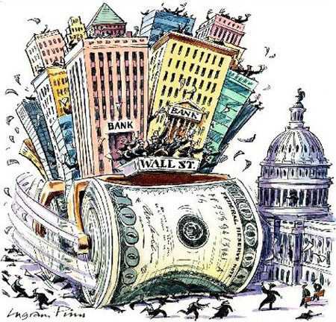 | Wall Street has more influence than regular people with Congress (shows Wall Street as a steamroller running over people in front of the Capitol) | Elitism | This shows elitism because the implication is that decisions are being made by the financial elite rather than through a more pluralistic model of policymaking.
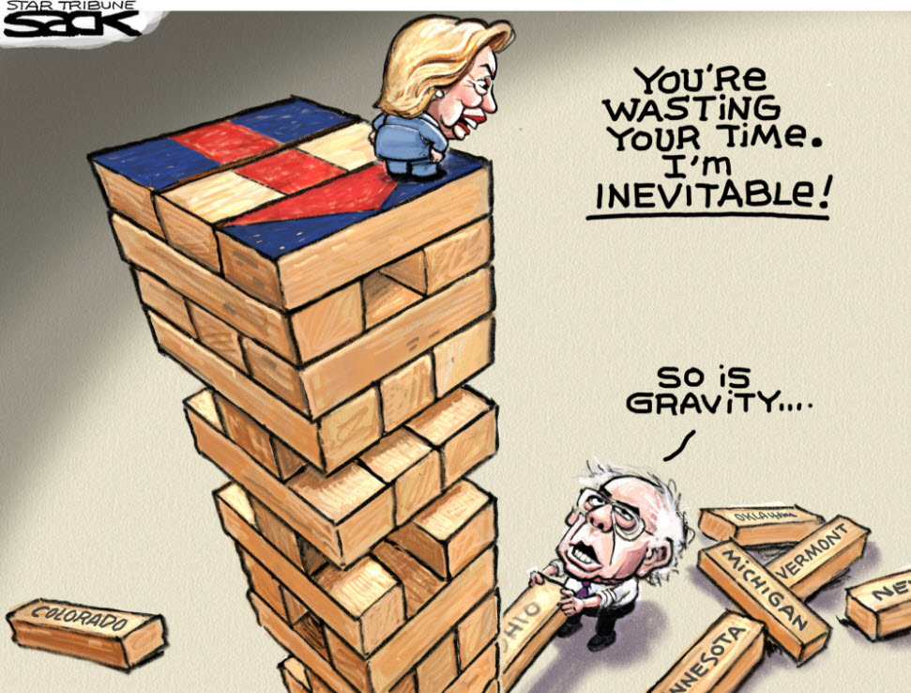 | Bernie Sanders is trying to chip away at Hilary Clinton’s dominance in the primary process due to her name recognition and connections. | Elitism OR Participatory Democracy | This shows elitism through an interpretation that Clinton is the elite’s choice and therefore she will win the nomination.  It shows participatory democracy by showing the votes of people in states for delegates to the nomination - the people’s participation is undermining her inevitability.
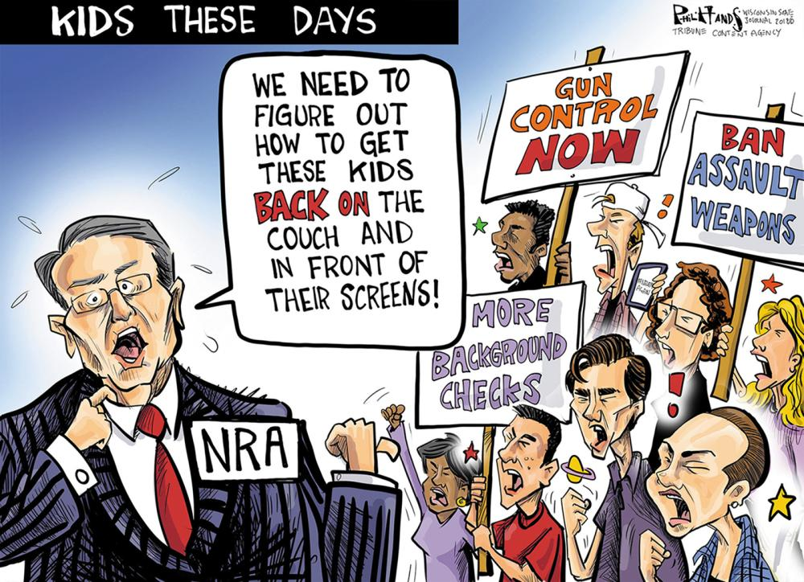 | The NRA feels threatened by the student protests and public outcries about school shootings. | Participatory democracy or Elitism | The children protesting and making the NRA head nervous with their protests shows the potential power of participatory democracy.  On the other hand, the NRA appears to be directing policy about this issue without participation by other interest groups.
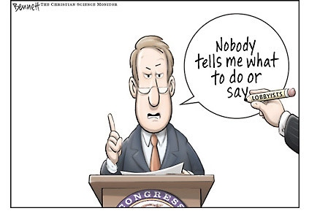 | The member of Congress is being portrayed as a puppet to interest groups. | Pluralism or Hyperpluralism | This could be interpreted as pluralism because policy is being made through the input of many different groups; or hyperpluralism because the groups are essentially controlling the congressman but to the extent that nothing gets done.
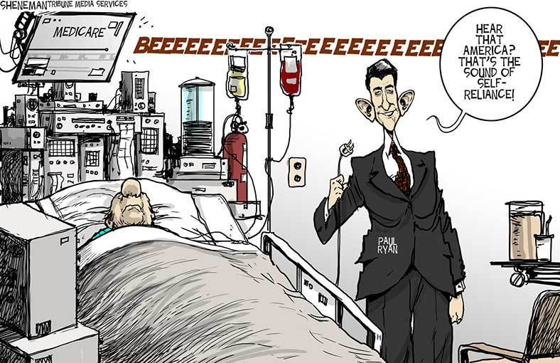 | The Republican Speaker of the House, Paul Ryan, is pulling the plug on Medicare funding, citing his reasoning from a typical conservative ideological position about self-reliance. | Elitism | The cartoon implied elitism with a perspective that the parties in congress are making this decision without regard for public opinion or interest groups.
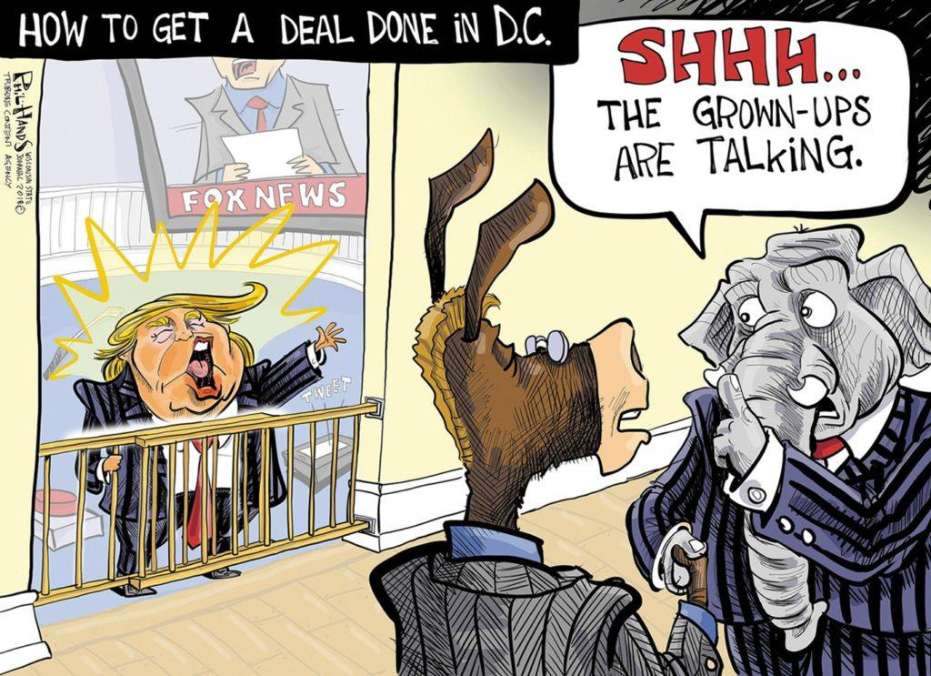 | The cartoonist implies that the president is underdeveloped in the arena of policymaking and how it is done. It portrays him as a toddler. | Elitism | Elitism is reflected because the political parties with experience in Washington (the elites/old guard) are making policy the ways that they always have, without regard to the opinions of the president.
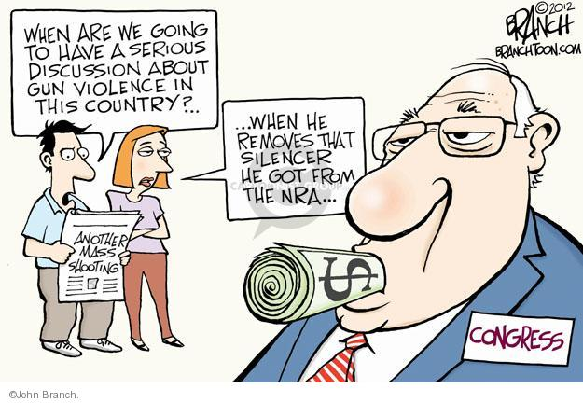 | The cartoonist implies that Congress won’t listen to the people because they are bankrolled by the NRA. | Participatory democracy or elitism. | This reflects participatory democracy with the people trying to voice their opinions through the media and their conversation. It reflects elitism through the implication that Congress is “bought” by one interest group who directs all policy in this policy area.

Quotations:
Quotation | Democratic Model | Explanation
The most important question that was ever proposed to your decision, or to the decision of any people under heaven, is before you, and you are to decide upon it by men of your own election, chosen specially for this purpose. --Brutus 1 | Participatory democracy | The people are being given the opportunity to specifically choose who they want to vote on the issue of ratification.
Each State shall appoint, in such Manner as the Legislature thereof may direct, a Number of Electors, equal to the whole Number of Senators and Representatives to which the State may be entitled in the Congress: but no Senator or Representative, or Person holding an Office of Trust or Profit under the United States, shall be appointed an Elector. --Constitution, Article 2.1 | Elite theory | This part of the constitution references the electoral college which acts as a mediating influence on the people’s votes for president; substituting that vote with those chosen by the legislatures for this task.
The House of Representatives shall be composed of Members chosen every second Year by the People of the several States, and the Electors in each State shall have the Qualifications requisite for Electors of the most numerous Branch of the State Legislature. --Constitution, Article 1.1 | Participatory democracy | This is one of the only affirmative mentions that the people will vote for representatives in the Constitution.
The instability, injustice, and confusion introduced into the public councils, have, in truth, been the mortal diseases under which popular governments have everywhere perished --Federalist 10 | Participatory democracy | Madison is warning against the dangers of allowing the majority of the people to make the rules because it will lead to instability, injustice and confusion if the people are too involved in the process.
The influence of factious leaders may kindle a flame within their particular States, but will be unable to spread a general conflagration through the other States. A religious sect may degenerate into a political faction in a part of the Confederacy; but the variety of sects dispersed over the entire face of it must secure the national councils against any danger from that source. A rage for paper money, for an abolition of debts, for an equal division of property, or for any other improper or wicked project, will be less apt to pervade the whole body of the Union than a particular member of it; in the same proportion as such a malady is more likely to taint a particular county or district, than an entire State. --Federalist 10 | Pluralism | Having many factions will cure against the evils of one particularly strong faction (group). The system sets up divisions that prevent any group from becoming too solidified and able to wreak havoc over the whole.
--That whenever any Form of Government becomes destructive of these ends, it is the Right of the People to alter or to abolish it, and to institute new Government, laying its foundation on such principles and organizing its powers in such form, as to them shall seem most likely to effect their Safety and Happiness. --Declaration of Independence | Participatory | Jefferson’s justification for revolution - if the people’s rights are not protected, the people have the right to form a new contract.

Scenarios:
Scenario | Democratic Model | Explanation
During the 1760’s and 1770’s, Great Britain began taxing some items sold in the colonies, including paper, tea and glass. Some colonists protested these policies by boycotting British goods. | Participatory | Boycotts/protests by the people
Delegates to political party conventions nominate the candidate for president from their party, sometimes using the votes of Superdelegates, who are elected party officials, to steer the nomination in the direction they prefer.. | Elite theory | Superdelegates are an elite group within the party who can steer a nomination away from the people’s choices.
Faced with repeated communications from their constituents and numerous interest group pressures, Congress passes an immigration reform bill. | Pluralism | This references the impact of a variety of interests in effecting policy change.
Knowing through her work in the local chapter of the NAACP that Black leaders were looking for a test case to take to the Supreme Court to challenge Jim Crow laws, a black woman refused to give up her seat in the whites-only section of the bus, sparking a successful bus boycott and providing momentum to the civil rights movement. | Pluralism | Rosa Parks helped an interest group bring about change by using the legal system to bring a case. She did not act alone.
Disturbed by a series of violent encounters between police officers and African Americans, an NFL football player decided to take a knee during the National Anthem as a sign of protest against institutional racism in governmental agencies. His actions set off similar actions by others in both the professional and collegiate sports realms and has filtered down to some high school venues as well. | Participatory | Professional athletes are trying to bring attention to an issue without the help of interest groups or elites.

When you complete this activity and submit it, you have one more task to show your understanding of this concept. Click here to complete an activity with more recent scenarios. Type in the comments on this assignment to let me know you have completed the other so I will look for your submission.

