Applying the Models of Democracy

LOR-1.B. Explain how models of representative democracy are visible in major institutions, policies, events, or debates in the U.S.

For this activity, you will see a series of images, quotations and scenarios. For each, you should identify which of the models of democratic government is most visible and explain why you chose that model. You will work with the people in your table group to complete this activity.

The models you will identify are: participatory model of democracy, pluralist model of democracy or elite model of democracy
- A political cartoon is a type of drawing used to present opinions, comments, or criticisms of a situation, person, or event. Cartoons help us understand information by presenting it in a visual and memorable way. Cartoonists use many different techniques to achieve their goals:
  - Caricature - exaggerating one or more physical features - a large mouth to show someone who often speaks out on an issue.
  - Symbols - using a recognizable item to communicate an idea - an elephant to represent the Republican Party.
  - Caption - having the characters speak or summarizing the message in a few words above or below the cartoon.
These cartoons are also available in the folder on our table in larger format.
Cartoon | Cartoonist’s Point of View | Democratic Model | Explanation of your choice
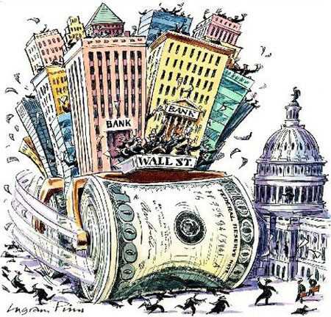
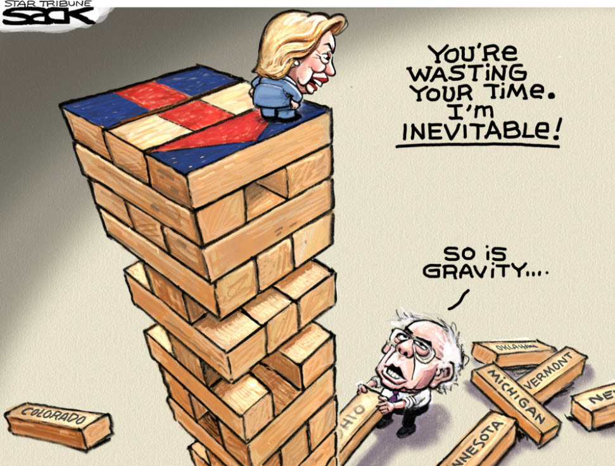
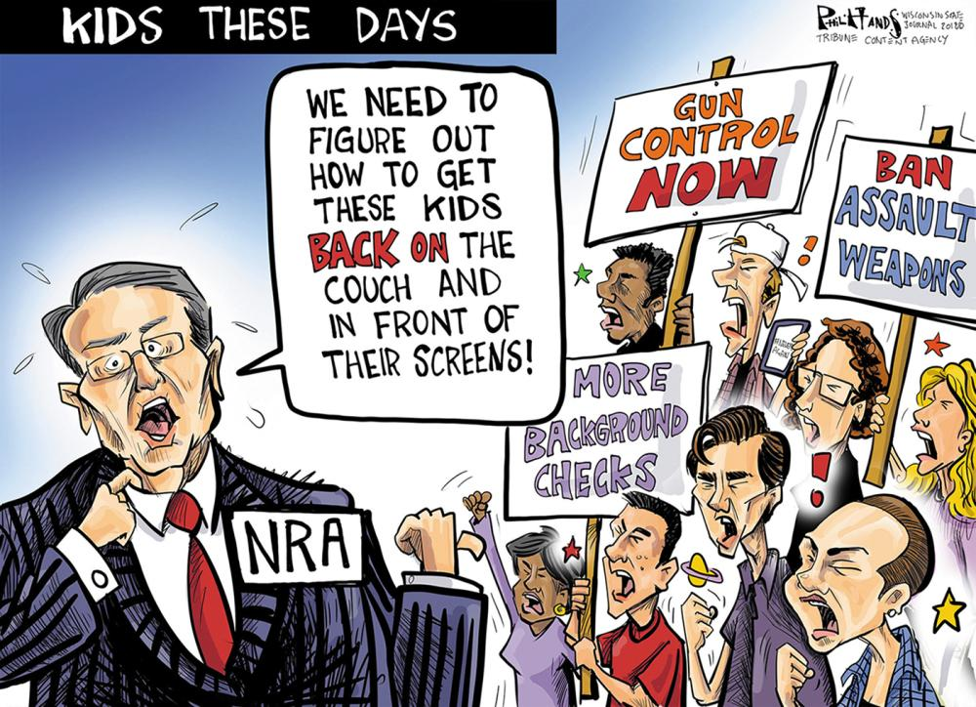
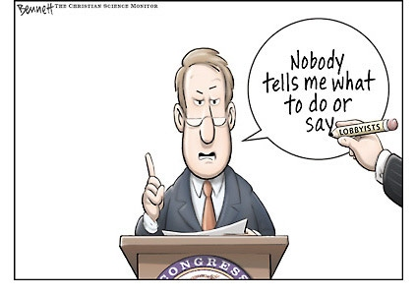
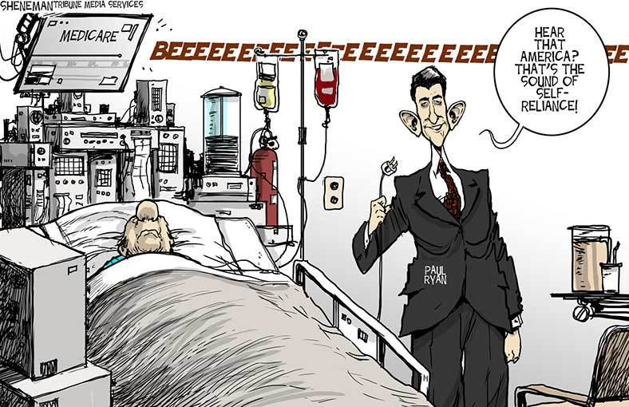
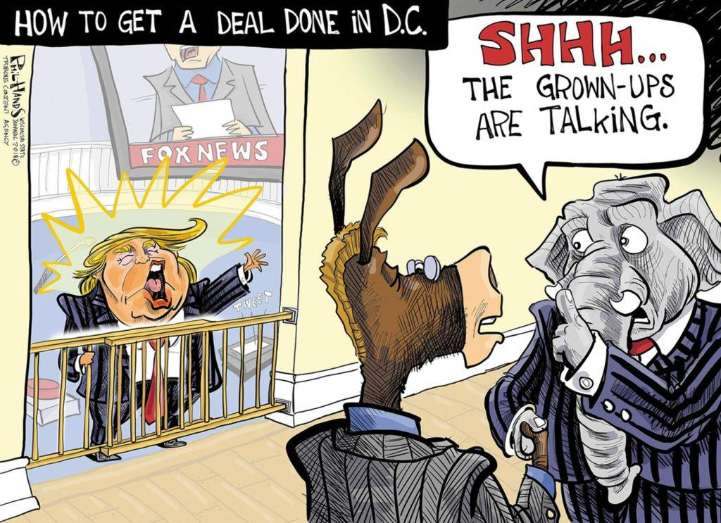

Quotations:
Quotation | Democratic Model | Explanation
The most important question that was ever proposed to your decision, or to the decision of any people under heaven, is before you, and you are to decide upon it by men of your own election, chosen specially for this purpose. --Brutus 1
It is insisted, indeed, that this constitution must be received, be it ever so imperfect. If it has its defects, it is said, they can be best amended when they are experienced. But remember, when the people once part with power, they can seldom or never resume it again but by force. --Brutus 1
Each State shall appoint, in such Manner as the Legislature thereof may direct, a Number of Electors, equal to the whole Number of Senators and Representatives to which the State may be entitled in the Congress: but no Senator or Representative, or Person holding an Office of Trust or Profit under the United States, shall be appointed an Elector. --Constitution, Article 2.1
The House of Representatives shall be composed of Members chosen every second Year by the People of the several States, and the Electors in each State shall have the Qualifications requisite for Electors of the most numerous Branch of the State Legislature. --Constitution, Article 1.1
The instability, injustice, and confusion introduced into the public councils, have, in truth, been the mortal diseases under which popular governments have everywhere perished --Federalist 10
The influence of factious leaders may kindle a flame within their particular States, but will be unable to spread a general conflagration through the other States. A religious sect may degenerate into a political faction in a part of the Confederacy; but the variety of sects dispersed over the entire face of it must secure the national councils against any danger from that source. A rage for paper money, for an abolition of debts, for an equal division of property, or for any other improper or wicked project, will be less apt to pervade the whole body of the Union than a particular member of it; in the same proportion as such a malady is more likely to taint a particular county or district, than an entire State. --Federalist 10
--That whenever any Form of Government becomes destructive of these ends, it is the Right of the People to alter or to abolish it, and to institute new Government, laying its foundation on such principles and organizing its powers in such form, as to them shall seem most likely to effect their Safety and Happiness. --Declaration of Independence
We, therefore, the Representatives of the united States of America, in General Congress, Assembled, appealing to the Supreme Judge of the world for the rectitude of our intentions, do, in the Name, and by Authority of the good People of these Colonies, solemnly publish and declare, That these United Colonies are, and of Right ought to be Free and Independent States --Declaration of Independence

Scenarios:
Scenario | Democratic Model | Explanation
During the 1760’s and 1770’s, Great Britain began taxing some items sold in the colonies, including paper, tea and glass. Some colonists protested these policies by boycotting British goods.
In 1778, Pennsylvania passed a law allowing the state to take the property of residents who did not support the Revolutionary cause. The state seized goods from many members of religious groups like the Society of Friends (Quakers) who did not want to take sides during the war.
Even in the face of repeated acts of violence in the public schools, most legislatures have failed to pass new legislation for the protection of students.
Delegates to political party conventions nominate the candidate for president from their party, sometimes using the votes of Superdelegates, who are elected party officials, to steer the nomination in the direction they prefer..
Faced with repeated communications from their constituents and numerous interest group pressures, Congress passes an immigration reform bill.

