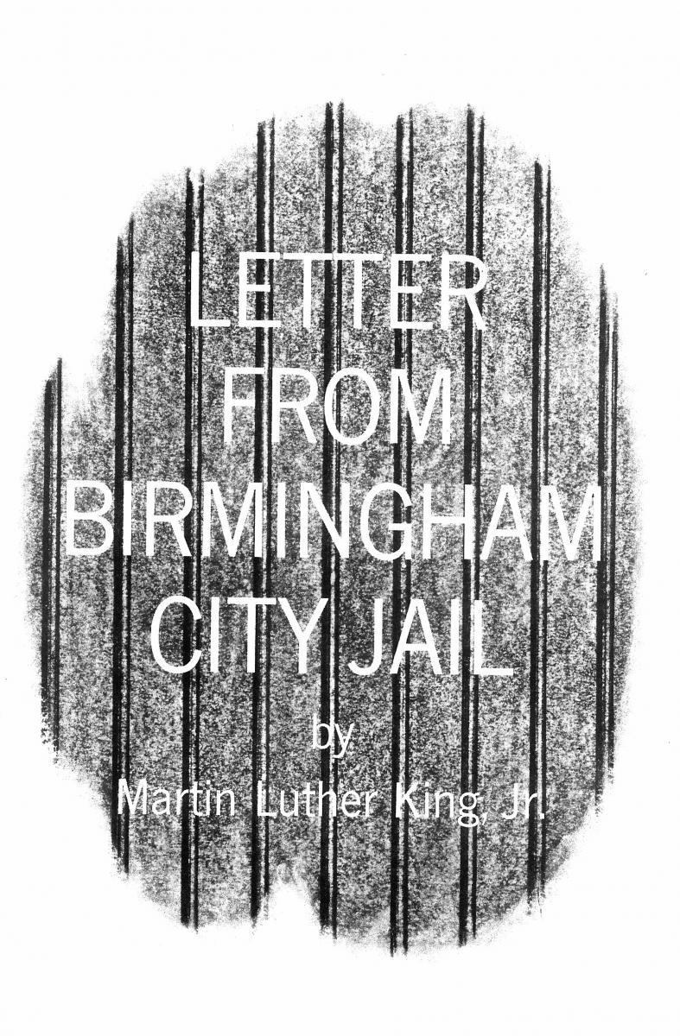Letter from A Birmingham Jail

An analysis of civil disobedience and peaceful protest in the era of fighting for the 14th Amendments Equal Protection Clause.

**Part I:** Watch the following video clip on the background of Dr. King's letter; <https://youtu.be/XIpfCVt2eb4> . Your aim is to fully understand the context leading up to the letter, the intentions of his writing and the audience in which he is addressing

**Part II:** . **Read - Stop - Think.** Using the excerpts below you will need to analyze the themes and elements found in Dr. King's Letter. You will be asked to complete the following for your analysis:

1. Using the column on the left, write down the most important words used in each section.
2. Highlight and/or annotate the most important information from each excerpt
3. Answer the questions that follow each portion of the letter in order to analyze the main themes and arguments.

|  |  |
| --- | --- |
|  | “While confined here in the Birmingham city jail, I came across your recent statement calling my present activities "unwise and untimely." Seldom do I pause to answer criticism of my work and ideas...But since I feel that you are men of genuine good will and that your criticisms are sincerely set forth, I want to try to answer your statement in what I hope will be patient and reasonable terms.”  “I think I should indicate why I am here in Birmingham, since you have been influenced by the view which argues against "outsiders coming in."  “...I am in Birmingham because injustice is here. Just as the prophets of the eighth century B.C. left their villages and carried their "thus saith the Lord" far beyond the boundaries of their hometowns, and just as the Apostle Paul left his village of Tarsus and carried the gospel of Jesus Christ to the far corners of the Greco Roman world, so am I compelled to carry the gospel of freedom beyond my own home town. Like Paul, I must constantly respond to the Macedonian call for aid.”  “Moreover, I am cognizant of the interrelatedness of all communities and states. I cannot sit idly by in Atlanta and not be concerned about what happens in Birmingham. **Injustice anywhere is a threat to justice everywhere. We are caught in an inescapable network of mutuality, tied in a single garment of destiny**. Whatever affects one directly, affects all indirectly. Never again can we afford to live with the narrow, provincial "outside agitator" idea. Anyone who lives inside the United States can never be considered an outsider anywhere within its bounds.” |

How does King answer to the charge of being an outsider?

How does King address the reasons for being in Birmingham in light of his ideas on justice and equality for all? How does this apply to each person living in the United States?

|  |  |
| --- | --- |
|  | “In any nonviolent campaign there are four basic steps: collection of the facts to determine whether injustices exist; negotiation; self purification; and direct action. We have gone through all these steps in Birmingham. There can be no gainsaying the fact that racial injustice engulfs this community. Birmingham is probably the most thoroughly segregated city in the United States. Its ugly record of brutality is widely known. Negroes have experienced grossly unjust treatment in the courts. There have been more unsolved bombings of Negro homes and churches in Birmingham than in any other city in the nation. These are the hard, brutal facts of the case. On the basis of these conditions, Negro leaders sought to negotiate with the city fathers. But the latter consistently refused to engage in good faith negotiation.” |

What is Dr. King looking to say to his audience? Why does he take the time to explain these ideals?

|  |  |
| --- | --- |
|  | “Then, last September, came the opportunity to talk with leaders of Birmingham's economic community. In the course of the negotiations, certain promises were made by the merchants--for example, to remove the stores' humiliating racial signs. On the basis of these promises, the Reverend Fred Shuttlesworth and the leaders of the Alabama Christian Movement for Human Rights agreed to a moratorium on all demonstrations. As the weeks and months went by, we realized that we were the victims of a broken promise...As in so many past experiences, our hopes had been blasted, and the shadow of deep disappointment settled upon us.”  “...Mindful of the difficulties involved, we decided to undertake a process of self purification. We began a series of workshops on nonviolence, and we repeatedly asked ourselves: "Are you able to accept blows without retaliating?" "Are you able to endure the ordeal of jail?" |

Why does King provide this example to his readers? What he is communicating about their views of the protests and the views of how the community / local gov. has responded?

|  |  |
| --- | --- |
|  | “You may well ask: "Why direct action? Why sit ins, marches and so forth? Isn't negotiation a better path?" You are quite right in calling for negotiation. Indeed, this is the very purpose of direct action. Nonviolent direct action seeks to create such a crisis and foster such a tension that a community which has constantly refused to negotiate is forced to confront the issue. It seeks so to dramatize the issue that it can no longer be ignored. My citing the creation of tension as part of the work of the nonviolent resister may sound rather shocking. But I must confess that I am not afraid of the word "tension." I have earnestly opposed violent tension, but there is a type of constructive, nonviolent tension which is necessary for growth. Just as Socrates felt that it was necessary to create a tension in the mind so that individuals could rise from the bondage of myths and half truths to the unfettered realm of creative analysis and objective appraisal, so must we see the need for nonviolent gadflies to create the kind of tension in society that will help men rise from the dark depths of prejudice and racism to the majestic heights of understanding and brotherhood. The purpose of our direct action program is to create a situation so crisis packed that it will inevitably open the door to negotiation. I therefore concur with you in your call for negotiation. Too long has our beloved Southland been bogged down in a tragic effort to live in monologue rather than dialogue.” |

How does Dr. King address the idea of ‘direct action’? How does he connect it to the movement, and the attainment of civil rights?

|  |  |
| --- | --- |
|  | “One of the basic points in your statement is that the action that I and my associates have taken in Birmingham is untimely. Some have asked: "Why didn't you give the new city administration time to act?" The only answer that I can give to this query is that the new Birmingham administration must be prodded about as much as the outgoing one, before it will act. We are sadly mistaken if we feel that the election of Albert Boutwell as mayor will bring the millennium to Birmingham...**My friends, I must say to you that we have not made a single gain in civil rights without determined legal and nonviolent pressure**...**We know through painful experience that freedom is never voluntarily given by the oppressor; it must be demanded by the oppressed.** Frankly, I have yet to engage in a direct action campaign that was "well timed" in the view of those who have not suffered unduly from the disease of segregation. For years now I have heard the word "Wait!" It rings in the ear of every Negro with piercing familiarity. This "Wait" has almost always meant "Never." We must come to see, with one of our distinguished jurists, that "justice too long delayed is justice denied."  ...We have waited for more than 340 years for our constitutional and God given rights.” |

How does Dr. King address his foes that believe his quickness in response is ‘untimely’?

Describe the idea being represented in the bold section above. How is he relating his argument to historical means, and to the goals of the movement? How is he addressing the Constitutional rights that many civil rights activists are fighting for?

|  |  |
| --- | --- |
|  | “How does one determine whether a law is just or unjust? A just law is a man made code that squares with the moral law or the law of God. An unjust law is a code that is out of harmony with the moral law. To put it in the terms of St. Thomas Aquinas: An unjust law is a human law that is not rooted in eternal law and natural law. Any law that uplifts human personality is just. Any law that degrades human personality is unjust.”  “...Let us consider a more concrete example of just and unjust laws. An unjust law is a code that a numerical or power majority group compels a minority group to obey but does not make binding on itself. This is difference made legal. By the same token, a just law is a code that a majority compels a minority to follow and that it is willing to follow itself. This is sameness made legal. Let me give another explanation. A law is unjust if it is inflicted on a minority that, as a result of being denied the right to vote, had no part in enacting or devising the law. Who can say that the legislature of Alabama which set up that state's segregation laws was democratically elected? |

How does he compare just and unjust laws? What is he saying about the situation in Alabama based on this concept?

|  |  |
| --- | --- |
|  | “Sometimes a law is just on its face and unjust in its application. For instance, I have been arrested on a charge of parading without a permit. Now, there is nothing wrong in having an ordinance which requires a permit for a parade. But such an ordinance becomes unjust when it is used to maintain segregation and to deny citizens the First-Amendment privilege of peaceful assembly and protest.  I hope you are able to see the distinction I am trying to point out. In no sense do I advocate evading or defying the law, as would the rabid segregationist. That would lead to anarchy. One who breaks an unjust law must do so openly, lovingly, and with a willingness to accept the penalty. I submit that an individual who breaks a law that conscience tells him is unjust, and who willingly accepts the penalty of imprisonment in order to arouse the conscience of the community over its injustice, is in reality expressing the highest respect for law.” |

How is Dr. King addressing the idea of natural rights, republicanism and civil rights in the excerpt above?

How does he describe paying your highest respect for the law? What do you think he would say that would take in light of recent events in America?

**Part III: (We will complete this in class tomorrow)** The sentiments of Dr. King’s letters have echoed in history as a response to peaceful protest movements, social upheavals and the continued pursuit of civil rights in American.

1. After analyzing his letter above and pulling out the key elements you are going to compare it to a piece of modern day protest literature, music, or speech. You will be analyzing the modern day example in the same way you did the King piece above; accounting for important words, themes and primary ideas that the author is looking to express on the idea of Civil Rights in America.

|  |
| --- |
| **{Put the title to the modern piece here}** |
| Use this area for your analysis |

1. After you have completed your analysis you will be creating a visual representation of the two documents that brings them together. You may pick from one of the options below.
   1. Create a **word cloud** of the two documents; using <https://www.wordclouds.com/> or <https://wordart.com/>. You may also complete it by hand on a white piece of paper with colored pencils.
      1. Your word cloud must be in a symbolic shape that represents your analysis
      2. You will use the most important words, ideas and concepts from both of your pieces to build the word cloud.
   2. Create a protest poster that brings in the two sources ideas
      1. This can be hand-drawn or computer generated
      2. You must use images and words that draw the two ideas together to show the impact on Civil Rights
   3. Create an album cover that would display the idea of the two sources you have chosen
      1. This can be computer generated or hand-drawn
      2. You will want to use images and ideas that depict the ideas of the sources and visually represent symbolic ideas of the sources.
   4. Create a boxing poster that represents the two individuals who wrote the sources and their ideas
      1. You must have a visual representation of each of the individuals
      2. You must show ideas and pull in the major protest implications of the sources
      3. You need to create a colorful well done poster that brings us into the upcoming match

1. At the bottom of your visual representation answer the following:
   1. How does the modern protest you analyzed show the same concepts as A Letter from a Birmingham Jail? How does it show the differences and / or an evolution over time between the original letter and modern day civil rights protest movements?
   2. What are two quotes (one from each document) that display your answer to A. above

Modern Day protest options: (***These are merely examples, you do not have to use anything on this list, and may find something else that interests you***)

|  |  |
| --- | --- |
| **Songs** | **Speeches** |
| * Common, John Legend - “Glory_ - [Song Link](https://youtu.be/HUZOKvYcx_o) * Alicia Keys - “We gotta pray” - [Song Link](https://youtu.be/ReK4t3Pfdpo) * Janelle Monae’s - “Turntables” - [Song link](https://youtu.be/lEB0y79Fkjg) * Tyler Childers - “Long Violent History” - [Song Link](https://youtu.be/2_I3Rp1CQak) * EarthGangs’s - “What’s Going On” Marvin Gaye Cover - [Song link](https://youtu.be/uGgv-C8Foas) * Usher - “I Cry” - [Song Link](https://youtu.be/Nag1L8OYY-4) * The 20 Best Protest Songs of 2017: Critics Pick - [BillBoard Music](https://www.billboard.com/articles/columns/pop/8063598/best-protest-songs-of-2017-top-20) * NPR - We Insist - Protest Music of 2020 - [NPR Series](https://www.npr.org/898709145/we-insist-a-timeline-of-protest-music-in-2020) * Ongoing History of Music Protest - [Website](https://www.ongoinghistoryofprotestsongs.com/category/2020-the-year-in-protest-music/) * NPR - Think Politics is Gone from Country Music? - [Website](https://www.npr.org/sections/therecord/2018/03/20/594043497/think-politics-is-gone-from-country-music-listen-closer) | * Megan Rapinoe Speech (Best Women's player acceptance) - [Video Link](https://youtu.be/tMoTp_w41gw) * Dear Class of 2020 Graduation   + Beyonce - [Video Link](https://youtu.be/iGtJE58bli0)   + Condoleezza Rice - [Video Link](https://youtu.be/72xuFXTTa74) * Barack Obama - Response to George Floyd - [Video Link](https://youtu.be/0ui923iXlKU) * Lebron James, Carmelo Anthony, Chris Paul and Dwayne Wade - ESPYS - [Click Here](https://time.com/4406289/lebron-james-carmelo-anthony-espy-awards-transcript/) |
| **Literature or Articles** | |
| * John Lewis - “Together, you Can Redeem the Soul of the Nation” - [Article link](https://www.nytimes.com/2020/07/30/opinion/john-lewis-civil-rights-america.html) * Maya Angelou - Poem; “On the Pulse of the Morning” - [Poem Link](https://hwcfiercereadersornot.com/2017/09/06/on-the-pulse-of-morning-by-maya-angelou/) | |