State of the Union Bingo Name____________________________________
Tuesday, February 24th, 6pm Pacific Time
Choose 24 of the options below or from the brainstorm we did in class to fill in your BINGO card. You can only use an option once.
Phrases  - POTUS says a version of “Make America Great” or “America First”  - POTUS says “tremendous”  - POTUS says “God Bless”  - POTUS says “Americans” at least 5 times  - POTUS says “Democrat Party” instead of “Democratic”  - POTUS says “Radical Left”  Topics  - POTUS talks about guests in the House Gallery  - POTUS mentions a specific Congressman  - POTUS mentions a specific cabinet member  - POTUS references need for bipartisanship  - POTUS references an AP Gov founding doc  - POTUS quotes a former president  - POTUS insults an American politician  - POTUS discusses his family as an anecdote  - POTUS discusses Russia  - POTUS discusses Israel  - POTUS discusses China  - POTUS discusses Greenland  - POTUS discusses Iran  - POTUS discusses Venezuela / Maduro  - POTUS discusses veterans or the US military | - POTUS discusses AI  - POTUS discusses upcoming midterm elections  - POTUS mentions Portland and/or Minnesota  - POTUS discusses ICE  - POTUS discusses border security  - POTUS discusses Federal Reserve nominee  - POTUS discusses the stock market  - POTUS discusses Big Beautiful Bill tax cuts  - POTUS discusses low unemployment  - POTUS discusses guns  - POTUS discusses housing  - POTUS discusses education  - POTUS discusses SAVE Act / voter ID  - POTUS discusses health care  Actions  - POTUS is interrupted by applause more than 10x  - A majority of Democrats stand up & applause 3x+  - POTUS gets a standing ovation by almost everyone in the room  - A Supreme Court justice claps  - The camera zooms in on a MAGA hat in the crowd  - Someone publicly protests during the speech  - POTUS gets interrupted by someone shouting at him  - POTUS does NOT discuss Epstein

B | I | N | G | O
 |  | 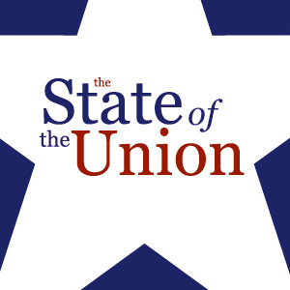

TIEBREAKER: WHO IS THE “DESIGNATED SURVIVOR”? ____________________________________
State of the Union Address Debrief and Reflection

1. What are five topics you really hope President Trump addresses this year? How well did he address them?

2. What are two areas of domestic public policy that seem to be most important to Trump? Describe his goals.

3. What are two areas of foreign policy that seem most important to Trump? Describe his goals.

4 What other priorities did you find interesting?

5. Watch the Democratic response. What are three critiques that were most interesting?

