August 10, 2024
Update on Haiti New Life Ministries
We praise the Lord for the opportunities He has provided to us so that we can continue our activities in Haiti. We also thank each of our supporters who contribute in prayer, finances, or other ways for our continued progress in the poorest country in Western Hemisphere.
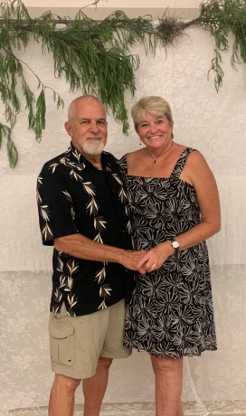
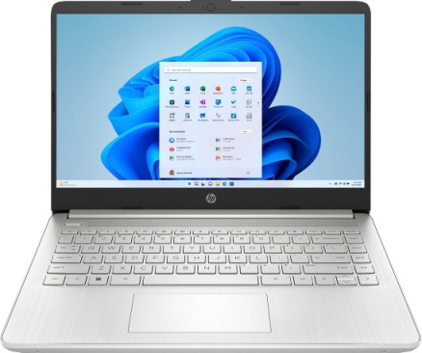
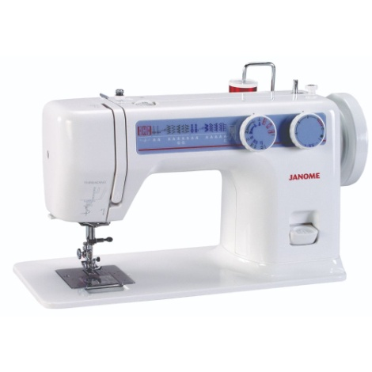
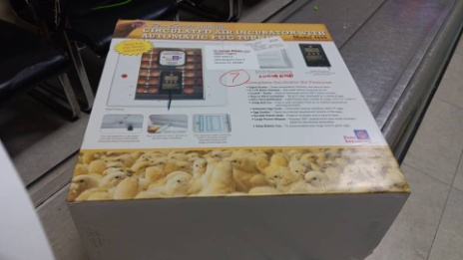
Fundraiser in April: We were small in numbers but mighty in the Lord. We saw the Lord provide for our specific projects for the technical school. We raised money for 15 turkeys (but we were advised it would be much more profitable to purchase an incubator, so we did!), 14 laptops (Acer), and 13 treadle sewing machines(Janome). We are working on shipping them to Haiti now. They received the incubator last week and the laptops are at the airport ready to be shipped. Next we will be sending the sewing machines by container.
Gary & I will be leaving for Haiti September 7th. We are in the northern part of Haiti and Lucner assures us that we will be safe. We will be visiting the new Empowered Global Campus, HNLM property, the Messiah University and strategizing with Dr. Lucner Pierre & staff. It has been four years since we have been to Haiti and we are looking forward to reconnecting in person.
If you would like to help in anyway, please go to our website www.haitinewlifeministries.com or mail a check to: HNLM, 6168 Roberta Dr, Englewood, FL 34224.
May the Lord bless you and we appreciate your prayers for a safe trip.
Gary & LeAnne, HNLM Board

