10/25/2023 - Update on Haiti New Life Ministries
We praise the Lord for the opportunities He has provided to us so that we can continue our activities in Haiti. We also thank each one of our supporters who contributes in prayer, finances, or other ways for our continued progress in the poorest country in Western Hemisphere.
We want to personally thank Gary & LeAnne for their outstanding contribution for the growth of Haiti New Life. Many thanks to Gail & her husband Roger, who recently joined our fight to see a brighter future and a new life for our Haitian people.
Below is a brief report of our accomplishments so far this year and some of our short term projects ahead.
Our recent accomplishments:
- We completed the payment on the first of the two property sections. We now have a permanent location for our institution in the future.

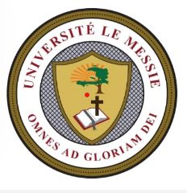
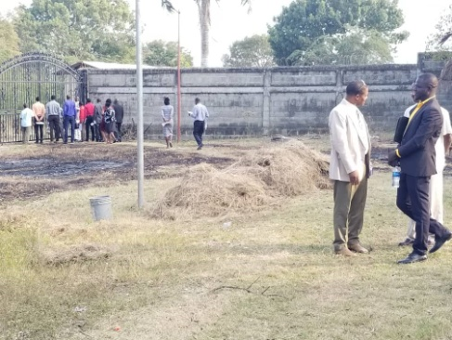
- We recently connected with a new organization called “Empowered Global.” This organization is letting us use their established campus (which is not far from our first location in Vaudreuil) to run our professional and technical programs.

- On July 22nd, we launched a university (Universiste Le Messie, ULEM) to provide higher education in Haiti. Messiah University will offer diploma, bachelor, master, and doctorate programs. Classes will start in November.

Projects:
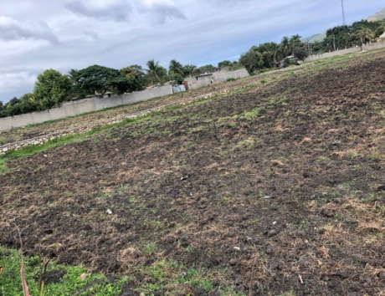
- In September, we began the process of constructing a wall around the first part of our property. This will provide the needed security for the temporary gardens and no possibility of squatters.
- We need to raise the additional $70,000 so that we can buy the second section of land. Then we will have 3 acres of land to build the future project.
- We are updating the curriculum of our Haiti New Life Technical College to make people successful in starting their own business. They need to be entrepreneurs when they graduate. Areas to teach them is how to grow crops, raise chickens and other animals, auto repair, cosmetology, sewing, etc.
- HNLM Technical College with 70 students starting in November 13th.
- Messiah University 90 students starting soon.
Continue to pray for all the teachers and students in both schools.
We are excited for these projects and the vision the Lord has given us. We cannot move forward without your prayers and support. We also need monthly supporters. Will you join us?
If you would like to help in anyway, please go to our website www.haitinewlifeministries.com or mail a check to: HNLM, 6168 Roberta Dr, Englewood, FL 34224.
May the Lord bless you as you continue to pray for our world and for all the atrocities happening in Israel.
HNLM Team

