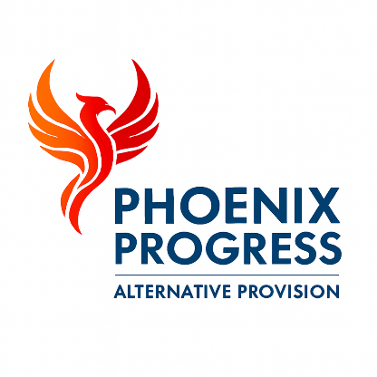

Phoenix Progress – Health & Safety and Risk Assessment Policy
Policy approved by: Jonathan Henery (Director)
Signed: Jonathan Henery
Date reviewed: February 2026
Next review date: February 2027

1. Policy Statement
Phoenix Progress is committed to ensuring, so far as is reasonably practicable, the health, safety and welfare of all pupils, staff, visitors and contractors. The organisation recognises its legal responsibilities under health and safety legislation and is committed to providing a safe and secure environment in which children and young people can learn and develop.
Health and safety is regarded as an integral part of the effective management of Phoenix Progress, and all staff are expected to take reasonable care of themselves and others who may be affected by their actions.
This policy statement is approved and signed by the Director of Phoenix Progress.

2. Scope of the Policy
This policy applies to:
- All employees of Phoenix Progress
- Volunteers, associates and contractors
- Pupils attending the provision
- Visitors to the site
This policy applies to all activities undertaken by Phoenix Progress, both on and off site.

3. Legal Framework
This policy is informed by, and operates in accordance with, the following legislation and guidance:
- Health and Safety at Work etc. Act 1974
- Management of Health and Safety at Work Regulations 1999
- Reporting of Injuries, Diseases and Dangerous Occurrences Regulations (RIDDOR) 2013
- Control of Substances Hazardous to Health Regulations (COSHH) 2002
- Relevant statutory guidance and local authority expectations
This policy has been informed by Suffolk County Council guidance on school safety, health and wellbeing

4. Competent Health and Safety Advice
Phoenix Progress ensures access to competent health and safety advice through:
- Guidance and documentation provided by Suffolk County Council
- External professional advice where required (e.g. specialist contractors, training providers)
- Ongoing review of statutory guidance and recognised good practice
This ensures that health and safety arrangements remain compliant, appropriate and proportionate to the nature of the provision.

5. Roles and Responsibilities
Director
The Director has overall responsibility for health and safety and will ensure that:
- Appropriate policies and procedures are in place
- Risk assessments are completed, implemented and reviewed
- Accidents, incidents and near misses are recorded, reviewed and reported where required
- Staff receive appropriate training, information and supervision
Staff
All staff have a responsibility to:
- Take reasonable care for their own health and safety and that of others
- Follow health and safety procedures
- Report hazards, concerns, accidents and near misses promptly

6. Risk Assessment
Phoenix Progress operates a robust risk assessment process to identify and manage hazards.
Risk assessments are carried out:
- For the premises and grounds
- For activities and learning sessions
- For off-site activities where applicable
Risk assessments are reviewed regularly and updated:
- Following an accident, incident or near miss
- When there is a significant change to activities, environment or pupil needs

7. Accident, Incident and Near Miss Reporting
All accidents, incidents and near misses involving pupils, staff or visitors must be reported and recorded in line with Phoenix Progress procedures.
Records are reviewed to identify patterns, reduce risk and improve safety practice.
Where required, accidents and incidents are reported in accordance with RIDDOR regulations.

8. First Aid
Phoenix Progress ensures appropriate first aid provision is available at all times.
All first aid treatment provided to pupils is recorded in a first aid log. Parents and carers are informed of any first aid treatment or injury involving their child as soon as reasonably practicable. Where appropriate, this communication is supported through the Bromcom management system.
Staff follow agreed first aid procedures and seek further medical assistance where required.

9. COSHH
Phoenix Progress recognises its responsibilities under the Control of Substances Hazardous to Health (COSHH) Regulations.
Hazardous substances used within the provision are identified, risk assessed and managed appropriately. Safety data sheets are followed, suitable control measures are implemented, and substances are stored securely. Staff receive relevant information, instruction and training where applicable.

10. Fire Safety and Emergency Procedures
Phoenix Progress has procedures in place for fire safety and emergency situations, including:
- Fire evacuation procedures
- Clearly identified exit routes
- Regular checks of fire safety equipment
Staff and pupils are expected to follow emergency instructions calmly and promptly.

11. Premises and Site Safety
Phoenix Progress takes reasonable steps to ensure that:
- The premises and grounds are safe and well maintained
- Hazards are identified and addressed promptly
- Visitors are managed safely while on site

12. Training and Information
Staff receive appropriate health and safety information and training relevant to their role.
Health and safety arrangements are communicated clearly to staff, pupils and visitors as appropriate.

13. Monitoring and Review
The Director is responsible for monitoring the effectiveness of this policy.
This policy is reviewed annually, or sooner if required due to changes in legislation, guidance or operational practice.

