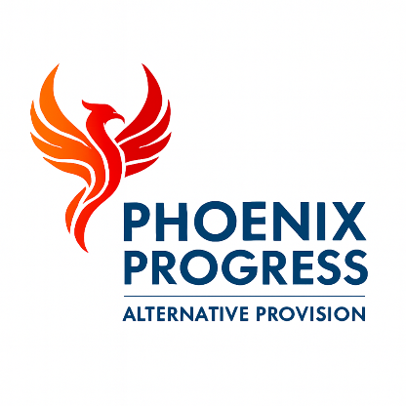

Phoenix Progress - Safer Recruitment Policy
Policy approved by: Jonathan Henery (Director)
Date reviewed: January 2026
Next review date: January 2027 (or sooner if statutory guidance changes)

1. Policy Statement
Phoenix Progress is committed to safeguarding and promoting the welfare of children and young people and expects all staff, volunteers, associates and contractors to share this commitment.
We recognise that safe recruitment practices are a vital part of safeguarding and are essential in preventing unsuitable individuals from gaining access to children and young people. Phoenix Progress is committed to following safer recruitment guidance as set out in Keeping Children Safe in Education (KCSIE) and relevant statutory guidance.
All recruitment and selection processes are designed to identify, deter and reject individuals who may pose a risk to children and young people. No person will be permitted to work with children unless all required safer recruitment checks have been satisfactorily completed.

2. Scope of the Policy
This policy applies to:
- All permanent staff
- Temporary and agency staff
- Volunteers
- Associates and contractors
- Directors and proprietors
This policy applies to all recruitment undertaken by Phoenix Progress where individuals may have access to children or young people.

3. Safer Recruitment Principles
Phoenix Progress follows the core principles of safer recruitment by ensuring that:
- The welfare of children is the primary consideration in all recruitment decisions
- All roles involving contact with children are subject to enhanced vetting
- Recruitment processes are transparent, fair and consistent
- Safeguarding responsibilities are clearly communicated to applicants
- Unsuitable applicants are identified and rejected at the earliest stage

4. Advertising and Applications
All job advertisements and recruitment materials will:
- Include a clear safeguarding statement
- State that enhanced DBS and safer recruitment checks are required
- Make clear that Phoenix Progress is committed to safeguarding and promoting the welfare of children
All applicants must complete a full application form. CVs alone are not accepted.

5. Shortlisting and Interviews
Shortlisting is carried out by at least one person trained in safer recruitment.
Applicants are assessed against the job description and person specification. Any gaps in employment history must be explained.
All interviews will:
- Explore the candidate’s motivation for working with children
- Assess their suitability to work with vulnerable young people
- Include safeguarding-based questions
- Test attitudes towards safeguarding and child protection

6. Pre-Employment Checks
A conditional offer of employment is subject to the satisfactory completion of all safer recruitment checks. No individual may start work until these checks have been completed.
The following checks are required for all staff, volunteers, associates and contractors:
a) Enhanced DBS Check
- Enhanced Disclosure and Barring Service (DBS) check
- Child workforce
- Children’s barred list check
- DBS Update Service registration where possible
b) Identity Verification
- Photographic identification
- Proof of current address
c) Right to Work in the UK
- In line with Home Office requirements
d) References
- Two references obtained prior to employment
- One reference must be from the most recent employer
- References are verified directly with the referee
e) Qualifications and Professional Registration
- Verification of relevant qualifications
- Professional registration where applicable
f) Employment History
- Full employment history checked
- Any gaps in employment explored and recorded
g) Prohibition Checks (where applicable)
- Teacher prohibition checks
- Section 128 checks for management positions

7. Agency and Contractor Staff
Phoenix Progress only uses reputable agencies that operate in line with safer recruitment standards.
Written confirmation is obtained from agencies that all required safeguarding and vetting checks have been completed prior to placement.
Agency staff are not permitted to work with children unless full compliance has been confirmed.

8. Induction and Training
All new staff, volunteers and contractors receive a safeguarding induction which includes:
- Safeguarding and Child Protection Policy
- Code of Conduct
- Behaviour Policy
- Whistleblowing Policy
- KCSIE guidance
- Reporting procedures
Safeguarding training is refreshed regularly and is mandatory for all staff.

9. Ongoing Safeguarding Responsibilities
Phoenix Progress recognises that safeguarding is an ongoing responsibility.
All staff are expected to:
- Maintain professional boundaries
- Report safeguarding concerns immediately
- Follow safeguarding procedures at all times
- Uphold the organisation’s values and standards
Failure to comply with safeguarding responsibilities may result in disciplinary action.

10. Record Keeping
Phoenix Progress maintains a Single Central Record (SCR) in line with the requirements of Keeping Children Safe in Education.
The SCR records all required safer recruitment checks for staff, volunteers, directors, associates and contractors.
The SCR is securely maintained using Bromcom Management Information System and is available for inspection by Ofsted and relevant regulatory authorities.

11. Monitoring and Review
This policy is reviewed annually or sooner in response to changes in legislation or statutory guidance.
The Directors are responsible for ensuring this policy is implemented effectively and consistently.

