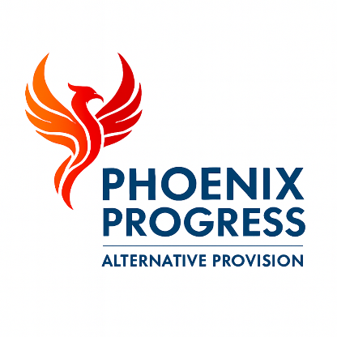

Phoenix Progress – Statement of Procedures for Dealing with Allegations Against Staff

Policy approved by: Jonathan Henery (Director)
Date reviewed: January 2026
Next review date: January 2027

Contents
- Policy Statement
- Statutory Framework
- Scope of Allegations
- Initial Response to an Allegation
- Role of the Local Authority Designated Officer (LADO)
- Managing the Allegation
- Outcomes and Referrals
- Unfounded, False or Malicious Allegations
- Confidentiality and Record Keeping
- Learning Lessons
- Review

1. Policy Statement
Phoenix Progress is committed to ensuring that all allegations of abuse or safeguarding concerns relating to staff, volunteers, contractors or visitors are dealt with promptly, fairly and in a way that protects children and young people.
We recognise our statutory duty to safeguard and promote the welfare of children and young people and to maintain a culture of transparency, accountability and professional integrity.
This policy applies to all adults working with or on behalf of Phoenix Progress and must be read in conjunction with the Safeguarding and Child Protection Policy.

2. Statutory Framework
This policy is written in accordance with the most recent edition of Keeping Children Safe in Education and is informed by the following legislation and guidance:
- Working Together to Safeguard Children
- The Children Act 1989 and 2004
- Suffolk Safeguarding Children Partnership procedures
Phoenix Progress follows all statutory guidance and local safeguarding partnership expectations when managing allegations.

3. Scope of Allegations
This policy applies where an allegation is made that an adult working with Phoenix Progress has:
- Behaved in a way that has harmed, or may have harmed, a child
- Possibly committed a criminal offence against or related to a child
- Behaved towards a child or children in a way that indicates they may pose a risk of harm
- Behaved in a way that indicates they may not be suitable to work with children
Allegations may relate to behaviour that occurred inside or outside of the workplace.

4. Initial Response to an Allegation
Any allegation or concern must be reported immediately to the Designated Safeguarding Lead (DSL) or a member of senior leadership.
The child involved will be listened to, reassured and supported appropriately.
No attempt will be made to investigate the allegation prior to consultation with the Local Authority Designated Officer (LADO).
If the allegation concerns the Designated Safeguarding Lead, Head of Provision or Director, the matter must be reported directly to the Local Authority Designated Officer without delay.
All staff, volunteers, contractors and visitors have the right to contact the LADO directly if they believe an allegation has not been handled appropriately.

5. Role of the Local Authority Designated Officer (LADO)
Phoenix Progress will contact the Local Authority Designated Officer for advice and guidance in all cases where an allegation meets the criteria set out in Section 3.
The LADO will provide advice on managing the allegation, determine whether the matter should be investigated by the police or children’s social care, and advise on appropriate actions, including suspension where necessary.
Phoenix Progress will follow all advice provided by the LADO.

6. Managing the Allegation
Allegations will be managed sensitively, professionally and confidentially.
The adult involved will be informed of the allegation at the appropriate time, as advised by the LADO.
Support will be offered to both the child and the adult involved throughout the process.
Records of the allegation, investigation and outcome will be kept securely.

7. Outcomes and Referrals
Where an allegation is substantiated, Phoenix Progress will take appropriate disciplinary action.
Referrals will be made to the Disclosure and Barring Service (DBS) where an individual is dismissed or removed from working with children due to safeguarding concerns.
Where applicable, referrals will also be made to the Teaching Regulation Agency.
All referrals will be made in line with LADO advice and statutory guidance.

8. Unfounded, False or Malicious Allegations
Where an allegation is determined to be unfounded or false, appropriate support will be provided to the adult involved.
If an allegation is found to be malicious, consideration will be given to how this is managed within safeguarding and behaviour frameworks.
Phoenix Progress recognises the potential emotional impact of false allegations and will ensure appropriate pastoral and professional support is provided.

9. Confidentiality and Record Keeping
Information relating to allegations will be shared on a strictly need-to-know basis.
Records will be retained securely until the individual reaches normal retirement age or for 10 years from the date of the allegation, whichever is longer, in line with KCSIE guidance.

10. Learning Lessons
Phoenix Progress will review safeguarding practice following any allegation in order to identify learning points, strengthen procedures and improve future safeguarding practice.

11. Review
This policy will be reviewed annually or sooner if required by changes to legislation or statutory guidance.

