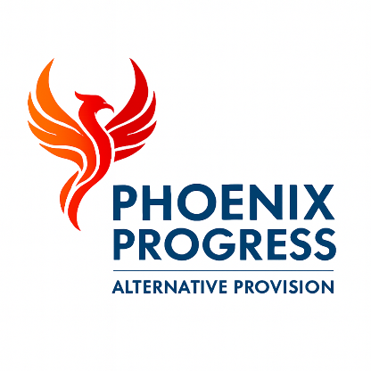

Phoenix Progress - Staff Code of Conduct & Safer Working Practice Policy
Policy Owner: Director
Review Cycle: Annual
Next Review: January 2027

1. Introduction
Phoenix Progress is committed to safeguarding and promoting the welfare of children and young people. This Staff Code of Conduct sets out the standards of behaviour, professionalism and safer working practice expected of all adults working for or on behalf of Phoenix Progress.
This policy applies to all employees, agency staff, volunteers, contractors and visitors.
All adults working within Phoenix Progress have a duty to act in the best interests of children and young people and to uphold the highest standards of professional conduct at all times.
This policy should be read in conjunction with the Safeguarding & Child Protection Policy, Behaviour Policy, Whistleblowing Policy and statutory guidance including Keeping Children Safe in Education.

2. Core Principles
All staff must:
- Treat pupils with dignity, respect and compassion
- Maintain appropriate professional boundaries at all times
- Act as positive role models
- Safeguard pupils from harm, abuse and exploitation
- Promote a culture of safety, trust and wellbeing
Staff must always conduct themselves in a manner that reflects the values of Phoenix Progress and protects the welfare of children and young people.

3. Professional Boundaries
Staff must not form personal or inappropriate relationships with pupils. This includes, but is not limited to:
- Sharing personal contact details
- Communicating with pupils via personal social media accounts
- Meeting pupils outside of work without organisational approval
- Engaging in behaviour that could be misinterpreted or place a child at risk
All interactions with pupils must remain professional and appropriate at all times.

4. Physical Contact
Physical contact must only take place when it is appropriate, necessary and in the best interests of the pupil.
Any physical intervention must be proportionate, reasonable and used only as a last resort, in line with the Phoenix Progress Behaviour Policy.
All incidents involving physical intervention must be recorded and reported in accordance with safeguarding procedures.

5. Behaviour Management
Staff must follow the Phoenix Progress Behaviour Policy and use positive, trauma-informed approaches to support pupils.
Behaviour management strategies must promote dignity, safety and respect and must never place a child or young person at risk of harm.

6. Confidentiality and Information Sharing
Information about pupils must only be shared on a need-to-know basis and in line with data protection principles.
Safeguarding concerns must always be shared immediately with the Designated Safeguarding Lead. Confidentiality must never be used as a reason to withhold information where a child may be at risk of harm.

7. Whistleblowing
Phoenix Progress promotes a culture of transparency, accountability and professional integrity.
All staff have a duty to report unsafe practice, safeguarding concerns or professional misconduct. Staff who raise concerns in good faith will be supported and protected in line with whistleblowing legislation and the Phoenix Progress Whistleblowing Policy.

8. Breaches of Policy
Failure to comply with this policy may result in disciplinary action and, where appropriate, referral to external agencies including the Local Authority Designated Officer or other relevant bodies.

9. Declaration
All staff are required to confirm annually that they have read, understood and agree to comply with this policy.

