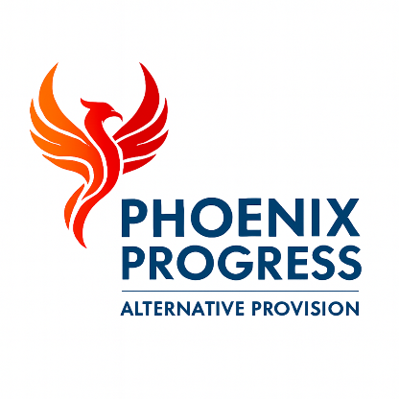

Phoenix Progress – Recruitment and Selection Policy

Policy approved by: Jonathan Henery (Director)
Date reviewed: January 2026
Next review date: January 2027

Contents
- Policy Statement
- Scope of the Policy
- Safer Recruitment Principles
- Recruitment Process
- Training and Induction
- Single Central Record
- Confirmation of Safer Recruitment Checks
- Monitoring and Review

1. Policy Statement
Phoenix Progress is committed to recruiting and retaining the highest quality staff and volunteers who are suitably qualified, competent and safe to work with children and young people. All recruitment decisions are made on the basis of merit, qualifications, experience and suitability, without discrimination.
Phoenix Progress is committed to safeguarding and promoting the welfare of children and young people and expects all staff, volunteers, associates and contractors to share this commitment. Recruitment and selection processes are designed to deter unsuitable applicants and to identify, reject and prevent the appointment of individuals who pose a risk to children and young people.
This policy reflects Phoenix Progress’ statutory duty to safeguard and promote the welfare of children and young people and is underpinned by the principles set out in Keeping Children Safe in Education (KCSIE) and Suffolk Safeguarding Partnership guidance.

2. Scope of the Policy
This policy applies to all recruitment and selection activity for:
- Permanent staff
- Temporary and agency staff
- Volunteers
- Associates
- Contractors
All adults engaged by Phoenix Progress who work with or have access to children and young people are subject to safer recruitment procedures.

3. Safer Recruitment Principles
Phoenix Progress follows robust safer recruitment principles to ensure that only suitable individuals are appointed to work with children and young people.
All staff and volunteers will undergo Safer Recruitment checks before starting work, including:
- Enhanced Disclosure and Barring Service (DBS) check
- Identity verification
- Right to work in the UK
- References from previous employers
- Verification of qualifications and experience
All staff working in regulated activity will be subject to a barred list check in addition to an enhanced DBS check.
Where applicable, Phoenix Progress will carry out disqualification by association checks in line with statutory guidance.
Agency staff and contractors will be checked by their employing agency, and Phoenix Progress will confirm in writing that all required safeguarding checks have been completed before the individual is permitted to work on site.
Recruitment processes are fully compliant with Keeping Children Safe in Education and Suffolk County Council safeguarding expectations.

4. Recruitment Process
Phoenix Progress operates a transparent, fair and rigorous recruitment process designed to identify high-quality candidates who demonstrate both professional competence and a strong safeguarding ethos.
Job descriptions and person specifications clearly define the role, responsibilities and safeguarding expectations. All advertisements are open, transparent and non-discriminatory, and include a safeguarding statement.
Shortlisting is carried out against objective criteria and candidates are required to provide a full employment history. Any gaps in employment are explored and clarified.
Interviews assess suitability for the role, including attitudes towards safeguarding, professional boundaries and child protection responsibilities.
As part of due diligence, Phoenix Progress carries out online searches for shortlisted candidates to identify any information that may indicate a safeguarding concern or reputational risk. Any issues identified are explored during interview.
Successful candidates are not permitted to start work until all pre-employment checks have been completed and verified.

5. Training and Induction
All staff, volunteers and agency workers receive a full induction which includes:
- Safeguarding and child protection
- Professional boundaries and code of conduct
- Equal opportunities
- Health and safety
- Policies and procedures relevant to their role
Ongoing training and professional development are provided to ensure staff remain competent and up to date with legislative, regulatory and safeguarding requirements.
All new staff are subject to a probationary period during which safeguarding practice, conduct and suitability are monitored closely.

6. Single Central Record
Phoenix Progress maintains a Single Central Record (SCR) in line with Keeping Children Safe in Education.
The SCR records all required recruitment and vetting checks for staff, volunteers and contractors, including:
- Identity checks
- Right to work in the UK
- Enhanced DBS and barred list checks
- References
- Qualifications
The SCR is reviewed regularly by the Director to ensure ongoing compliance.

7. Confirmation of Safer Recruitment Checks
Phoenix Progress confirms in writing that all staff, volunteers and agency workers engaged to work with children and young people have completed the full Safer Recruitment process before commencing their duties.
This includes verification of identity, right to work in the UK, references, qualifications and an enhanced DBS check, in line with statutory guidance and Suffolk County Council commissioning expectations.

8. Monitoring and Review
The Director is responsible for ensuring that recruitment and selection processes are followed consistently, lawfully and safely.
This policy is reviewed annually, or sooner if required by changes to legislation, statutory guidance or local safeguarding arrangements.

