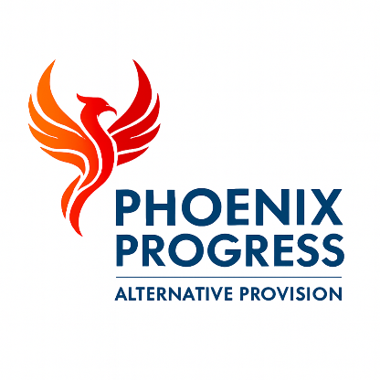

Phoenix Progress - Behaviour and Positive Handling Policy
Policy approved by: Jonathan Henery (Director)
Date reviewed: January 2026
Next review date: January 2027

1. Policy Statement
Phoenix Progress is committed to creating a safe, respectful and nurturing environment in which all children and young people feel valued, supported and able to engage positively with learning. We recognise that many of the pupils who attend our provision present with complex social, emotional and mental health needs and may have experienced trauma, exclusion or disrupted education.
We believe that behaviour is a form of communication and that children’s behaviour reflects their experiences, needs and emotional wellbeing. For this reason, Phoenix Progress adopts a trauma-informed, relational and restorative approach to behaviour support.
Our focus is on building positive relationships, promoting emotional regulation, reducing risk and supporting pupils to develop the skills they need to manage their behaviour safely and appropriately.
Behaviour is managed in a way that promotes dignity, inclusion, safety and wellbeing at all times.

2. Aims
This policy aims to ensure that Phoenix Progress provides a calm, structured and supportive learning environment where children and young people are encouraged to develop positive relationships, self-regulation and responsibility for their actions.
We seek to prevent harm, reduce disruption, promote engagement and ensure that all pupils are supported to access education in a way that meets their individual needs.

3. Behaviour Expectations
Phoenix Progress expects all pupils to:
- Treat others with respect
- Follow staff instructions
- Engage positively with learning activities
- Take responsibility for their actions
We recognise that many pupils require additional support to meet these expectations and therefore provide high levels of pastoral care, mentoring and emotional support.
Staff act as positive role models at all times and demonstrate calm, respectful and consistent behaviour management practice.

4. Behaviour Support Approach
Behaviour at Phoenix Progress is supported through a combination of:
- Trauma-informed practice
- De-escalation strategies
- Restorative approaches
- Therapeutic support
- Individualised behaviour planning
Staff work proactively to identify triggers, reduce anxiety and support emotional regulation.
Where required, individual behaviour support plans are developed in partnership with the pupil, their family and placing school.

5. Managing Challenging Behaviour
Where behaviour presents a risk to learning or safety, staff respond using proportionate and supportive interventions. These may include:
- Redirection and verbal support
- Supervised reflection time
- Use of calming spaces
- Targeted one-to-one support
Sanctions are used only where necessary and are always proportionate, fair and focused on learning, repair and positive change rather than punishment.

6. Physical Intervention and Reasonable Force
Physical intervention is used only as a last resort and only where it is necessary to prevent harm to the child, others or property.
Any physical intervention must be reasonable, proportionate and in line with statutory guidance, including:
Use of reasonable force in schools (Department for Education).
All incidents involving physical intervention are recorded, reviewed by senior leadership and monitored to ensure best practice. Staff who may be required to use physical intervention receive appropriate training.

7. Recording and Monitoring
All significant behaviour incidents are recorded and reviewed by senior leadership.
Behaviour data is monitored to:
- Identify patterns and emerging risks
- Inform safeguarding practice
- Support early intervention
- Inform ongoing support planning

8. Monitoring and Review
This policy is reviewed annually or sooner if required by changes in legislation, statutory guidance or operational need.

