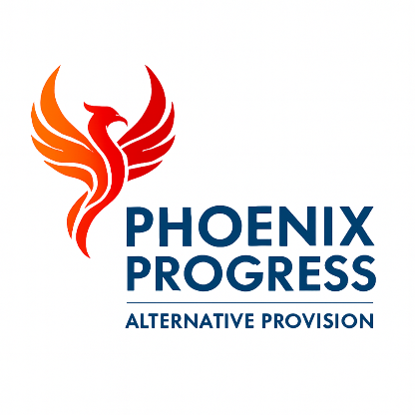

Phoenix Progress - Whistleblowing Policy
Policy Owner: Director
Review Cycle: Annual
Next Review: January 2027

1. Policy Statement
Phoenix Progress is committed to promoting a culture of openness, accountability and safeguarding. Staff, volunteers and contractors play a vital role in maintaining high standards of practice and in identifying concerns that may place children, colleagues or the organisation at risk.
All staff, volunteers and contractors have a duty to raise concerns about unsafe practice, misconduct, safeguarding failures or breaches of policy. Phoenix Progress encourages individuals to speak up and provides protection for those who raise concerns in good faith in line with the Public Interest Disclosure Act 1998.

2. Scope of Concerns
Whistleblowing concerns may include, but are not limited to, safeguarding failures, unsafe working practices, criminal activity, financial misconduct, abuse of authority, health and safety risks or serious breaches of organisational policy.

3. Raising a Concern
Concerns should normally be raised with the Director or the Designated Safeguarding Lead.
Where a concern relates to senior leadership, or where an individual feels unable to raise the matter internally, concerns may be raised directly with external bodies such as the Local Authority Designated Officer, Suffolk County Council or Ofsted.

4. Protection for Individuals
Phoenix Progress is committed to ensuring that individuals who raise concerns in good faith are supported and protected from victimisation, harassment or unfair treatment.

5. Confidentiality
All whistleblowing concerns are handled sensitively and confidentially. Information will only be shared on a need-to-know basis and where necessary to protect children or others from harm.

6. Review
This policy is reviewed annually or sooner in response to changes in legislation, statutory guidance or organisational requirements.

