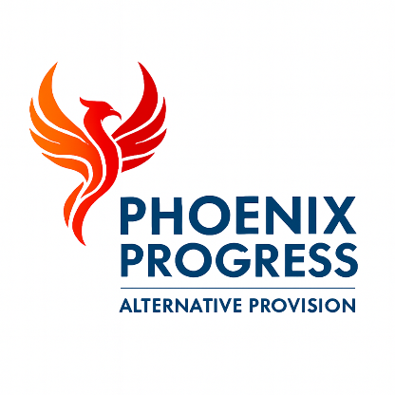

Phoenix Progress - Complaints Policy
Policy Owner: Director
Review Cycle: Annual
Next Review: January 2027

1. Policy Statement
Phoenix Progress is committed to delivering a high-quality, safe and professional service. We recognise the importance of listening to feedback and responding constructively to concerns and complaints.
Complaints are viewed as an opportunity to improve practice and strengthen relationships with pupils, families, placing schools and commissioning partners. All complaints are taken seriously and managed in a fair, transparent and timely manner.

2. Scope
This policy applies to parents and carers, pupils, placing schools, local authorities, commissioners, partner organisations and members of the public.
Raising a complaint will not result in any disadvantage or negative impact for a pupil or their family.

3. Principles
Phoenix Progress aims to resolve concerns at the earliest possible stage. All complaints are handled sensitively, confidentially and without bias.
We are committed to ensuring that complainants feel listened to, respected and kept informed throughout the complaints process.

4. Informal Resolution
Where possible, concerns should be raised informally with a member of staff or senior leader so that issues can be addressed promptly.
Phoenix Progress will aim to resolve informal concerns within five working days.

5. Formal Complaints
Where a concern cannot be resolved informally, a formal complaint may be submitted in writing or by email to the Director.
The Director will acknowledge receipt of the complaint within two working days, carry out a proportionate investigation and provide a written response within ten working days.
Any complaint raising safeguarding concerns will be managed in line with the Safeguarding & Child Protection Policy and may be referred to the relevant local authority.

6. Escalation
If a complainant remains dissatisfied following the formal stage, the complaint may be escalated to the placing school, commissioning local authority or relevant commissioning framework, where applicable.

7. Record Keeping
All complaints and their outcomes are recorded securely and reviewed to identify learning points and inform service improvement.

8. Review
This policy is reviewed annually or sooner in response to changes in legislation, statutory guidance or local authority requirements.

