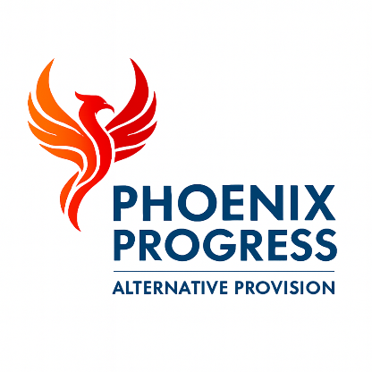

Phoenix Progress - Data Protection Policy

Policy approved by: Jonathan Henery (Director)
Date reviewed: January 2026
Next review date: January 2027

1. Purpose
Phoenix Progress is committed to protecting personal data and handling it lawfully, fairly and transparently in accordance with the UK General Data Protection Regulation (UK GDPR) and the Data Protection Act 2018.
We recognise the importance of protecting the privacy and rights of children, families, staff and partners and are committed to maintaining high standards of data protection, information security and confidentiality.
Phoenix Progress’s Privacy Policy is published on the our website and is available upon request.

2. Scope
This policy applies to all staff, contractors, volunteers and associates who process personal data on behalf of Phoenix Progress, including data relating to children, families, employees, partner organisations and commissioners.
All individuals working for or on behalf of Phoenix Progress are required to comply with this policy and related information governance procedures.

3. Legal Framework
Phoenix Progress processes personal data in accordance with:
- UK General Data Protection Regulation (UK GDPR)
- Data Protection Act 2018
- Human Rights Act 1998
- Freedom of Information Act 2000 (where applicable)
- Information Commissioner’s Office (ICO) guidance

4. Data Protection Principles
Phoenix Progress complies with the seven data protection principles. Personal data must be:
- Processed lawfully, fairly and transparently
- Collected for specified, explicit and legitimate purposes
- Adequate, relevant and limited to what is necessary
- Accurate and kept up to date
- Kept only for as long as necessary
- Processed securely
- Processed in a way that ensures accountability

5. Roles and Responsibilities
Data Protection Officer
Phoenix Progress has appointed a Data Protection Officer (DPO) in line with UK GDPR requirements.
The Data Protection Officer is:
Jonathan Henery
The Data Protection Officer is responsible for:
- Overseeing compliance with data protection legislation
- Providing advice and guidance to staff
- Monitoring information handling practices
- Managing data breaches
- Acting as the organisation’s main point of contact with the Information Commissioner’s Office (ICO)
All staff have a responsibility to protect personal data and report any concerns or breaches immediately.

6. ICO Registration
Phoenix Progress is registered with the Information Commissioner’s Office (ICO) as a data controller and complies fully with the requirements of the UK General Data Protection Regulation (UK GDPR) and the Data Protection Act 2018.
All personal data is processed lawfully, fairly and transparently in accordance with ICO guidance and statutory requirements.

7. Lawful Processing
Personal data is processed only where there is a lawful basis under UK GDPR, including:
- Legal obligation
- Public task
- Contractual necessity
- Vital interests
- Legitimate interests (where appropriate)
Special category data is processed only where an additional lawful condition applies.

8. Data Handling and Security
Phoenix Progress ensures that personal data is:
- Stored securely
- Accessed only by authorised staff
- Used only for legitimate purposes
- Protected against unauthorised access, loss or misuse
Technical and organisational security measures include:
- Secure electronic systems such as Bromcom
- Password-protected access
- Encryption where required
- Staff training
- Secure physical storage

9. Data Sharing
Information is shared only where necessary and lawful, and always in line with safeguarding, statutory and commissioning requirements.
Data sharing is carried out in accordance with:
- UK GDPR
- Data Protection Act 2018
- Information Sharing Agreements (where applicable)
- Safeguarding legislation
Safeguarding always takes precedence over confidentiality where a child is at risk of harm.

10. Data Retention
Personal data is retained in line with Phoenix Progress’ Data Retention and Disposal Policy.
Data is:
- Retained only for as long as necessary
- Reviewed regularly
- Disposed of securely and confidentially

11. Data Subject Rights
Phoenix Progress respects and upholds all data subject rights under UK GDPR, including:
- Right of access
- Right to rectification
- Right to erasure
- Right to restrict processing
- Right to data portability
- Right to object
All requests are handled within statutory timescales.

12. Data Breaches
All data breaches or suspected breaches must be reported immediately to the Data Protection Officer.
Breaches are managed in line with ICO guidance and Phoenix Progress’ Data Breach Procedure. Where required, breaches are reported to the ICO within statutory timescales.

13. Monitoring and Review
This policy is reviewed annually or sooner if required by changes to legislation, guidance or operational practice.

