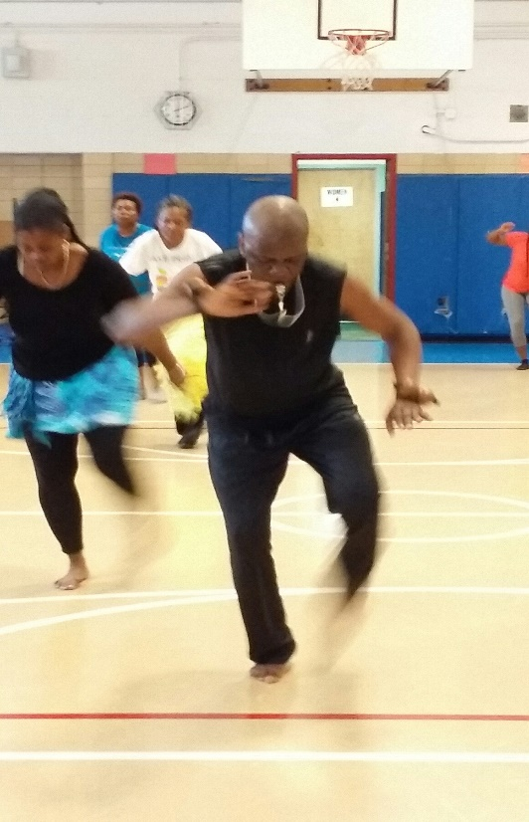

Jean Andoche Loubaki
Jean Andoche Hilarion Loubaki was born in Pointe Noire, Brazzaville Congo, and began his dance career in 1986, with the “Muesi Modern Dance Company”, directed by Celestin Kauset. In 1991 Andoche also became a member of the Traditional Dance Company “Ballet Mfouambila” and danced with both groups.
In 1993 Jean became the Co-Founder and Choreographer of the “Tourbillon Sonnore Percussion and Dance Company”, with Co-Director Gerve L’autre.
At the end of the civil war in 1999, Leonard Baniekoma created “Ballet Ngoma Za Kongo” and Andoche became a dancer and drummer with this Congolese Traditional group, with Boris Bouetoumousa as their choreographer.
In 2013, The Ngoma Za Kongo Dance Company was invited to tour the United States where they showcased their performance at the “Mist” in Harlem.
Jean has toured as a drummer and dancer to the Ghana “Aqua Fest”, the “Lybia Music Festival”, the “Mami Wata Production” in Cameroon, Gabon, and Kinshasa, the “Capesterre Festival” in Guadeloupe, the “Fia Festival in Kinshahsa, and the “African Round” in Guinee, Gabon and the Ivory Coast.
Since migrating to the United States in 2014, Jean Andoche Loubaki has taught classes at the Cumbe Center for African and Diaspora Dance, Gibney Dance Studio, Kow Teff’s yearly Juneteenth Celebration event, Boy’s and Girl’s Harbor, the Montclair Y, and collaborates with the International Child program, founded by Electra Weston, as a Percussionist and substitute teacher for seniors and children. Jean has taught French and Dance at the Boerum Hill School for International Studies, the Richard Rhoda Center, in Teaneck, New Jersey, and currently teaches drum and dance at various schools in the Bronx through the Bronx Arts Ensemble.
Jean has performed at The Museum of Natural History, Fordham University, Queens College, Bronx Museum, The United Nations, Miss Congo Beauty Pageant, the Shrine, Silvana’s, the African American Parade, and the Haitian Parade in New Orleans.
In 2015, Jean created the “Mfouambila Kongo Dance Company”, comprised of artists that depict everyday life of the Congolese people through their dance, music and songs. With the collaboration of other Congolese artists, Jean and Thelma Loubaki held their First “Mfouambila Kongo Congolese Dance Conference”, in July 2016, at the Obeira Dempsey Center in Harlem, and has hosted Four Annual Congolese Dance Conferences, at the Joseph P. Kennedy Center in Harlem.
In the summer of 2019, Jean Loubaki, the Mfouambila Kongo Dance Company, and students traveled to Brazzaville, Congo, for a cultural exchange with various teachers from Congo, who offered traditional classes in dance, percussion, cooking, and song. At the culmination of their trip, the Mfouambila Kongo Dance Company performed to an enthusiastic Congolese crowd, to demonstrate their love and appreciation of Congolese culture.
Jean has been teaching weekly Saturday Congolese Dance and Drum classes with Thelma Loubaki, for five years at the Isador and Ida Strauss School Beacon Program, in upper Manhattan, but due to the Covid-19 Pandemic, online Congolese Dance classes are being taught every Saturday, from 3-4 PM, welcoming all levels.

