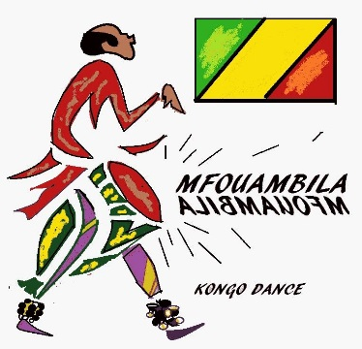

**Mission**

**The Mfouambila Kongo Dance Company**

Mfouambila, which means *“energy”,* in the Lari language, is a folkloric Congolese Dance Company, whose goal is to continue to bring Traditional and Contemporary dance, music, theater, and seminars, to inspire and promote pride, respect, and self-confidence, within the African American Community, and to all who love African Dance.

Congolese Dance and culture was introduced to New York City, by Titos Sompa, a native of Congo, Brazzaville, in 1972. We continue to share Congolese culture and show similarities between Central Africa, and American cultural heritage. Mfouambila Kongo is still committed through the expression of culture, songs, music, chants, call and response, and storytelling, to keep alive the rich culture of the various Congolese ethnic groups within the two Congo’s. Mfouambila Kongo is dedicated to continuing with the exchange of instructors from abroad and throughout the United States, to introduce various dance styles that inspire dancers to create, move, dance, and to bolster pride within each dancer who values tradition and community.

**Vision**

Mfouambila Kongo seeks to enrich the lives of adults, children, and seniors through seminars, weekly dance classes, theater, and conferences, with the collaboration of guest teachers. This is accomplished through structured performances, lectures, with drum and dance workshops designed to involve and inform the community, of the beauty and diversity of Congolese culture. Mfouambila Kongo’s goal is to help everyone become healthier through movement, and to provide the Harlem community with weekly classes, and an annual Dance and Drum Conference.

We are proud to be the only African Dance Conference in Harlem, and the community looks forward to attending this yearly three day conference with teachers from Paris, Congo, California, and New York City. Mfouambila Kongo collaborates with various teachers with diverse styles that share information about their unique ethnic groups, from the different regions of the Congo. This offers the students a broad view of the two Congo’s, with two different Presidents, Governments, and languages.