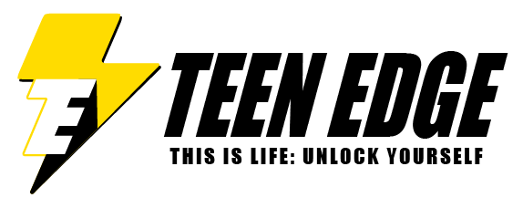
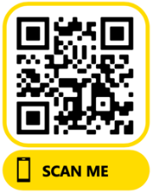
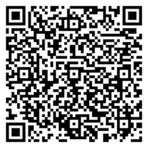
www.teen-edge.com
tracy@teen-edge.com
630.484.3725

Teen Name:
PLEASE RETURN TO ME.
Your Name:

Relationship to Teen:

At Teen Edge, teens are building their roadmap to success by identifying their passions, strengths and opportunities. They are also learning how to set goals and develop skills needed to achieve those goals.
Your feedback will help them to identify skills they need to develop in the future and build their personal brand.

Three words to describe me: Please be very honest as this will help me grow!

_________________________because…_________________________________________________________

_________________________because…_________________________________________________________

_________________________because…_________________________________________________________

What strengths & skills do I have? (Why I’m awesome!):
____________________________________________________________________________________________________________________________________________________________________________________
________________________________________________________________________________________________________________________________________________________________________________________________________________________________________________________________________________________________________________________________________________________________________

What skills could I work to develop further (What is holding me back)?
____________________________________________________________________________________________________________________________________________________________________________________
________________________________________________________________________________________________________________________________________________________________________________________________________________________________________________________________________________________________________________________________________________________________________

What was your first impression of me? Has your impression changed?
Think body language, communication skills, energy level & attitude.
____________________________________________________________________________________________________________________________________________________________________________________________________________________________________________________________________________________________________________________________________________________________________________________________________________________________________________________________________________________________________________________________________________________________________________________________________________
Please rate these skills for me. Be honest, it’s to help me.
Below Average, Average or Above Average
Communication__________________________
Confidence Level _________________________
Motivation______________________________
Taking Responsibility for their Actions_________________________________
Making Excuses _________________________
Goal Driven_____________________________
Action over Words_______________________
Respectful______________________________
Human Connection_______________________
Independent Thinker______________________
Self-Awareness__________________________
Leader__________________________________

