CHILDREN’S PAGES

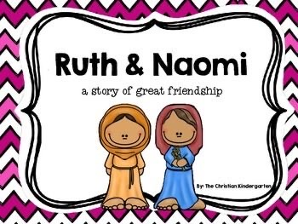

Sunday, 11 April 2021

Zion’s United Church of Christ of Taborton
741 Taborton Road
Sand Lake, NY 12164
518-674-1039 (office)
ziontabortonchurch@gmail.com

The Story of Naomi and Ruth
Bible Address: Ruth 1:1-18 (vv. 14-18)

¹⁴ Then they lifted up their voices and wept again. Orpah kissed her mother-in-law, but Ruth stayed with her. ¹⁵ Naomi said, "Look, your sister-in-law is returning to her people and to her gods. Turn back after your sister-in-law."
﻿¹⁶ But Ruth replied, "Don't urge me to abandon you, to turn back from following after you. Wherever you go, I will go; and wherever you stay, I will stay. Your people will be my people, and your God will be my God. ¹⁷ Wherever you die, I will die, and there I will be buried. May the LORD do this to me and more so if even death separates me from you." ¹⁸ When Naomi saw that Ruth was determined to go with her, she stopped speaking to her about it.
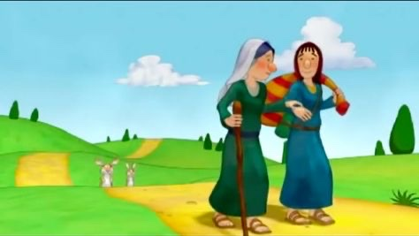
1
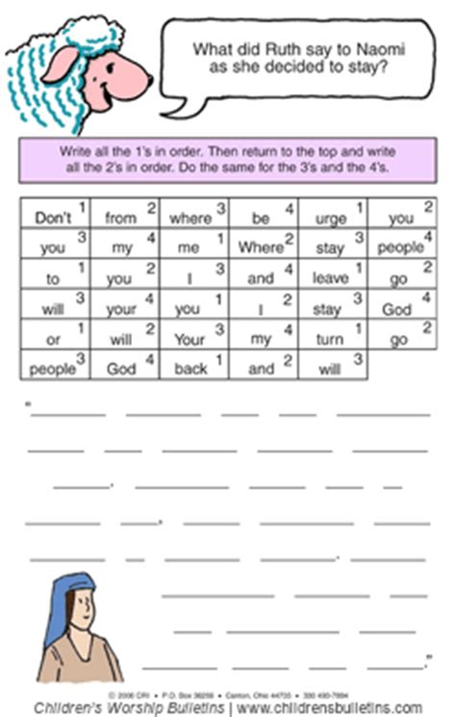

2
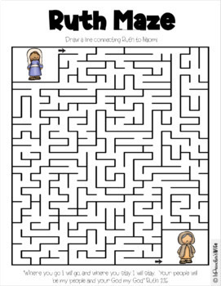

3
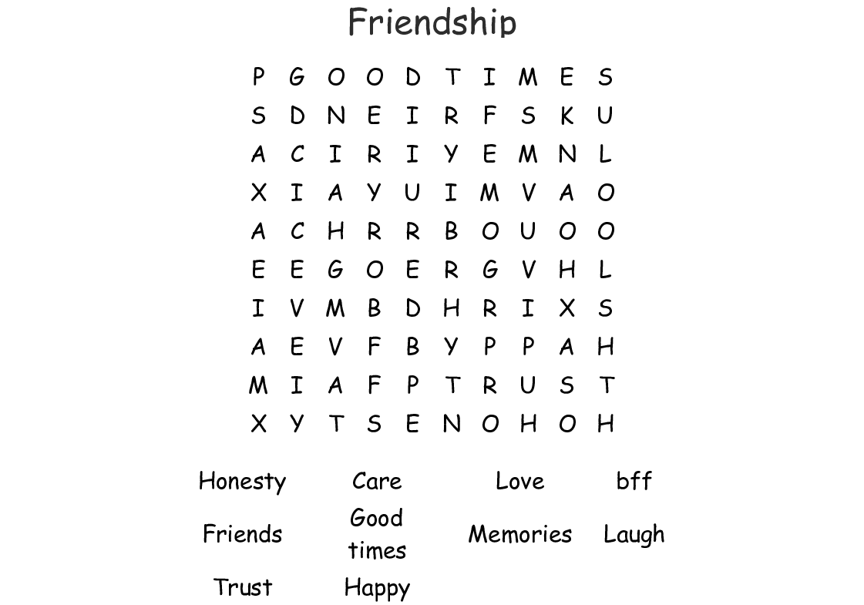

4
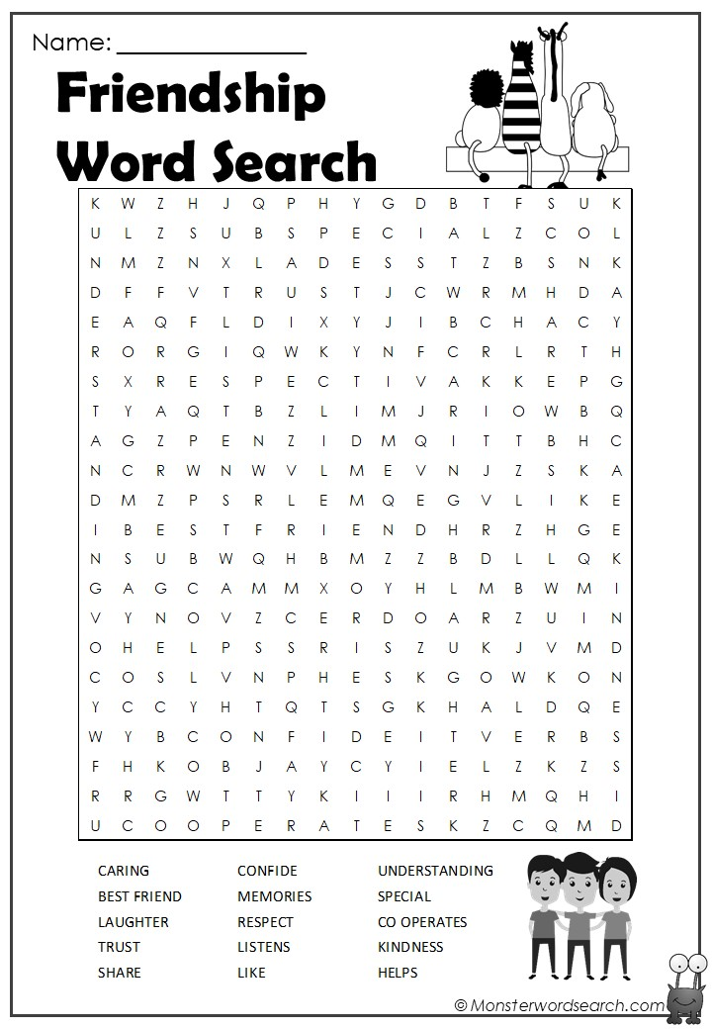

5

