CHILDREN’S PAGES

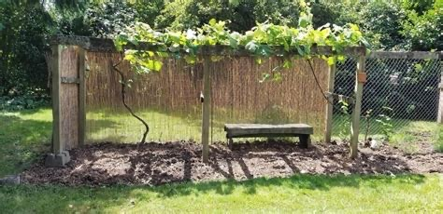

Sunday, 2 May 2021

Zion’s United Church of Christ of Taborton
741 Taborton Road
Sand Lake, NY 12164
518-674-1039 (office)
ziontabortonchurch@gmail.com


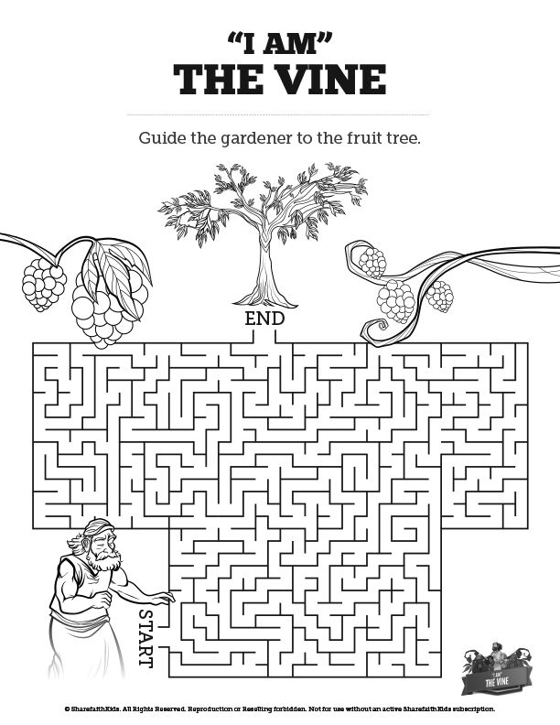



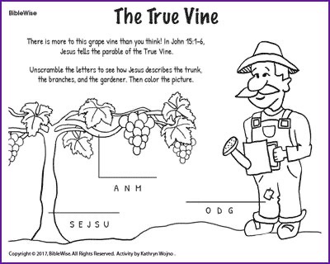
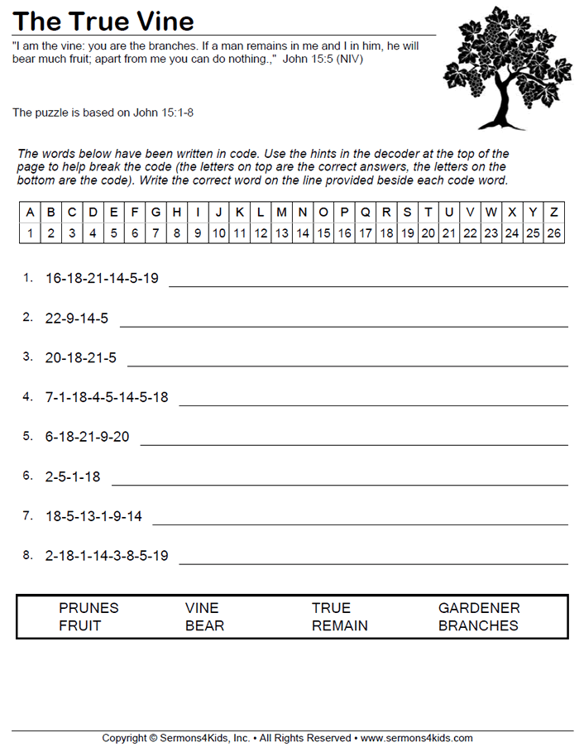







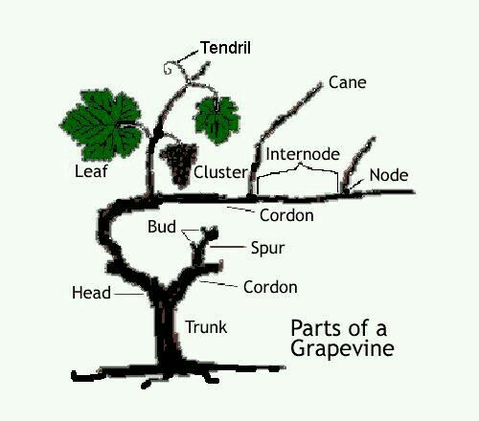

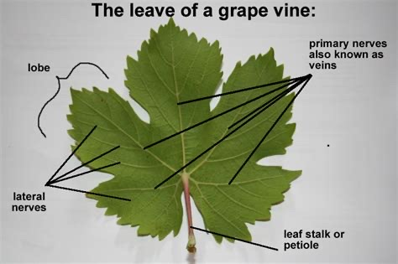



How to Make a Grape Vine Trellis From T-Posts
By Amelia Allonsy
homeguides.sfgate.com/make-grape-vine-trellis-tposts-53795.html

T-post trellises work well for training a single grapevine in a small home garden or for supporting an acres-long row of grape vines in a large vineyard operation. Made from sturdy steel, the T-shaped cross-pattern measures roughly 2 inches by 2 inches. While wooden fence posts require that you dig post holes and bury the ends, T-posts can simply be driven into the ground, using a post-hole driver that looks like a pipe with a closed end. You can install a single strand of wire for the trellis or use two strands to provide additional space for training the grape vines.

1
Drive wooden stakes in the ground at each end where you will install the grape vine trellis. Tie a string to one stake, pull it tight along the row and tie it to the other stake.
2
Mark the ground every 18 to 21 feet along the string line, using line-marking spray paint, to indicate the location for the T-posts.
3
Set 8-foot T-posts in the ground at each mark with a T-post driver until the ground anchor plate is concealed or about 2 feet in the ground.
4
Install earth anchors into the ground at a 45-degree angle to the outside of the end posts. These anchors feature an auger-style end that you simply twist to drive into the ground. The anchors should be a minimum of 40 inches long with 5/8-inch diameters.
5
Pull one strand of 12 1/2-gauge high-tensile wire across the row. Hold the wire in place about 3 inches from the top of the posts. Wrap the ends of the wire around the hook ends of the earth augers to hold the wire in place, leaving the strand loose along the rest of the trellis row.
6
Adjust the tension in the wire to about 250 pounds, using a wire-tensioning device. Fit the device on the wire, then twist or pump the tensioner until the desired amount of tension is achieved. Some tensioning devices have built-in tension gauges, while others require a bit of guesswork.
7
Attach the wire to the T-posts with T-post wire clips, beginning at one end of the fence. Push a wire clip in from the V-shaped side so the hooks end up on the open side of the posts. Push the wire strand onto the hooks, with one side of the wire clip under the wire and the other hook over the wire. Grip the hooks with a pair of pliersand wrap the wire hook ends around the wire strand.
8
Install wire clips to attach the wire to the remaining T-posts.
9
Install a second row of wire set about halfway up the post, adjusting the tension on the wire first, then securing the wire to the posts with T-post wire clips to hold the wire in place.

