CHILDREN’S PAGES

**Sunday, 25 April 2021**

**Zion’s United Church of Christ of Taborton**

**741 Taborton Road**

**Sand Lake, NY 12164**

**518-674-1039 (office)**

[**Ziontabortonchurch@gmail.com**](mailto:Ziontabortonchurch@gmail.com)

**The Conversion of Saul of Tarsus**

**Bible Address: Acts 9**

**2**

Sometimes when we are anxious or mad about something we say and do things that hurt the people around us. We can be anxious or mad about a lot of things. If we hold on to those feeling that keep us anxious and mad, we can hurt ourselves. Holding on to them will only make us more anxious and madder. What are some of the feelings that you might need to let go?

**3**

***Eight Things You Can Do***

***to Not Be So Mad and Anxious***

1. **Dancing (a “mad dance”) A child in a pink dress

   Description automatically generated with low confidence**
2. **Exercising** 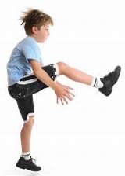
3. **Stomping feet A person drawing on a paper

   Description automatically generated with low confidence**
4. **Playing with clay or dough that can be pounded, twisted, and pulled** 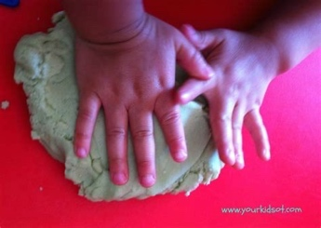

**4**

1. **Playing with water or sand**

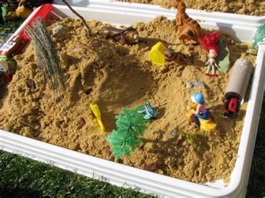

1. **Finger painting A picture containing person, colorful, skirt

   Description automatically generated**
2. **Going outside for a walk or run**

1. **Scribbling as hard as possible on a piece of paper that can be thrown away along with the anger.**

**5**

**6**

**7**

**Can you find the difference between the two pictures?**

**8**

**9**