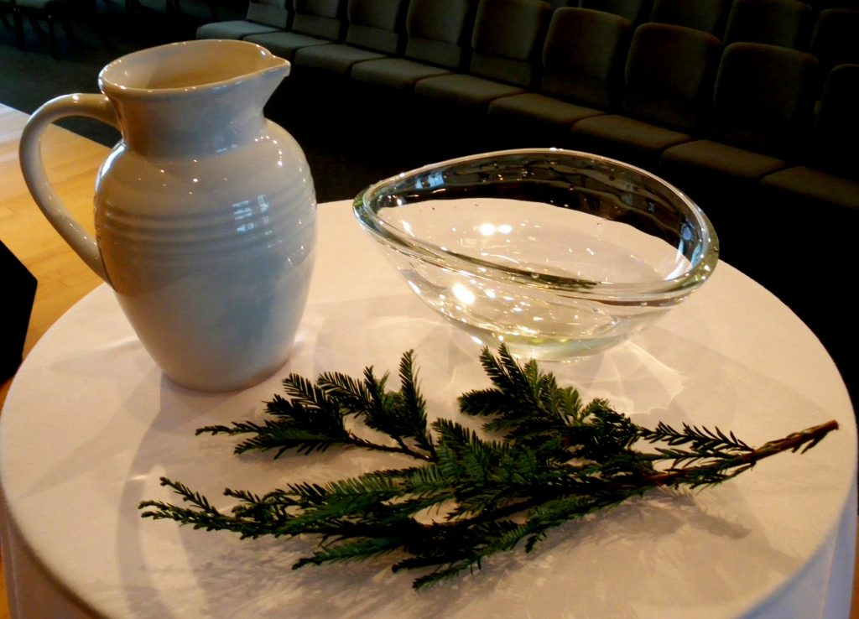

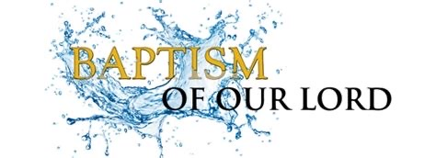

Sunday, January 10, 2022

Zion’s United Church of Christ of Taborton
741 Taborton Road
Sand Lake, New York 12153
518-674-1039 (office)
518-712-5008 (parsonage)
330-646-7954 (cell)
ziontabortonchurch@gmail.com
Zion’s United Church of Christ of Taborton
Service of the Worship of God
Sunday, January 3, 2021
The Baptism of Christ
Rev. Hafidha F. Saadiqah, Pastor * Mr. Robert Bondi, Board Moderator

PRELUDE

WELCOME & ANNOUNCEMENTS & CELEBRATIONS

CALL to WORSHIP
L: Hear these words from Holy Scripture:
“Just as the body is one
and has many members
and all the members of the body, though many, are one body,
so it is with Christ.”
P: For in the one Spirit
we were all baptized into one body—
Jews or Greeks, slaves or free—
and we were all made to drink of one Spirit.
L: Now you are the body of Christ and individually members of it.”
“God has told you what is good:
and what does the Lord require of you?
ALL: To do justice, and to love kindness, and to walk humbly with our God.”

* HYMN (p. 7) Come, O Fount of Every Blessing NETTLETON
CONFESSION OF SIN—A LITANY
L: Sovereign God,
in baptism you called us to turn from sin and to turn to Jesus Christ;
but we stray from his ways
and do not heed your call.
(Silence.)
Lord, have mercy.
P: Christ, have mercy.
L: In baptism you joined us to Christ in his death that we might be raised with Christ in new life; but we cherish old ways
and fail to embrace the risen life
of righteousness, justice, and love.
(Silence.)
Lord, have mercy.
P: Christ, have mercy.
In baptism you united us with all the baptized who confess your name;
but we foster division in the church.
We refuse to live as one people,
and so fail to witness to your reconciling love before the world.
(Silence.)
Lord, have mercy.
P: Christ, have mercy.
L: In baptism you call us to ministry
in all realms of life,
but we refuse the struggle to know your will; we do not nurture the ways of peace; we allow enmity and hatred to grow among us, putting neighbor against neighbor, and nation against nation.
We abuse the earth you entrust to our care, and live in discord with all you have made.
(Silence.)
Lord, have mercy.
P: Christ, have mercy.
L: In baptism you sent us to serve with compassion all for whom Christ died;
but we ignore the suffering of the oppressed
and the plight of the poor.
We take bread from the hungry,
and will not listen to cries for justice.
(Silence.)
Lord, have mercy.
P: Christ, have mercy.
L: In baptism you gave us the Holy Spirit to teach and guide us,
but we rely on ourselves,
and refuse to trust your direction.
We spurn your eternal wisdom, preferring the luring ways of the world.
(Silence.)

2
Lord, have mercy.
P: Christ, have mercy.
Lord, have mercy on us.
Remember the promises you made to us in our baptism, forgive our sinful ways and heal our brokenness.
Set us free from all that enslaves us,
and raise us to new life in Jesus Christ,
that we may be your faithful servants,
showing forth your healing love to the world,
to the glory of your holy name.
ALL: Amen.

* Words of Assurance (minister)
* Gloria Patri (spoken)
Glory to the Creator, the Christ, the Holy Spirit Three in One!
As it was in the beginning, is now, and ever shall be;
World without end. Amen. Amen.
*Offering Signs of Peace

CHILDREN’S TIME

INVITATION to STEWARDSHIP & OFFERING
Doxology (spoken)
Praise God from whom all blessings flow,
Praise God all creatures here below.
Praise God above, ye heavenly host.
Creator, Christ, and Holy Ghost. Amen.

Prayer of Dedication
Gracious God, accept these gifts, and with them our lives,
to be used in your service; through Jesus Christ our Lord.
Amen.

PRAYERS of the PEOPLE & THE LORD’S PRAYER

SCRIPTURE (p. 6 ) St. Mark 1:4-11

3
SERMON Baptism, It’s Just the Beginning

REAFFIRMATION of the BAPTISMAL COVENANT
Scripture Sentences
Profession of Faith
Renunciations
L: Do you renounce all evil,
and powers in the world which defy God’s righteousness and love?
P: I renounce them.

L: Do you renounce the ways of sin that separate you from the love of
God?
P: I renounce them.

L: Do you turn to Jesus Christ
and acknowledge him anew as your Lord and Savior?
P: I do.

L: Will you be Christ’s faithful disciple,
obeying God’s word and showing God’s love,
to your life’s end?
P: I will, with God’s help.

Profession Apostles’ Creed
L: With the whole church, let us confess our faith.
Do you believe in God the Father?
P: I believe in God, the Father almighty, creator of heaven and earth.
L: Do you believe in Jesus Christ, the Son of God?
P: I believe in Jesus Christ, God’s only Son, our Lord,
who was conceived by the Holy Spirit,
born of the Virgin Mary,
suffered under Pontius Pilate,
was crucified, died, and was buried; he descended to the dead.
On the third day he rose again;
he ascended into heaven,
he is seated at the right hand of the Father,

4

and he will come to judge the living and the dead.
L: Do you believe in God the Holy Spirit?
I believe in the Holy Spirit, the holy catholic church, the communion of saints, the forgiveness of sins,
the resurrection of the body, and the life everlasting. Amen.

Thanksgiving for Baptism (Pouring the waters)
L: The Lord be with you.
P: And also with you.
L: Let us give thanks to the Lord our God.
P: It is right to give our thanks and praise.
L: Let us pray. Eternal and gracious God, we give you thanks.
In countless ways you have revealed yourself in ages past, and have blessed us with signs of your grace.

We praise you that through the waters of the sea you led your people Israel out of bondage,
into freedom in the land of your promise.

We praise you for sending Jesus your Son,
who for us was baptized in the waters of the Jordan, and was anointed as the Christ by your Holy Spirit. Through the baptism of his death and resurrection you set us free from the bondage of sin and death and give us cleansing and rebirth.

We praise you for your Holy Spirit,
who teaches us and leads us into all truth, filling us with a variety of gifts, that we might proclaim the gospel to all nations and serve you as a royal priesthood.

We rejoice that you claimed us in our baptism, and that by your grace we are born anew. By your Holy Spirit renew us,
that we may be empowered to do your will and continue forever in the risen life of Christ, to whom, with you and the Holy Spirit,
be all glory and honor, now and forever.
ALL: Amen.

5

L: Remember your baptism and be thankful.
In the name of the Father and of the Son and of the Holy Spirit.
ALL: Amen.

* HYMN (p. 8) Called as Partners in Christ’s Service BEECHER
* BENEDICTION

POSTLUDE

Today’s Scripture:
St. Mark 1:4-11
(Common English Bible)

﻿⁴ John the Baptist was in the wilderness calling for people to be baptized to show that they were changing their hearts and lives and wanted God to forgive their sins. ⁵ Everyone in Judea and all the people of Jerusalem went out to the Jordan River and were being baptized by John as they confessed their sins. ⁶ John wore clothes made ﻿of camel's hair, with a leather belt around his waist. He ate locusts and wild honey. ⁷ He announced, "One stronger than I am is coming after me. I'm not even worthy to bend over and loosen the strap of his sandals. ⁸ I baptize you with water, but he will baptize you with the Holy Spirit."
⁹ About that time, Jesus came from Nazareth of Galilee, and John baptized him in the Jordan River. ¹⁰ While he was coming up out of the water, Jesus saw heaven splitting open and the Spirit, like a dove, coming down on him. ¹¹ And there was a voice from heaven: "You are my Son, whom I dearly love; in you I find happiness."

THANK YOU FOR WORSHIPPING WITH US!

6

﻿
in
Fellowship Hall!

HYMNS FOR THE LORD’S DAY

COME, THOU FOUNT OF EVERY BLESSING

HYMN TUNE: NETTLETON
LYRICS: Robert Robinson; Ps.36:7-9

- Come, thou Fount of every blessing, tune my heart to sing thy praise;
streams of mercy, never ceasing, call for songs of loudest praise.
Teach me some melodious sonnet, sung by flaming tongues above.
Praise the mount! I’m fixed upon it, mount of God’s unchanging love.

7

- Here I raise my Ebenezer; hither by thy help I’m come;
And I hope, by thy good pleasure, safely to arrive at home.
Jesus sought me when a stranger, wandering from the fold of God;
He, to rescue me from danger, interposed his precious blood.

- O to grace how great a debtor daily I’m constrained to be!
Let they grace now, like a fetter, bind my wandering heart to thee.
Prone to wander, Lord, I feel it, prone to leave the God I love;
Here’s my heart; O take and seal it; seal it for thy courts above.

CALLED AS PARTNERS IN CHRIST’S SERVICE

HYMN TUNE: BEECHER
LYRICS: Jane Parker Huber

- Called as partners in Christ’s service, called to ministries of grace,
We respond with deep commitment fresh new lines of faith to trace.
May we learn the art of sharing, side by side and friend with friend,
equal partners in our caring to fulfill God’s chosen end.

- Christ’s example, Christ’s inspiring, Christ’s clear call to work and worth,
let us follow, never faltering, reconciling folk on earth.
Men and women, richer, poorer, all God’s people, young and old,
blending human skills together, gracious gifts from God unfold.

- Thus new patterns for Christ’s mission, in a small or global sense,
Help us bear each other’s burdens, breaking down each wall or fence.
Words of comfort, words of vision, words of challenge, said with care,
bring new power and strength for action, make us colleagues, free and fair.

- So, God grant us for tomorrow ways to order human life
that surround each person’s sorrow with a calm that conquers strife.
Make us partners in our living, our compassion to increase,
Messengers of faith, thus giving hope and confidence and peace.

8

***CHANGE: Sunday School for Children - Classes will begin on Sunday, January 24, 20201. See you then!

Food Pantry 2021: The Mission Committee is busy making plans to open a Food Pantry for individuals and families who may need assistance. There is much to plan for and do. If you would like to contribute to the organizing efforts of getting this mission off the ground, please leave your donation in the offering plate, or send it to the church office. Also, there is a donation container in Fellowship Hall.

2021 Calendars from Perry-Komdat Funeral Chapel are available in the Narthex.

Bring Your Own Theology Gathering happens every Wednesday evening, 7:00pm to 8:00pm. We are in conversation with St. John’s UCC in Elmore, OH and Park Church UCC in Toledo, OH. The Meeting ID# is 876 2695 1505 and the Passcode is 764342.

