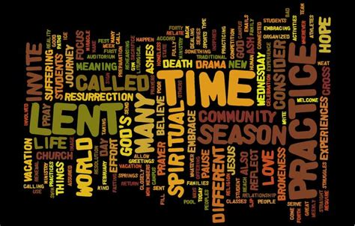

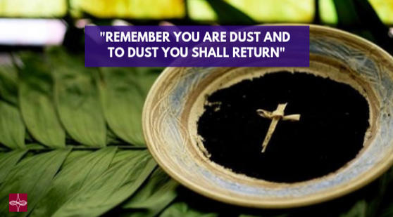

ASH WEDNESDAY

Wednesday, February 17, 2021

Zion’s United Church of Christ of Taborton
741 Taborton Road
Sand Lake, New York 12153
518-674-1039 (office)
518-712-5008 (parsonage)
330-646-7954 (cell)
ziontabortonchurch@gmail.com
Zion’s United Church of Christ of Taborton
Service of the Worship of God
Wednesday, February 17, 2021
Rev. Hafidha F. Saadiqah, Pastor * Mrs. Ronda Stevens, Board Moderator
GATHERING MUSIC

CALL to WORSHIP
L: The grace of our Lord Jesus Christ be with you!
P: And also with you.
L: Bless the Lord, O my soul, and all that is within me, bless God’s
holy name.
P: Bless the Lord, O my soul, and forget not all God’s benefits.
L: Who forgives all your sins and heals all your infirmities;
P: Who redeems your life from the grave, and crowns you will mercy and
loving-kindness.

OPENING PRAYER

HYMN Lord Jesus, Who through Forty Days ST. FLAVIAN

1 Lord, Jesus, who through forty days for us did fast and pray,
Teach us with you to mourn our sins, and close by you to stay.

2 And through these days of penitence, and through this Passiontide,
Yes, evermore, in life and death, O Christ with us abide.

FIRST READING Joel 2:1-2, 12-17a
Blow the trumpet in Zion;
sound the alarm on my holy mountain!
Let all the inhabitants of the land tremble,
for the day of the Lord is coming, it is near—
² a day of darkness and gloom,
a day of clouds and thick darkness!
Like blackness spread upon the mountains
a great and powerful army comes;
their like has never been from of old,
nor will be again after them
in ages to come.
¹² Yet even now, says the Lord,
return to me with all your heart,
with fasting, with weeping, and with mourning;
¹³ rend your hearts and not your clothing.
Return to the Lord, your God,
for he is gracious and merciful,
slow to anger, and abounding in steadfast love,
and relents from punishing.
¹⁴ Who knows whether he will not turn and relent,
and leave a blessing behind him,
a grain offering and a drink offering
for the Lord, your God?
¹⁵ Blow the trumpet in Zion;
sanctify a fast;
call a solemn assembly;
¹⁶ gather the people.
Sanctify the congregation;
assemble the aged;
gather the children,
even infants at the breast.
Let the bridegroom leave his room,
and the bride her canopy.
¹⁷ Between the vestibule and the altar
let the priests, the ministers of the Lord, weep.
Let them say, “Spare your people, O Lord,
and do not make your heritage a mockery,
a byword among the nations.
Why should it be said among the peoples,
‘Where is their God?’”

SOLO Give Me a Clean Heart arr. M. Douroux
Give me a clean heart so that I may serve thee.
Lord, fix my heart so that I may be used by thee.
For I’m not worthy of all these blessings.
Give me a clean heart, and I’ll follow thee.

2
I’m not asking for the riches of this land.
I’m not asking for high men to know my name.
Please give me, Lord, a clean heart so that I may follow thee.
For I’m not worthy of all these blessings.
Give me a clean heart and I’ll follow thee.

SECOND READING II Corinthians 5:20, 6:2-10
5 we entreat you on behalf of Christ, be reconciled to God.
²¹ For our sake he made him to be sin who knew no sin,
6 As we work together with him, we urge you also not to accept the grace of God in vain. ² For he says,
“At an acceptable time I have listened to you,
and on a day of salvation I have helped you.”
See, now is the acceptable time; see, now is the day of salvation! ³ We are putting no obstacle in anyone’s way, so that no fault may be found with our ministry, ⁴ but as servants of God we have commended ourselves in every way: through great endurance, in afflictions, hardships, calamities, ⁵ beatings, imprisonments, riots, labors, sleepless nights, hunger; ⁶ by purity, knowledge, patience, kindness, holiness of spirit, genuine love, ⁷ truthful speech, and the power of God; with the weapons of righteousness for the right hand and for the left; ⁸ in honor and dishonor, in ill repute and good repute. We are treated as impostors, and yet are true; ⁹ as unknown, and yet are well known; as dying, and see—we are alive; as punished, and yet not killed; ¹⁰ as sorrowful, yet always rejoicing; as poor, yet making many rich; as having nothing, and yet possessing everything.

RESPONSE
L: Cry, and God will answer.
P: Call, and the Lord will say, “I am here.”
L: Your light will rise in the darkness and your shadows become like noon.
The lord will always guide you, giving you relief in desert places.
P: Cry, and God will answer. Call, and the Lord will say, “I am here.”

THIRD READING Matthew 6:1-6, 16-21
“Beware of practicing your piety before others in order to be seen by them; for then you have no reward from your Father in heaven.
² “So whenever you give alms, do not sound a trumpet before you, as the hypocrites do in the synagogues and in the streets, so that they may be praised by others. Truly I tell you, they have received their reward. ³ But when you give alms, do not let your
3
left hand know what your right hand is doing, ⁴ so that your alms may be done in secret; and your Father who sees in secret will reward you.

⁵ “And whenever you pray, do not be like the hypocrites; for they love to stand and pray in the synagogues and at the street corners, so that they may be seen by others. Truly I tell you, they have received their reward. ⁶ But whenever you pray, go into your room and shut the door and pray to your Father who is in secret; and your Father who sees in secret will reward you.
⁷ “When you are praying, do not heap up empty phrases as the Gentiles do; for they think that they will be heard because of their many words. ⁸ Do not be like them, for your Father knows what you need before you ask.
⁹ “Pray then in this way:
Our Father in heaven,
hallowed be your name.
¹⁰ Your kingdom come.
Your will be done,
on earth as it is in heaven.
¹¹ Give us this day our daily bread.
¹² And forgive us our debts,
as we also have forgiven our debtors.
¹³ And do not bring us to the time of trial,
but rescue us from the evil one.
¹⁴ For if you forgive others their trespasses, your heavenly Father will also forgive you; ¹⁵ but if you do not forgive others, neither will your Father forgive your trespasses.

¹⁶ “And whenever you fast, do not look dismal, like the hypocrites, for they disfigure their faces so as to show others that they are fasting. Truly I tell you, they have received their reward. ¹⁷ But when you fast, put oil on your head and wash your face, ¹⁸ so that your fasting may be seen not by others but by your Father who is in secret; and your Father who sees in secret will reward you.

¹⁹ “Do not store up for yourselves treasures on earth, where moth and rust[consume and where thieves break in and steal; ²⁰ but store up for yourselves treasures in heaven, where neither moth nor rust consumes and where thieves do not break in and steal. ²¹ For where your treasure is, there your heart will be also.

4
HYMN Just As I Am WOODWORTH
1 Just as I am, without one plea
but that thy blood was shed for me,
and that thou biddest me come to thee,
O Lamb of God, I come, I come!

2 Just as I am, though tossed about
with many a conflict, many a doubt,
and fears, within, without,
O Lamb of God, I come, I come!

INVITATION to the OBSERVANCE of the LENTEN DISCIPLINE
L: The Lord be with you.
P: And also with you.

IMPOSITION of ASHES
Those desiring to receive the ashes are invited to form a line and come forward.
Please indicate where you would like the ashes applied: forehead or back of the hand.

A PSALM of CONFESSION Psalm 51:1-17
Have mercy on me, O God,
according to your steadfast love;
according to your abundant mercy
blot out my transgressions.
² Wash me thoroughly from my iniquity,
and cleanse me from my sin.
³ For I know my transgressions,
and my sin is ever before me.
⁴ Against you, you alone, have I sinned,
and done what is evil in your sight,
so that you are justified in your sentence
and blameless when you pass judgment.
⁵ Indeed, I was born guilty,
a sinner when my mother conceived me.
⁶ You desire truth in the inward being;
therefore teach me wisdom in my secret heart.
⁷ Purge me with hyssop, and I shall be clean;
5
wash me, and I shall be whiter than snow.
⁸ Let me hear joy and gladness;
let the bones that you have crushed rejoice.
⁹ Hide your face from my sins,
and blot out all my iniquities.
¹⁰ Create in me a clean heart, O God,
and put a new and right^{[b]} spirit within me.
¹¹ Do not cast me away from your presence,
and do not take your holy spirit from me.
¹² Restore to me the joy of your salvation,
and sustain in me a willing^{[c]} spirit.
¹³ Then I will teach transgressors your ways,
and sinners will return to you.
¹⁴ Deliver me from bloodshed, O God,
O God of my salvation,
and my tongue will sing aloud of your deliverance.
¹⁵ O Lord, open my lips,
and my mouth will declare your praise.
¹⁶ For you have no delight in sacrifice;
if I were to give a burnt offering, you would not be pleased.
¹⁷ The sacrifice acceptable to God is a broken spirit;
a broken and contrite heart, O God, you will not despise.

RECONCILIATION and COMMENDATION

PRAYERS of the PEOPLE & THE LORD’S PRAYER

HYMN Beneath the Cross of Jesus ST. CHRISTOPHER
- Beneath the cross of Jesus I fain would take my stand,
The shadow of a mighty rock within a weary land;
A home within the wilderness, a rest upon the way.
From the burning of the noontide heat, and the burden of the day.

- I take, O cross, they shadow for my abiding place;
I ask no other sunshine than the sunshine of his face;
Content to let the world go by to know no gain or loss;
My sinful self my only shame, my glory all the cross

BENEDICTION

