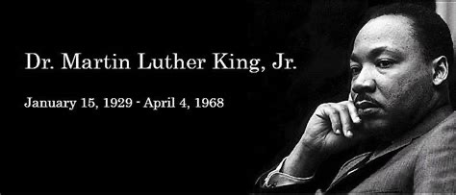

Sunday, January 17, 2022

Zion’s United Church of Christ of Taborton
741 Taborton Road
Sand Lake, New York 12153
518-674-1039 (office)
518-712-5008 (parsonage)
330-646-7954 (cell)
ziontabortonchurch@gmail.com
Zion’s United Church of Christ of Taborton
Service of the Worship of God
Sunday, January 17, 2021
Second Sunday After Epiphany
The Rev. Dr. Martin Luther King, Jr. Sunday
Rev. Hafidha F. Saadiqah, Pastor * Mr. Robert Bondi, Board Moderator

WELCOME & ANNOUNCEMENTS & CELEBRATIONS

CALL to WORSHIP
L: We worship the God who inhabits our world and indwells our lives.
We need not look up to find God;
we need only look around:
within ourselves, beyond ourselves, into the eyes of another.
We need not listen for a distant thunder to find God,
P: we need only listen to the music of life,
the words of children,
the questions of the curious,
the rhythm of a heartbeat.
ALL: We worship the God who inhabits our world and who indwells our lives.
Presbyterianmission.org

* HYMN (p.6 ) O God, Our Help in Ages Past LEONI

RESPONSIVE PRAYER of CONFESSION
L: The struggles of our world feel overwhelming, Jesus;
beyond our ability to understand, let alone solve.
P: We do not have the capacity
to silence the justifications,
to heal the addictions,
to restore the brokenness,
to repair the destruction,
or to reverse the trajectories
of our self-centered, short-sighted weakness,
our heartless, dehumanizing aggression.
L: But, we do not face these struggles alone, Jesus;
P: You have aligned yourself with us,
in taking on flesh,
in going through the waters of life and death,
in laying down your life;

ALL: And you have invited us to partner with you,
in proclaiming Good News,
in freeing the imprisoned,
in restoring the broken,
in uniting the divided;
And you have given us the capacity,
the divine Spirit,
to be co-workers with God.
For this, we are eternally grateful. Amen.
Sacridise.com

* Words of Assurance (minister)
* Gloria Patri (spoken)
Glory to the Creator, the Christ, the Holy Spirit Three in One!
As it was in the beginning, is now, and ever shall be;
World without end. Amen. Amen.
*Offering Signs of Peace

CHILDREN’S TIME

INVITATION to STEWARDSHIP & OFFERING
Doxology (spoken)
Praise God from whom all blessings flow,
Praise God all creatures here below.
Praise God above, ye heavenly host.
Creator, Christ, and Holy Ghost. Amen.

Prayer of Dedication
Gracious God: The seeds of your Kin-dom are forever being sown
into our lives and our world. Use us and the gifts we bring - seeds of justice with
accountability, compassion, and transformation - to flower.

2
Through the power of Jesus, the Risen Christ, we pray. Amen.

PRAYERS of the PEOPLE & THE LORD’S PRAYER

SCRIPTURE (p. 4 ) I Samuel 3:1-20 & St. John 1:43-51

SERMON Answering the Call

A COVENANT PRAYER of RECOMMITMENT to JUSTICE
L: O God, who has created your children to be free, we attest in word and deed
that you are our God and we are your people. From our earliest days as the people whom you intend to be free, O God, you have called us forth from self- seeking bondage, comfort, complacency, and complaint, to freeing and redeeming action for justice everywhere in the world.
P: You are our freeing God, and we would be your free and freeing people.
L: O God of Exodus and the Burning Bush, of the Prophets and of Jesus,
we hear your powerful calling to be your servants in the service of all those
who are oppressed. At every turn we hear your voice in the cries of the poor,
the hungry, the imprisoned, and the broken, for you made yourself one with
those who seek justice, freedom, and peace. We share a vision, a promise, and
a yearning for the day of your reign, O God.
P: You are our servant God, and we would be your serving people.
L: O God, Our Sustainer, search our hearts and reveal to us our sinfulness, all
the ways that we contribute to injustice and to self-destroying bondage. Give
us deep courage to find the true path of your way, ready to give our very
selves as living sacrifices for your will. We have heard your calling.
Hear us now as we make our pledge.
ALL: You are our God and we are your people. We pledge ourselves now to
pursue relentlessly that living, breathing justice which transforms
persons and peoples. To your will for justice, we recommit ourselves and
pledge ourselves, our funds, our actions. Through Christ we pray. Amen.

* HYMN (p. 7 ) O God of Strength WELWYN

* BENEDICTION

3

Today’s Scripture:
I Samuel 3:1-10
(Common English Bible)

﻿Now the boy Samuel was serving the LORD under Eli. The LORD's word was rare at that time, and visions weren't widely known.
² One day Eli, whose eyes had grown so weak he was unable to see, was lying down in his room. ³ God's ﻿lamp hadn't gone out yet, and Samuel was lying down in the LORD's temple, where God's chest was. ⁴ The LORD called to Samuel. "I'm here," he said. ⁵ Samuel hurried to Eli and said, "I'm here. You called me?" "I didn't call you," Eli replied. "Go lie down." So, he did. ⁶ Again the LORD called Samuel, so Samuel got up, went to Eli, and said, "I'm here. You called me?" "I didn't call, my son," Eli replied. "Go and lie down." ⁷ Now Samuel didn't yet know the LORD, and the LORD's word hadn't yet been revealed to him. ⁸ A third time the LORD called Samuel. He got up, went to Eli, and said, "I'm here. You called me?" ﻿Then Eli realized that it was the LORD who was calling the boy. ⁹ So Eli said to Samuel, "Go and lie down. If God calls you, say, 'Speak, LORD. Your servant is listening.'" So, Samuel went and lay down where he'd been.
¹⁰Then the LORD came and stood there, calling just as before, "Samuel, Samuel!" Samuel said, "Speak. Your servant is listening."

St. John 1:43-51
(Common English Bible)

﻿ ⁴³The next day Jesus wanted to go into Galilee, and he found Philip. Jesus said to him, "Follow me."
⁴⁴Philip was from Bethsaida, the hometown of Andrew and Peter.
⁴⁵Philip found Nathanael and said to him, "We have found the one Moses wrote about in the Law and the Prophets: Jesus, Joseph's son, from Nazareth."
⁴⁶Nathanael responded, "Can anything from Nazareth be good?" Philip said, "Come and see."
⁴⁷Jesus saw Nathanael coming toward him and said about him, "Here is a genuine Israelite in whom there is no deceit."

4
﻿⁴⁸Nathanael asked him, "How do you know me?" Jesus answered, "Before Philip called you, I saw you under the fig tree."
⁴⁹Nathanael replied, "Rabbi, you are God's Son. You are the king of Israel."
⁵⁰Jesus answered, "Do you believe because I told you that I saw you under the fig tree? You will see greater things than these! ⁵¹I assure you that you will see heaven open and God's angels going up to heaven and down to earth on the Human One."

THANK YOU FOR WORSHIPPING WITH US!

﻿
in
Fellowship Hall!

5

HYMNS FOR THE LORD’S DAY

O GOD, OUR HELP IN AGES PAST

HYMN TUNE: LEONI
LYRICS: Isaac Watts

- O God, our help in ages past,
our hope for years to come;
Our shelter from the stormy blast,
and out eternal home.

- Under the shadow of your throne,
your saints have dwelt secure;
Sufficient is thine arm alone,
and our defense is sure.

- A thousand ages in your sight,
are like an evening gone;
Short as the watch that ends the night
before the rising sun.

- O God, our help in ages past,
our hope for years to come,
Still be our God while troubles last,
and our eternal home.

6

O GOD OF STRENGTH

HYMN TUNE: WELWYN
LYRICS: Shepherd Knapp

- O God of strength, whose purpose, never swerving,
shall make complete the work Christ has begun;
Grant us to join and work with all disciples,
filled with your strength to see your will is done.

- O Word Made Flesh, who work God’s word continued,
one with the Spirit’s thought and deed and word;
Now make us one, companions in your service,
your living body by the Spirit stirred.

- O Power of Peace, who brings to us good tidings,
teach us to speak your word of hope and cheer;
Rest for the soul, and strength for all our striving,
Light for the path of life, and truth brought near.

- O God, whose grace has called us to your service,
how good your thoughts toward us, how great your sum!
We work with you, we go where you will lead us,
until in all the earth your reign shall come.

7
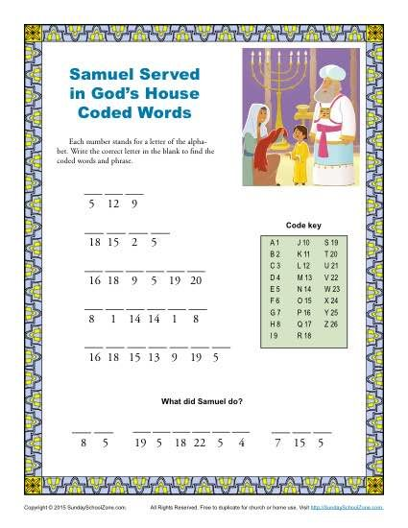

Sunday School for Children is in recess. Classes will begin on Sunday, January 24, 20201. See you then!

Zion’s UCC Annual Meeting is set for Sunday February 7, 2021 immediately after morning worship.

Food Pantry 2021: The Mission Committee is busy making plans to open a Food Pantry for individuals and families who may need assistance. There is much to plan for and do. If you would like to contribute to the organizing efforts of getting this mission off the ground, please leave your donation in the offering plate, or send it to the church office. Also, there is a donation container in Fellowship Hall.

2021 Calendars from Perry-Komdat Funeral Chapel are available in the Narthex.

Bring Your Own Theology Gathering happens every Wednesday evening, 7:00pm to 8:00pm. We are in conversation with St. John’s UCC in Elmore, OH and Park Church UCC in Toledo, OH. The Meeting ID# is 876 2695 1505 and the Passcode is 764342.

