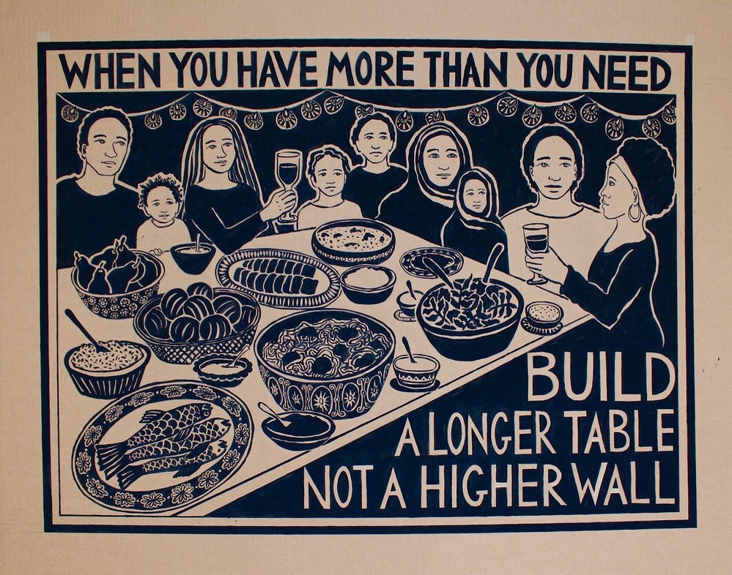

Sunday, November 22, 2020

Zion’s United Church of Christ of Taborton
741 Taborton Road
Sand Lake, New York 12153
518-674-1039 (office)
518-712-5008 (parsonage)
330-646-7954 (cell)
ziontabortonchurch@gmail.com
Zion’s United Church of Christ of Taborton
Service of the Worship of God
Twenty-Fifth Sunday After Pentecost
Rev. Hafidha F. Saadiqah, Pastor * Mr. Robert Bondi, Board Moderator
Mr. Conor Frost, Musician

WELCOME & ANNOUNCEMENTS

GATHERING HYMN Now Thank We All Our God NUN DANKET

1 Now thank we all our God with heart and hands and voices,
who wondrous things has done, in whom this world rejoices;
Who from our parents’ arms, has blessed us on our way
with countless gifts of love, and still is ours today.

2 O may this bounteous God through all our life be near us,
with ever joyful hearts and blessed peace to cheer us;
And keep us still in grace, and guide us when perplexed,
and free us from all ills in this world and the next.

OPENING PRAYER and PRAYERS of the PEOPLE (repeat three times slowly)
Breathing in: “I stand in awe…”
Breathing out: “…of all creation.”

WORDS of THANKGIVING for the GOOD EARTH
(food, water, trees, air, beach, meadows, mountains)

HYMN Let Us with a Joyful Mind INNOCENTS

1 Let us with a joyful mind praise our God forever kind,
Refrain: Rich in mercies that endure, ever faithful, ever sure.

2 New-made earth was filled with light through God’s all commanding might, Refrain: Rich in mercies that endure, ever faithful, ever sure.

3 Creatures of the sea and land all are fed by God’s own hand,
Refrain: Rich in mercies that endure, ever faithful, ever sure.
A PRAYER OF THANKSGIVING -adpt,. Rev. Walter Rauschenbusch 1861-1918

For the wide sky and the blessed sun, the salt sea and the running water,
the everlasting hills
the never-resting winds;
trees and the common grass underfoot - creator God, we thank you!
We thank you for our senses by which we hear the songs of birds,
see the splendor of the summer fields
taste of the autumn fruits,
rejoice in the feel of the snow
and smell the breath of spring.
Grant us a heart wide open to all this beauty;
and save our souls from being so blind
that we pass unseeing
when even the common thornbush
is aflame with your glory.
This we pray, O, God our creator, who lives and reigns for ever and ever.

CHILDREN’S TIME

INVITATION to STEWARDSHIP
Doxology (spoken)
Praise God from whom all blessings flow,
Praise God all creatures here below.
Praise God above, ye heavenly host.
Creator, Christ, and Holy Ghost. Amen.

Prayer of Dedication
Gracious God, we give You what is already yours,
whatever the gift may be; all that we have is Yours alone,
a trust, O God, from You. Amen.

WORDS of THANKSGIVING for CITIZENSHIP and FREEDOM
(country, democracy, peace and international neighbors)

HYMN This is My Song FINLANDIA

2
1 This is my song, O God of all the nations,
a song of peace for lands afar and mine;
this is my home, the country where my heart is;
here are my hopes, my dreams, my holy shrine:
but other hearts in other lands are beating
with hopes and dreams as true and high as mine.

- May truth and freedom come to every nation;
may peace abound where strife has raged so long;
that each may seek to love and build together,
a world united, righting every wrong;
a world united in its love for freedom,
proclaiming peace together in one song.

WORDS of THANKSGIVING for INSTITUTIONAL INVOLVEMENTS
(work, service organizations, schools)

HYMN For the Fruit of All Creation AR HYD Y NOS

- For the fruit of all creation, thanks be to God.
For God’s gift to every nation, thanks be to God.
For the plowing, sowing, reaping,
Silent growing while we are sleeping,
Future needs in earth’s safe-keeping, thanks be to God.

- In the just reward of labor, God’s will is done,
In the help we give our neighbor, God’s will is done.
In our world-wide task of caring
For the hungry and despairing,
In the harvests we are sharing, God’s will is done.

A PRAYER of THANKSGIVING
L: Let us join our hands and hearts in gratitude on this wondrous day,
where we have the abundance of our lives before us.
P: We remember on this day of bounty all of those who do not have enough,
who are afraid, who are lonely, and who suffer.

3
L: We work so that the abundance of this world will be shared, for fear to become love, for the lonely to feel welcomed, and for the suffering to know rest and joy.
P: For the labors, the love, the care that gave us the delights of this and every day, we say “Thanks!”
L: For the nourishment of our spirit, the challenges that strengthen us, and the friends we have on the journey, we sing “Thanks!”
ALL: For all that is our life, for these good gifts, we whisper, “Thanks!” Overflowing with gratitude, let us shout, “Thanks!” Amen.
-by Naomi King

WORDS of THANKSGIVING for INTERPERSONAL RELATIONSHIPS
(family, friends, diversity, new acquaintances)

HYMN Let Us Build a House M. Haugen

- Let us build a house where love can dwell and all can safely live,
a place where saints and children tell how hearts learn to forgive.
Built of hopes and dreams and visions, rock of faith and vault of grace;
here the love of Christ shall end divisions:
“All are welcome, all are welcome, all are welcome in this place.”

- Let us build a house where prophets speak, and words are strong and true,
where all God’s children dare to seek to dream God’s reign anew.
Here the cross shall stand as witness and as symbol of God’s grace;
Here as one we claim the faith of Jesus:
“All are welcome, all are welcome, all are welcome in this place.”

- Let us build a house where all are named, their songs and visions heard
and loved and treasured, taught and claimed as words within the Word.
Built of tears and cries and laughter, prayers of faith and songs of grace;
Let this house proclaim from floor to rafter:
“All are welcome, all are welcome, all are welcome in this place.”

A PRAYER of THANKSGIVING
L: For family who are friends, and friends who are family…

4
P: (speak those names of family and friends who will or would be at your table this week)

WORDS of THANKSGIVING for SPIRITUAL RESOURCES
(faith, Zion’s UCC, scriptures, teachers, music)

CLOSING HYMN Draw Us in the Spirit’s Tether UNION SEMINARY

- Draw us in the Spirit’s tether for when humbly in your name,
Two or three are met together, Thou art in the midst of them;
Alleluia! Alleluia! Touch we now Thy garments hem.

- All our meals and all our living make as sacraments of Thee,
That by caring, helping, giving, we may true disciples be.
Alleluia! Alleluia! We may serve Thee faithfully.

CLOSING PRAYER ~excerpted, Rev. Howard Thurman, 1899–1981
Today, we make our sacrament of thanksgiving.
we conclude this service mindful of the simple things of our days:
fresh air to breathe,
clean, cool water to drink,
the taste of food,
the protection of houses and clothes,
the comforts of home.
for all these we make an act of Thanksgiving this day!

BENEDICTION

5
Join us for Coffee Hour in Fellowship Hall!





6

R E M I N D E R S…

Zion’s UCC Quilts on Display: Linda Bondi has coordinated the two quilts which hang in our sanctuary to be included in a month-long exhibit at the Sand Lake Center for the Arts. The quilts will be on display through the month of November.

Turkey Trot: Please join us for the 6th Annual Taborton Family Turkey Trot 5 K Walk/Run on Thanksgiving morning at 9:00 AM beginning at the Taborton Zion Church. This is a family friendly gathering no numbers will be given out or times will be kept. Participants are asked to give a donation to the church for organizing the event. Donations will be collected before the race begins. Children and dogs are welcome. Due to Covid-19, masks will be required, and we must limit this event to a maximum of 50 participants.

Collection for Sunday School: If you would like to help the children with their November/December missions they will be collecting non-perishable food items along with mittens, hats, socks, underwear, gently used or new coats, and masks in all colors and sizes.
Items may be put in the plastic bins by the Church doors at any time from now until Christmas. Monetary donations are also accepted.

Bring Your Own Theology Gathering resumes every Wednesday evening, 7:00pm to 8:00pm. We are in conversation with St. John’s UCC in Elmore, OH and Park Church UCC in Toledo, OH. The Meeting ID# is 876 2695 1505 and the Passcode is 76434.

7

