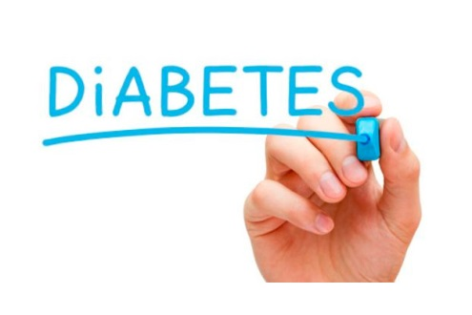
ALCOHOL, , AND YOU

Wondering if alcohol is off limits with diabetes? Most people with diabetes can have a moderate amount of alcohol. Research has shown that there can be some health benefits such as reducing risk for heart disease. But, moderation is important. If you have any questions about whether alcohol is safe for you, check with your doctor. People with diabetes should follow the same guidelines as those without diabetes if they choose to drink:
- Women should have no more than 1 drink per day.
- Men should have no more than 2 drinks per day.
*One drink is equal to a 12 oz beer, 5 oz glass of wine or 1 ½ oz distilled spirits (vodka, whiskey, gin, etc.).
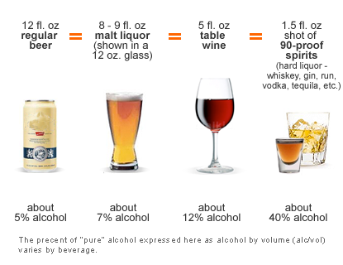

Some Tips to Sip By
- If you have diabetes, practice caution when drinking. Do not drink on an empty stomach or when your blood glucose is low. If you choose to drink, follow the guidelines above and have it with food. Have a zero calorie beverage by your side to keep yourself hydrated like water, diet soda or iced tea

- Alcohol can cause hypoglycemia shortly after drinking and for up to 24 hours after drinking. If you are going to drink alcohol, check your blood glucose before you drink, while you drink and for up to 24 hours. You should also check your blood glucose before you go to bed to make sure it is at a safe level – between 100 and 140 mg/dL. If your blood glucose is low, eat something to raise it.

- The symptoms of too much alcohol and hypoglycemia can be similar – sleepiness, dizziness and disorientation. You do not want anyone to confuse hypoglycemia for drunkenness, because they might not give you the proper assistance and treatment. The best way to get the help you need if you are hypoglycemic is to always wear an I.D. that says "I have diabetes."

- Alcohol may lessen your resolve to stay on track with healthy eating. If you plan to have a glass of wine at dinner or if you are going out for the night, plan ahead so you'll be able to stick to your usual meal plan and won't be tempted to overindulge.

For more information visit The American Diabetic Association at www.diabetes.org

