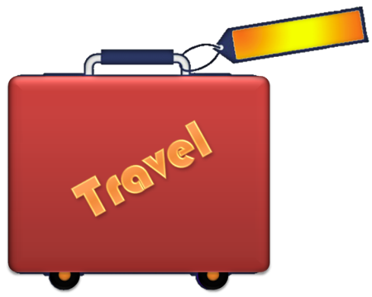
TIPS

Planning a trip? Whether you're camping or cruising, you can go anywhere and do almost anything. It just takes a little planning ahead to handle your diabetes.
See your doctor before you go
- Before a long trip, have a medical exam to make sure your diabetes is in good control.
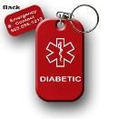
Medical IDs
- Have this with you at all times!
Packing Tips
- Pack at least twice as much as you think you will need.
- Pack a “carry-on” bag to keep with you at all times. This should include:
- Blood and urine testing supplies (include extra batteriers for your glucose meter)
- All oral medications (an extra supply is a good idea)
- Other medications or medical supplies, such as glucagon, anti-diarrhea medication, antibiotic ointment, anti-nausea drugs
- Your ID and diabetes identity card
- A well-wrapped, air-tight snack pack of crackers or cheese, peanut butter, fruit, a juice box, and some form of sugar (hard candy or glucose tablets) to treat low blood glucose
Have insulin, will travel
- When you travel with insulin, give some thought to where you’ll be storing your supplies. Insulin does not need to be refrigerated, but insulin stored in very hot or very cold temperatures may lose strength.
- Don’t store your insulin in the glove compartment or trunk of your car. Backpacks and cycle bags can get quite hot in the direct sunlight. If you plan to travel by car or bike or to be out in the elements, take steps to protect your insulin. Many travel packs are available to keep your insulin cool.
Crossing time zones
- If you take insulin shots and will be crossing time zones, talk to your doctor or diabetes educator before your trip. They can help you plan the timing of your injections while you travel.
- Remember: eastward travel means a shorter day. If you inject insulin, less may be needed. Westward travel means a longer day, so more insulin may be needed.
- To keep track of shots and meals through changing time zones, keep your watch on your home time zone until the morning after you arrive.
When you get there
- After a long flight, take it easy for a few days. Check your blood glucose often. Plan your activities so you can work in your insulin and meals.
- If you are more active than usual, your blood glucose could go to low. Take along snacks when hiking or sightseeing. Don’t assume you will be able to find food wherever you are.
- Wear comfortable shoes and never go barefoot. Check your feet every day. Look for blisters, cuts, redness, swelling, and scratches. Get medical care at the first sign of infection or inflammation.
- Take special care during extreme heat. Stay hydrated.

For more information visit the American Diabetes Association at www.diabetes.org

