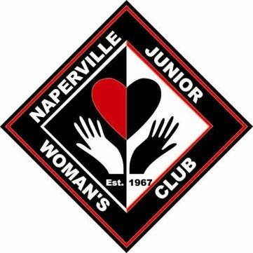
Correspondence
Naperville Junior Woman’s Club
Established in 1967
NAPERVILLE JUNIORS WOMANS CLUB
WOMAN’S CLUB

1807 S. Washington
Suite 110, - PMB 329
Naperville, IL 60565-2050

www.napervillejuniors.org

MEMBERSHIP APPLICATION

Name________________________________________________________Home Phone_________________________________________
Cell Phone__________________________________ E-Mail________________________________________________________________
Address _________________________________________________________________________________________________________
City____________________________ Zip Code_________________Subdivision______________________________________________
Birthdate__________________________ Moved from (Home State) ________________________________________________________
Children and (Year Born)___________________________________________________________________________________________
_________________________________________________________________________________________________________________

Current Occupation________________________________________________________________________________________________ Past Occupations__________________________________________________________________________________________________ Other clubs you belong to (AAUW, Garden Club, Professional Organizations). Please list duties or activities you participate in:
_________________________________________________________________________________________________________________
College___________________________________________________________Degree_________________________________________ Post Grad/Professional_________________________________________________Degree______________________________________

Have you ever been a member of a Federated Woman’s Club or Junior Club? If so, when and where?
_________________________________________________________________________________________________________________ Do you know anyone in NJWC? _____________________________ How did you hear about us?_______________________________
Hobbies/Interests:_________________________________________________________________________________________________ Skills/abilities to assist NJWC:_______________________________________________________________________________________

Membership Meeting

1
^{st}

GM

2
^{nd}

GM

